Visoka škola strukovnih studija za

informacione i komunikacione

tehnologije

Baningtion Watches

<http://bannington-watches.epizy.com>

Smer: Internet tehnologije

Predmet: Web programiranje PHP 1

Student:Djordje Taskovic 188/18

Beograd, 2021

## Sadrzaj

Uvod 4

Korišćeni programski jezici i okruženja 4

Opis funkcionalnosti 5

Admin panel 5

Proizvodi 5

Straničenje 5

Kontakt forma 5

Registracija i logovanje 5

Prikaz sadržaja 5

Anketa 5

Korpa 6

Dinamički meni 6

Template 6

Korisceni plugin fajovi 6

Organizacija 6

Organizaciona Sema Sajta 6

Organizaciona Sema Baze 7

Mapa Sajta 7

Opis stranisa sajta 8

Index.php 8

Product.php 14

Author.html 15

Register.php 15

Login.php 16

Single_product.php 18

Cart.php 19

Admin.php 20

Insert_update_proizvod.php 21

Ankete.php 22

Kontakt.php 23

Kodovi 24

Root 24

Admin.php 24

Author.php 26

Cart.php 28

Index.php 30

Login.php 37

Products.php 39

Register.php 43

Single_product.php 45

Page_parts 48

Footer.php 48

Head.php 49

Nav.php 50

Products_part.php 52

Modeli 54

Ad_insert_proizvod_obrada.php 54

Ad_update_proizvod_obrada.php 56

Anketa_obrada.php 57

Contact_obrada.php 58

Filkat.php 60

Filter_item_by_id.php 61

Fungcije.php 62

Log.php 70

Logout.php 72

Order_obrada.php 72

Reg.php 73

Config 75

Connection.php 75

Adminfiles 76

Ankete.php 76

Brisanje_proizvod.php 81

Insert_update_proizvod.php 81

Kontakt.php 91

CSS 96

Temify-icons.css 96

Style.css 118

Js 212

Main.js 212

Podaci baze 230

Anketa 230

Baner 230

Boja 230

Kontakt 231

Korisnici 231

Navigacija 231

Pol 231

Porudzbine 232

Proizvod 232

Slika 233

Slika_proizvod 233

Tip 234

Uloga 234

Vesti 234

# Uvod

## Korišćeni programski jezici i okruženja

* Html 5
* CSS 3
* JavaScript
* Jquery
* Bootstrap 4
* Ajax
* Visoal Studio Code
* Php
* Xampp

## Opis funkcionalnosti

### Admin panel

Adminu je omogićen unos, ažuriranje i brisanje svih unetih proizvoda.

Omogućen mu je uvid u sve porudžbine i sve primljene kontakt poruke kao i ’review fiddbeck’-a opisnh komentara korisnika.

### Proizvodi

Sav sadržaj stranice proizvodi je učitan dinamički putem ajaxa iz baze podataka.

Na stranici postoji dinamička dropdown lista za filtriranje proizvoda po marci telefona i jedna dropdown lista za sortiranje proizvoda po ceni i nazivu.

Takođe nalazi se i jedno polje za pretragu po nazivu i marci proizvoda.

### Straničenje

### 

Straničenje se koristi na stanici za proizvode,

za bolji prikaz usled velikog broja proizvoda, prikazuju se proizvoda na stranici.

### Kontakt forma

Na index stranici korisnik može da pošalje poruku administratoru sajta, ako ima bilo kakve nedoumice. Neophodno je da se unesu svrha poruke, email adresa, ime, prezime, telefon korisnika kao i sama poruka.

### Registracija i logovanje

Na sajtu postoji registracija i logovanje korisnika. Provera podataka prilikom registracije je urađena na serverskoj i klijentskoj strani, tj.realizuje se putem ajax-a. Prilikom uspešne registracije korisnik dobija ulogu korisnika, koju može da menja samo administrator.

Provera podataka prilikom logovanja se vrši na serverskoj i klijentskoj strani i ako podaci nisu dobri obaveštava se korisnik gde je pogrešio prilikom logovanja.

Ako su i email i lozinka ispravni pravi se sesija koja sadrži sve podatke o korisniku i prosledju je mu se poruka da je proces registracija/logovanje uspesan.

### Prikaz sadržaja

Sav ključan sadržaj na sajtu se kreira dinamički, gde se u većini slučajeva koristi ajax.

### Anketa

Postoji jedna aktivni ’review’ deo na ’single_product’ stranici.

Ovde korisnici mogu da ostave svoje utiske o proizvodu. Gde prosledjuje svoje podatke

Kao i svo odgovor administratoru.

### Korpa

Samo autorizovani korisnik može dodavati proizvode u korpu. Sistem korpe za klijentsku stranu realizovan je pomoću ’ cookies’.

Korisnik u korpu može da doda više proizvoda, kao i više proizvoda istog tipa. Takođe omogućeno mu je da briše proizvode iz korpe.

Klikom na taster ’Make an Order’ korisniku se prikazuje poruka koja ga obaveštava da je uspešno izvršio kupovinu, podaci se memorišu u bazu i prikazuju administratoru sajta o porudžbini.

### Dinamički meni

Prilikom učitavanja stranice prikazuje se dinamiči meni, koji prikazuje odgovarajuće linkove za admina, običnog autorizovanog ili neautorizovanog korisnika, u zavisnosti od aktivnosti i stanja korisničke sesije.

## Template

Template nije korišćen iz drugih izvora, napisan je samostalno i prilagodjen za potrebe dodatnih fungionalnosti sa dodatim modifikacijama za ovaj predmet.

## Korisceni plugin fajovi

Za potrebe sajta i same konstrukcije su koriscene klasse bootstrapa

kao i ’owl-carusel’ klasa za bojlu organizaciju i prikazivanje produkta na sajtu. Na sajtu su takodje je koriscen ’temify-icons’ set fontova za bolji izgled.

# Organizacija

## Organizaciona Sema Sajta

Sa svake stranice se može pristupiti svakoj stranici (naravo u zavisnosti od uloge korisnika),

osim stranici za opis konkretnog proizvoda ’single_product.php’.

Do te stranice se može doći klikom na link sa oznakom ’lupe’ koji sadrži svaki proizvod,

koji se nalazi na stranici za sve proizvode.

Takođe sa te stranice se može pristupiti bilo kojoj stranici.

Index.php

Single_product.php

Register.php

Products.php

Author.php

Admin.php

Login.php

Cart.php

## Organizaciona Sema Baze

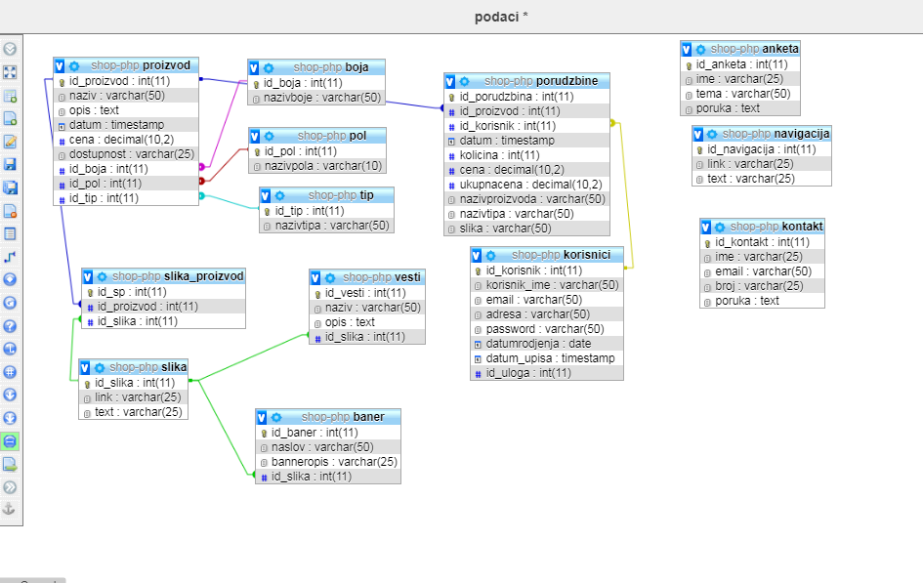

## Mapa Sajta

<urlset xmlns="http://www.sitemaps.org/schemas/sitemap/0.9">

<url>

    <loc>https://bannington-watches.epizy.com/index.php</loc>

    <lastmod>2021-6-26</lastmod>

    <changefreq>daily</changefreq>

    <priority>1</priority>

</url>

<url>

    <loc>https://bannington-watches.epizy.com/author.php</loc>

    <lastmod>2021-6-20</lastmod>

    <changefreq>weekly</changefreq>

    <priority>0.9</priority>

</url>

<url>

    <loc>https://bannington-watches.epizy.com/cart.php</loc>

    <lastmod>2021-6-20</lastmod>

    <changefreq>daily</changefreq>

    <priority>1</priority>

</url>

<url>

    <loc>https://bannington-watches.epizy.com/login.php</loc>

    <lastmod>2021-6-20</lastmod>

    <changefreq>weekly</changefreq>

    <priority>0.5</priority>

</url>

<url>

    <loc>https://bannington-watches.epizy.com/register.php</loc>

    <lastmod>2021-6-20</lastmod>

    <changefreq>weekly</changefreq>

    <priority>0.5</priority>

</url>

<url>

    <loc>https://bannington-watches.epizy.com/single_product.php</loc>

    <lastmod>2021-6-20</lastmod>

    <changefreq>weekly</changefreq>

    <priority>0.5</priority>

</url>

</urlset>

## Opis stranisa sajta

### Index.php

Dinaičko učitavnje meni linkova na svim stranama .

Meni je prilagodjen za sve vrste uredjaja tako da se na manjim ekranima prikazuje „hamburger”i klikom na njega se otvara meni.

Pojavljivanje sub-menija prilikom ’hover’ nekih od linkova. Kljcne icone na desnoj strani menija za registraciju ,logovanje kao i pojava dodatnih ’cart’ i ’logout’ icona prilikom logovanja korisnika ili admina.

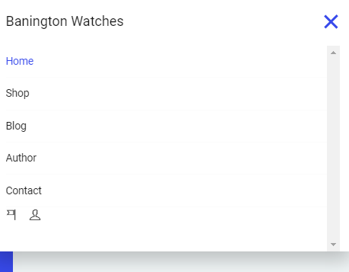

Dinamicko Prikazivanje ’banner’ sekcije na index strani sa podacima koji reklamiraju sajt u obliku carusela.

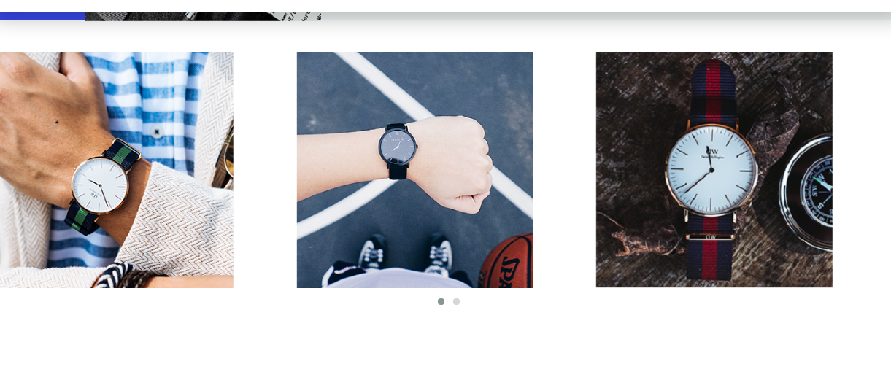

Dinamicko ispisivanje ’trending ’ producta iz baze sa opsijom stranicenja gde se odredjeni broj producta ispisuje na drugoj strani.

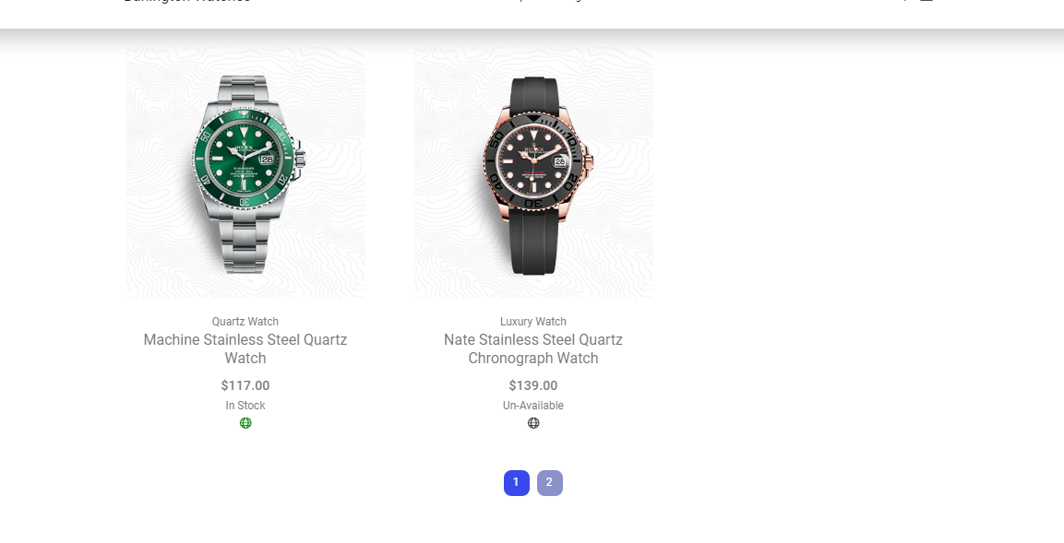

Svaki proizvod na strani poseduje dva linka koji se prikazuju na ’hover ’ efectu samih itema.

Link sa oznakom lupe prikazuje zaseban proizvod na strani ’single_product.php’.

Link sa oznakom ’kolica’ omogucuje da korisnik unese odabranji proizvod u korpu, gde se lista izabranih itema moze videti na korpa stranici’cart.php’(ako je korisnik ulogovan).

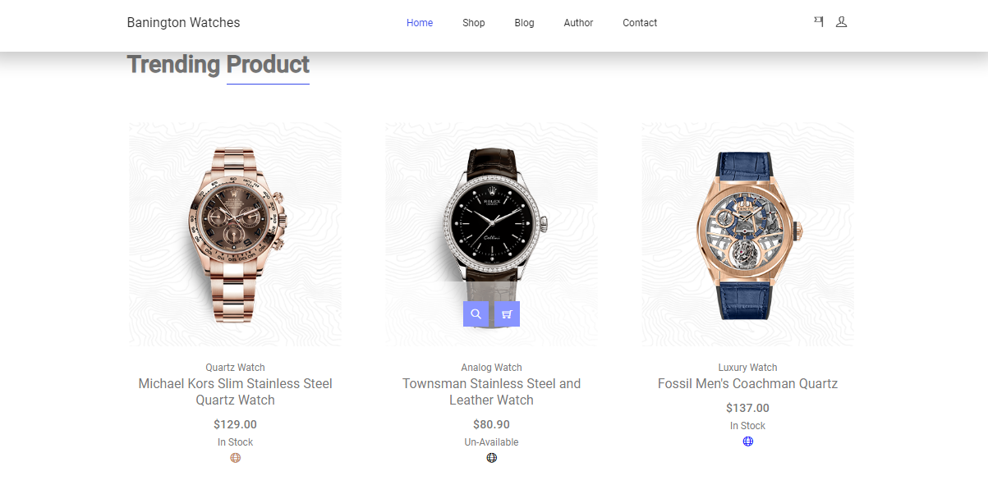

Dinamicko ispisivanje sekcije novosti ili ’news’ na stranici.

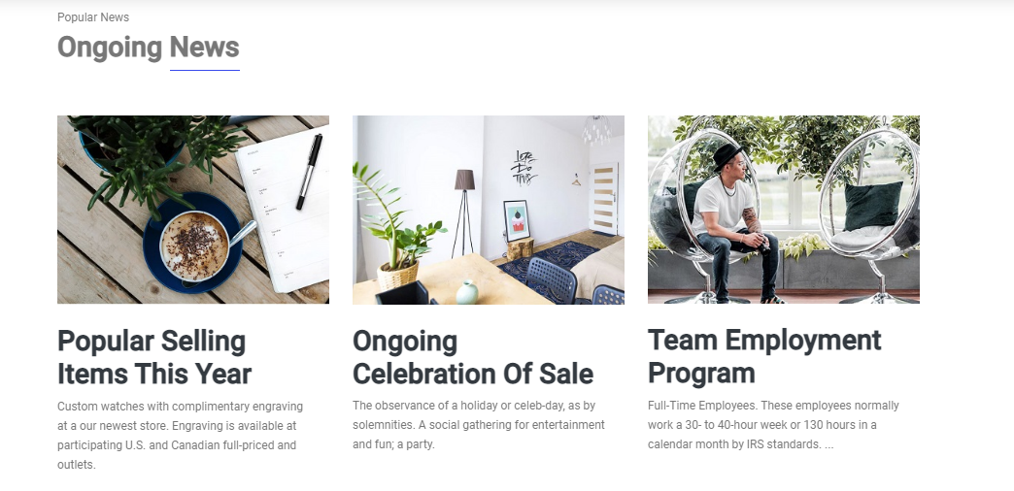

Kontakt sekcija sa podacima kompanije sajta , kao i forma za slanje poruke korisnika za uspostavljanje veze i ostvarivanje bolje kupovine.

Podaci su provereni regex izrazima i salju se u bazu podataka.

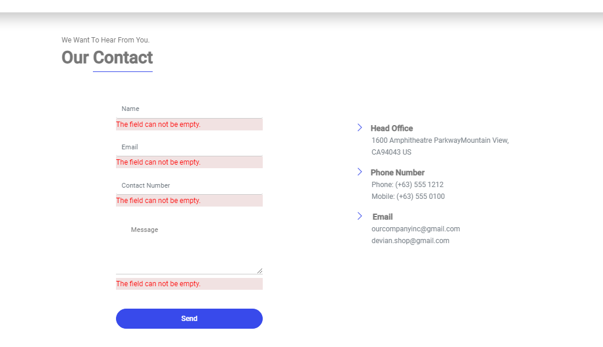

Sekctja ’footer’ koja je prisutna i na svakoj stranici sa motom companije kao i korisnim informacijama i linkovima u svrhu ostvarivanja boljitka.

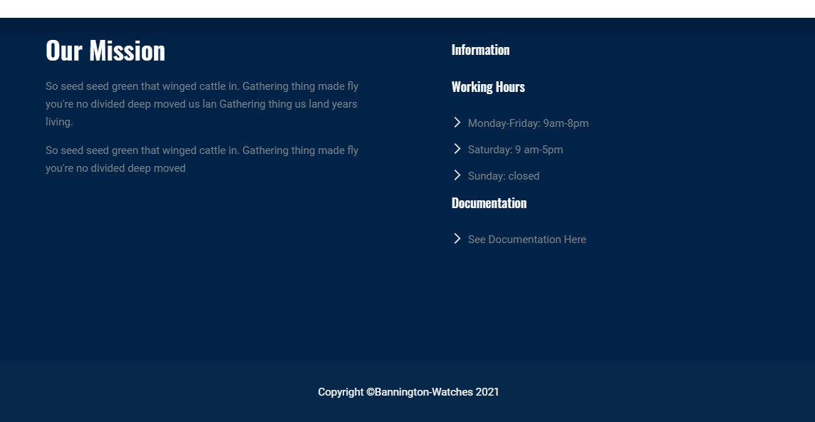

### Product.php

Dinamicko ispisivanje svih proizvoda na strani. Pored ispisa mogucnost filtriranja producta klikom na nekih od kategorija sa leve strane kao i fungcionalnost sortiranja istih klikom na sort bu price dorpdow liste.Pored toga omogucena je i pretraga odredjenog itema po nazivu.

Kao i na index strani porizvodi poseduju linkove ’lupa’ i ’korpa’ za prikazivanje samostalnog itema i upisa u korpu.

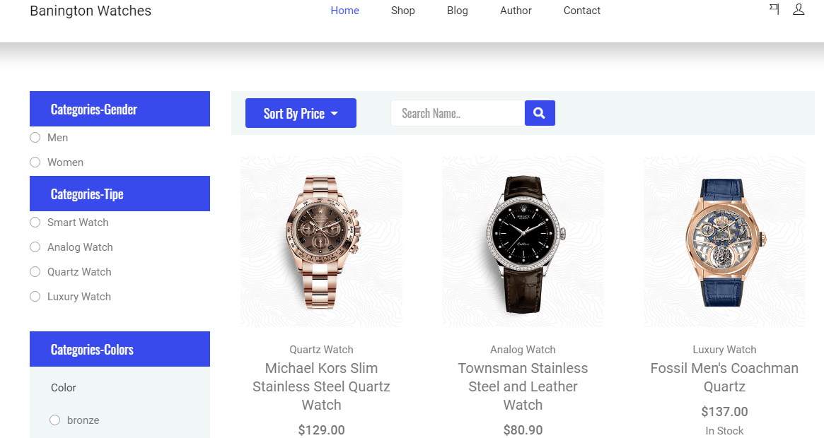

### Author.html

Podaci o autoru sajta kome se moze pristupiti preko navigacijonig linka ’Author’.

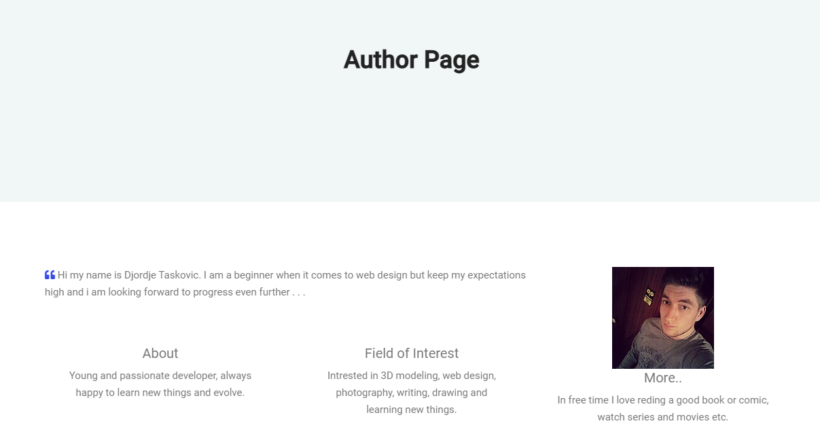

### Register.php

Stranica za registraciju novih korisnika obezbedjena regex izrazima za uspesnije upisivanje korisnika.Prilikom registracije korisnik dobija potvrdu dali je nalog kreiran.

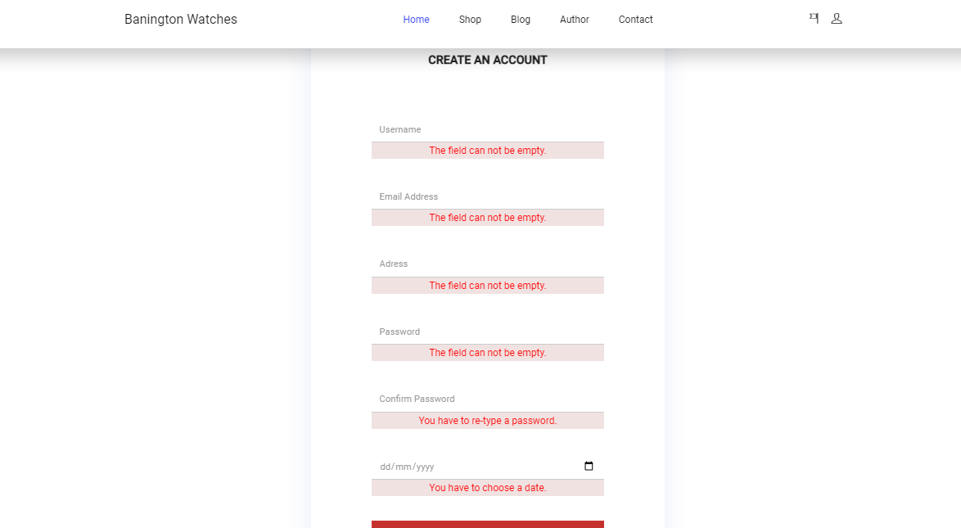

### Login.php

Stranica za logovanje korisnika/admina obezbedjena izrazima gde se posle uspesnog ili neuspesnog logovanja prikazuje poruka o stanju.

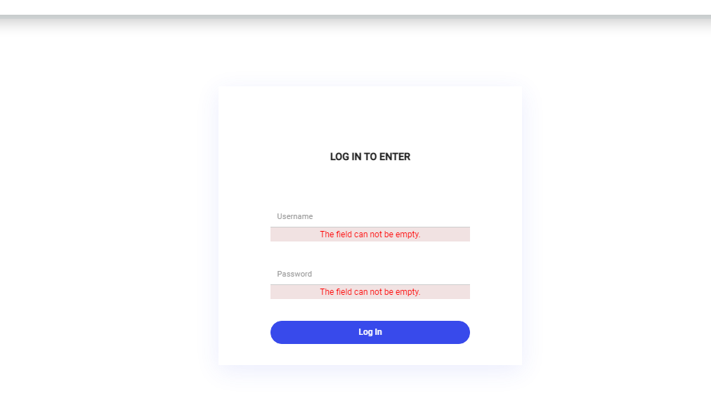

### Single_product.php

Ispisivanje izbranog proizvoda sa opsirnijim podacima iz sesije i klikom na ’lupa’ ikonu proizvoda.

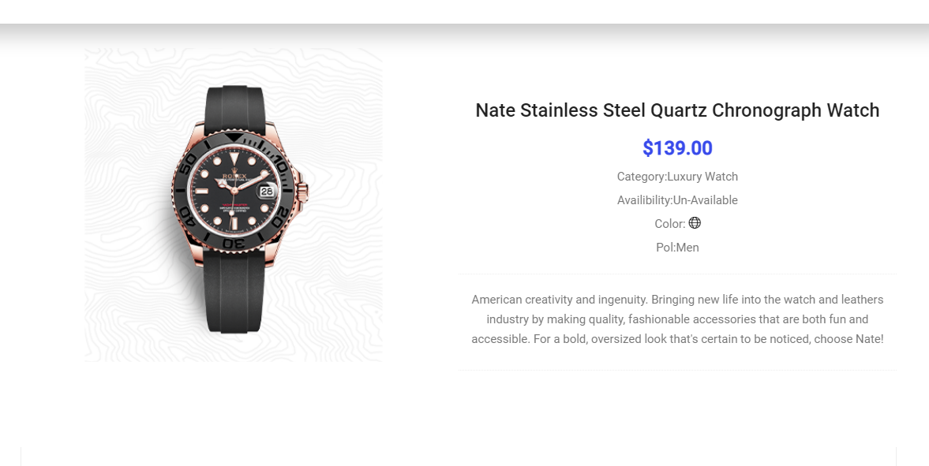

Review forma na ’single_product.php’ strani gde korisnik ostavlja podatke o svom iskustvu

U vezi sajt ili odabranog proizvoda. Podaci ankete se salju u bazu.

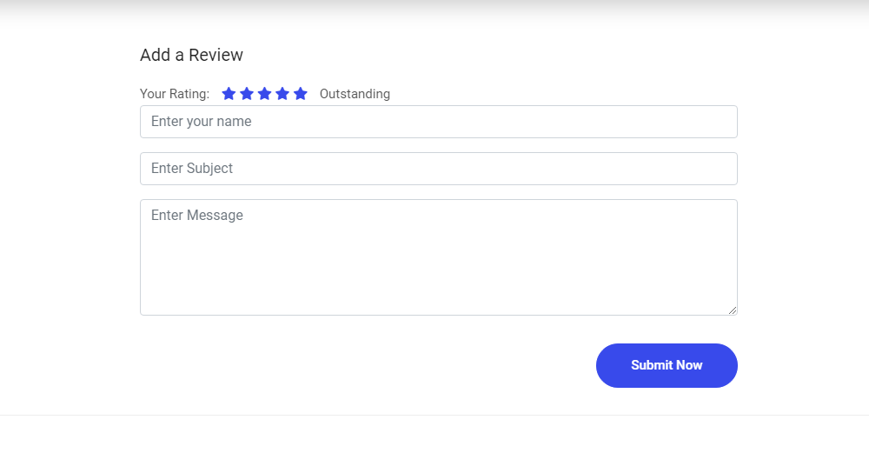

### Cart.php

Stranica za ispisivanje odabranih itema sa sajta.Pristup strani je moguc samo ulogovanim korisnicima koji dobijaju ikonu ’cart’ u navigacionom meniju. Nakon odabira itema

se im se prikazuje lista odabranih.

Korisnik moze da obrise listu i da nastavi kopovinu ’Continue Shoping’ ili da klikom na ’Make an order’ izvrsi zahtev za porudzbinu koja se cuva u bazi.

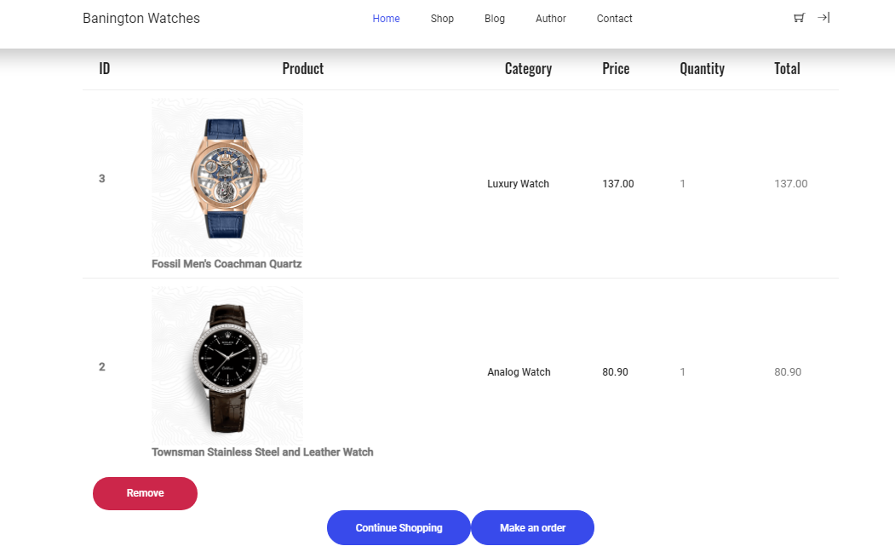

### Admin.php

Pristup ovoj strani poseduje samo admin preko koje se prikazuju svi proizvodi na sajtu.

Klikom na ’Remove’ link sa desne strane admin moze da obrise izabrani proizvod sa sajta.

Klikom na ’Modify’ link sa desne strane odlazi do update/insert strane za dalju obradu.

Linkovi sa leve strane prikazuju dodatne informacije o sajtu.

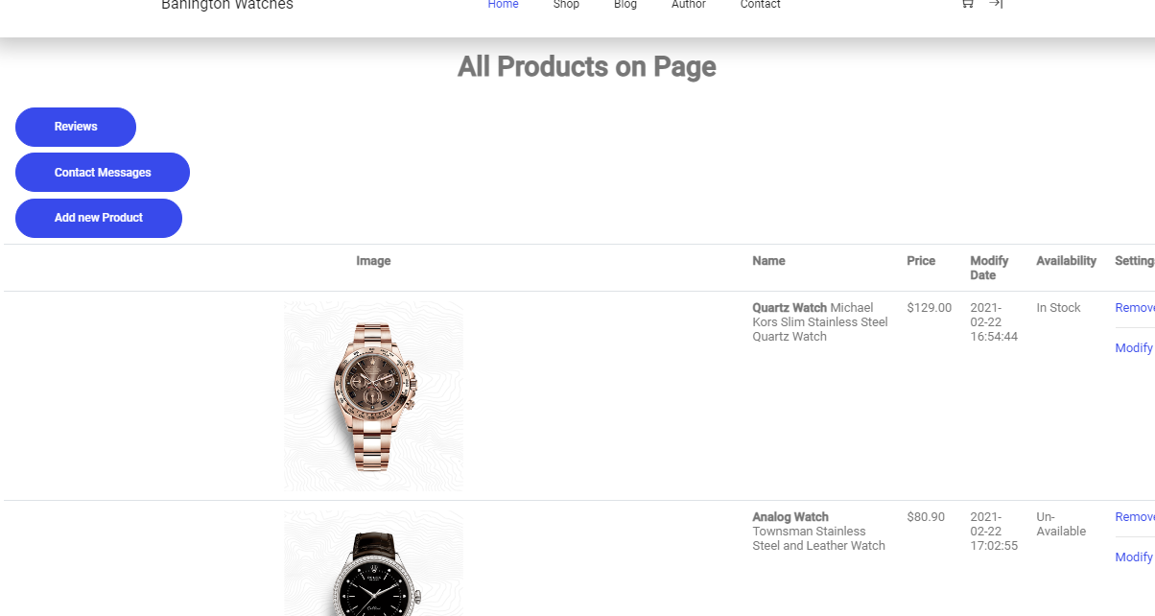

### Insert_update_proizvod.php

Strana sa formama za insert novid proizvoda i update podataka izabranog itema na desnoj strani.Poruka o izvrsenoj akciji se ispisuje na kraju forme.

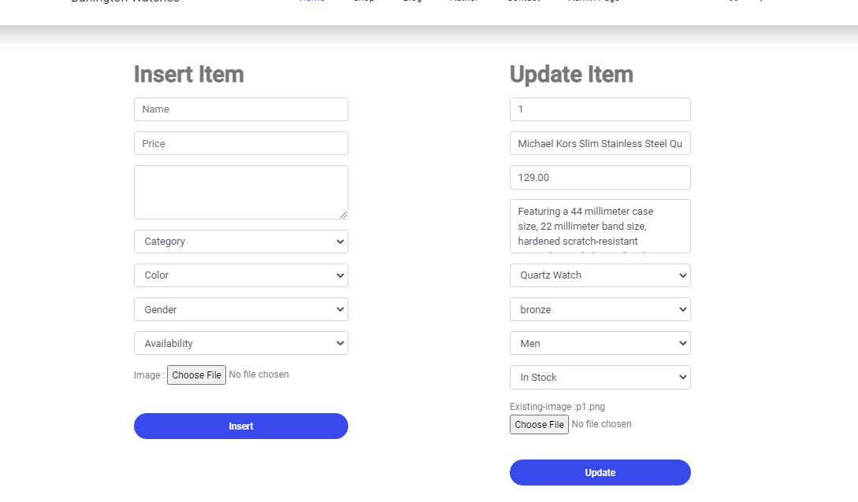

### Ankete.php

Stranica ankete ili ’reviews’ kojoj se pristupa preko admin strane sadrzi podatke o

Poslatim podacima korisnika i posetioca sajta.

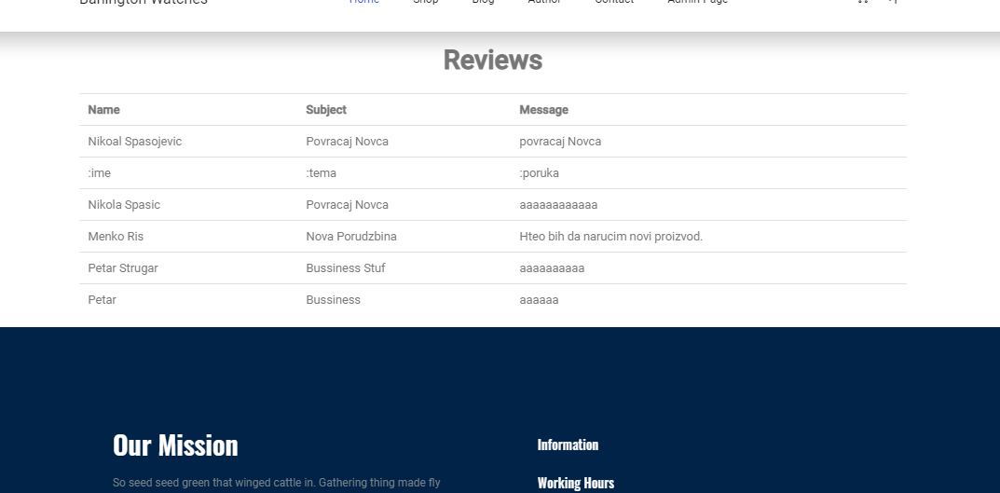

### Kontakt.php

Stranica kontakt poruka prosledjenih od strane posetioca sajta .

Strani se pristupa preko admin panela.

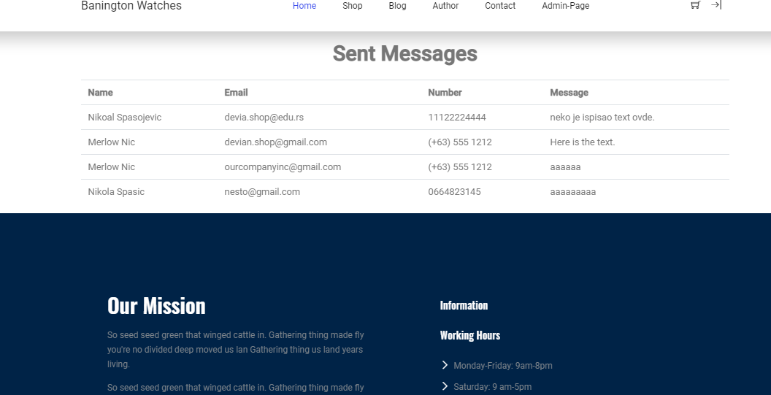

# Kodovi

## Root

### Admin.php

<html>

<?php

    session_start();

  include "config/connection.php";

  include "modeli/fungcije.php";

    @include('page_parts/head.php');

?>

<body>

<header class="header_area">

<div class="main_menu">

<?php

    @include('page_parts/nav.php');

    ?>

</div>

</header>

<section>

        <?php

        if(!isset($_SESSION["korisnik"]) || $_SESSION["korisnik"]->naziv!="admin"){

            header("Location: errors/403.php");

            }

            else if(isset($_SESSION['korisnik'])):

                $korisnik =  $_SESSION['korisnik'];

                if($korisnik->naziv=="admin"):

          ?>

<div class="container mt-3">

<div class="row">

          <div class="col-12 pb-3 text-center">

                        <h3>All Products on Page</h3>

            </div>

       </div>

</div>

<div class="container-fluid" id="proizvodi">

<div class="col-12 mt-2 mb-2">

   <a class="button button hero mb-2" href="adminfiles/ankete.php">Reviews</a>

                <br>

   <a class="button button hero mb-2" href="adminfiles/kontakt.php">Contact Messages</a>

   <br>

   <a class="button button hero" href="adminfiles/insert_update_proizvod.php">Add new Product</a>

</div>

    <table class="table table-responsive">

        <tr>

            <th class="text-center" scope="col">Image</th>

            <th scope="col">Name</th>

            <th scope="col">Price</th>

            <th scope="col">Modify Date</th>

            <th scope="col">Availability</th>

            <th scope="col">Settings</th>

        </tr>

    <?php

         $proizvodi =  vratiSveProducte();

        foreach($proizvodi as $p):

        ?>

    <tr>

    <td class="d-flex justify-content-center">

    <img class="w-25" src="img/products/<?= $p->link?>" alt="<?= $p->text?>"></td>

    <td><b><?=$p->nazivtipa?> </b><?= $p->naziv?></td>

    <td>$<?= $p->cena?></td>

    <td><?=$p->datum?></td>

    <td><?=$p->dostupnost?></td>

    <td>

    <a href="adminfiles/brisanje_proizvod.php?id=<?=$p->id_proizvod?>">Remove</a>

        <hr>

    <a href="adminfiles/insert_update_proizvod.php?id=<?=$p->id_proizvod?>">Modify</a></td>

    </tr>

    <?php

    endforeach;

    ?>

    </table>

 </div>

        <?php

        endif;

        endif;

        ?>

</section>

<?php

    @include('page_parts/footer.php');

 ?>

</body></html>

### Author.php

<html >

<?php

session_start();

    @include('page_parts/head.php');

?>

<body>

<header class="header_area">

<div class="main_menu">

<?php

  include "config/connection.php";

  include "modeli/fungcije.php";

    @include('page_parts/nav.php');

    ?>

</div>

</header>

<section class="blog-banner-area" id="category">

      <div class="container h-100">

            <div class="blog-banner">

                <div class="text-center">

                <h1>Author Page</h1>

                </div>

            </div>

      </div>

</section>

          <section id="author" class="container">

                     <div class="row jumblock mt-5 mb-5">

                     </div>

                      <div id="pageauthor" class="jumblock">

                        <div class=" container bg-white">

                        <div class="row text-center">

                          <div class="col-md-8">

                            <div class="row">

                              <div id="autext1" class="col-md-12 text-left mb-5 bborder">

                                  <blockquote>

                                      <i class="fas fa-quote-left"></i>

                                      Hi my name is Djordje Taskovic.

                                      I am a beginner when it comes to web design but keep my expectations

                                      high and i am looking forward to progress even further . . .

                                       </blockquote>

                              </div>

                            </div>

                            <div class="row  d-flex justify-content-around">

                              <div id="autext2" class="col-lg-5 col-sm-12 " >

                                <h4 class="about">About</h4>

                                <div class="heading-underline"></div>

                                <p class="autextpromena">Young and passionate developer,

                                  always happy to learn new things

                                   and evolve.

                                </p>

                              </div>

                              <div id="autext3" class="col-lg-5 col-sm-12 " >

                                  <h4 class="fieldofinterest">Field of Interest</h4>

                                  <div class="heading-underline"></div>

                                  <p class="autextpromena"> Intrested in 3D modeling, web design,

                                     photography, writing,

                                      drawing and learning new things.

                                  </p>

                              </div>

                            </div>

                          </div>

                          <div class="col-md-4">

                            <div class="row">

                              <div class="col-12">

                                  <img src="img/other/profil1.jpg" alt="profil">

                              </div>

                              <div id="autext4" class="col-12">

                                  <h4 class="more" >More..</h4>

                                  <div class="heading-underline"></div>

                                  <p class="autextpromena"> In free time I love

                                     reding a good book or comic,

                                      watch series and movies etc.

                                  </p>

                                </div>

                            </div>

                          </div>

                        </div>

                        </div>

                      </div>

                      </section>

<?php

    @include('page_parts/footer.php');

    ?>

</body></html>

### Cart.php

<html >

    <?php

    session_start();

      include "config/connection.php";

      include "modeli/fungcije.php";

    @include('page_parts/head.php');

    ?>

<body>

<header class="header_area fixed">

<div class="main_menu">

<?php

    @include('page_parts/nav.php');

    ?>

</div>

</header>

<section class="blog-banner-area" id="category">

<div class="container h-100">

<div class="blog-banner">

<div class="text-center">

<h1>Shopping Cart</h1>

<nav aria-label="breadcrumb" class="banner-breadcrumb">

<ol class="breadcrumb">

<li class="breadcrumb-item"><a href="#">Home</a></li>

<li class="breadcrumb-item active" aria-current="page">Shopping Cart</li>

</ol>

</nav>

</div>

</div>

</div>

</section>

<section class="cart_area">

<div class="container">

<div class="cart_inner">

<div class="table-responsive">

<table class="table">

        <thead>

        <tr>

        <th scope="col"><h5>ID</h5></th>

           <th scope="col" class="text-center"><h5>Product</h5></th>

                <th scope="col"class="text-center"><h5>Category</h5></th>

               <th scope="col"><h5>Price</h5></th>

              <th scope="col"><h5>Quantity</h5></th>

             <th scope="col"><h5>Total</h5></th>

        </tr>

        </thead>

  <tbody id="cart_ispis">

   <!-- cart_ispis -->

  </tbody>

</table>

<div id="shoping-checkout " class="container">

<div class="row">

  <div class="col-12 bottom_button d-flex">

    <button type="button" class="button btn-delete">Remove</button>

  </div>

  <div class="col-12">

    <div class="checkout_btn_inner d-flex align-items-center justify-content-center">

      <a class="button button-hero" href="products.php">Continue Shopping</a>

      <a class="button button-hero" href="#" id="make_order">Make an order</a>

    </div>

    <div id="order_poruka"></div>

  </div>

</div>

</div>

</div>

</div>

</div>

</section>

<?php

@include('page_parts/footer.php');

if(isset($_SESSION['korisnik'])):

  $korisnik = $_SESSION['korisnik'];

  $IDkorisnik = $korisnik->id_korisnik;

 // var_dump("ID");

 // var_dump($IDkorisnik);

 ?>

<p id="proslediID"><?=$IDkorisnik?></p>

 <?php

 endif;

 ?>

</body>

</html>

### Index.php

<!DOCTYPE html>

    <?php

    session_start();

    include "config/connection.php";

    include "modeli/fungcije.php";

    @include('page_parts/head.php');

    ?>

 <body>

    <header class="header_area fixed">

    <div class="main_menu nav-down">

    <?php

    @include('page_parts/nav.php');

    ?>

    </div>

    </header>

    <main class="site-main">

    <!--HERO-BANNER-->

    <section class="hero-banner">

    <div class="container">

    <div class="row no-gutters align-items-center pt-60px">

    <div class="col-5 d-none d-sm-block">

    <div class="hero-banner__img">

    <img class="img-fluid" src="img/hero/hero.png" alt="hero-banner">

    </div>

    </div>

    <div class="col-sm-7 col-lg-6 offset-lg-1 pl-4 pl-md-5 pl-lg-0">

    <div class="hero-banner__content">

    <h4>Shop is fun</h4>

    <h1>Browse Our Premium Product</h1>

    <p>Us which over of signs divide dominion deep fill bring

     they're meat beho upon own earth without morning over third.

     Their male dry. They are great appear whose land fly grass.</p>

    <a class="button button-hero" href="#">Browse Now</a>

    </div>

    </div>

    </div>

    </div>

    </section>

    <!--BANNER-->

    <section id="banner" class="section-margin mt-5">

        <div class="owl-carousel car owl-theme">

            <?php

            $banner = vratiBanere();

            foreach($banner as $b):

            ?>

             <div class="owl-item caritem hero-carousel__slide">

                <img src="img/banner/<?=$b->link?>" alt="<?=$b->text?>" class="img-fluid">

                <a href="#" class="hero-carousel__slideOverlay">

                <h3><?=$b->naslov?></h3>

                <p><?=$b->banneropis?></p>

                </a>

            </div>

            <?php

            endforeach;

            ?>

        </div>

            <div class="owl-dots"></div>

        </div>

    </section>

    <!--PRODUCTS-->

    <section class="section-margin calc-60px">

    <div class="container">

        <div class="section-intro pb-60px">

        <p>Popular Item in the market</p>

        <h2>Trending <span class="section-intro__style">Product</span></h2>

        </div>

    <div class="row">

        <!-- product -->

        <?php

        @include('page_parts/products_part.php');

        ?>

        <!-- page change -->

         <!-- product -->

    </div> <!-- row -->

    </div> <!-- container -->

    </section>

    <!--SHOP NOW-->

    <div id="sale-section" class="sectionbreak">

    </div>

    <section class="site-section">

        <div class="container">

          <div class="row large-gutters">

            <div class="col-lg-6  shopnow-desc">

                <h4>Up To 20% Off</h4>

              <h1>This Year Summer Sale</h1>

                  <p>This anual market is open ounce again and the prices are sky rocketing far figh.

                      Hury up and chatch your premium product for a limited time.</p>

                  <ul class="list-unstyled ul-check success">

                    <li><i class="ti-angle-right"></i>Placeat maxime animi minus</li>

                    <li><i class="ti-angle-right"></i>omnis ullam pariatur itaque nisi</li>

                    <li><i class="ti-angle-right"></i>Placeat maxime animi minus</li>

                    <a class="button button--active mt-3 mt-xl-4" href="#">Shop Now</a>

                  </ul>

            </div>

            <div class="col-lg-6 mb-5">

                <div class="owl-carousel slide-one-item with-dots shopnow">

                    <div><img src="img/banner/banner1.png" alt="Image" class="img-fluid"></div>

                    <div><img src="img/banner/banner3.png" alt="Image" class="img-fluid"></div>

                  </div>

            </div>

          </div>

        </div>

      </section>

    <section class="section-margin calc-60px" id="bestsellers">

    <div class="container">

    <div class="section-intro pb-60px">

    <p>Popular Item in the market</p>

    <h2>Best <span class="section-intro__style">Sellers</span></h2>

    </div>

    <div class="owl-carousel salles owl-theme">

    <!-- best sellers -->

        <?php

        if(isset($_SESSION['korisnik'])){

            $klasa="add-to-cart-enabled";

        }

        else{

            $klasa="add-to-cart-disabled";

        }

        $bestseller = vratiProizvodedruga();

        foreach($bestseller as $s):

        ?>

        <div class="item">

            <div class="card text-center card-product ">

                <div class="card-product__img">

                <img class="img-fluid" src="img/products/<?=$s->link?>" alt="<?=$s->text?>">

                <ul class="card-product__imgOverlay">

                <!-- href="single_product.php" -->

                <li>

                    <a href="single_product.php">

                <button class="button_single" data-id="<?= $s->id_proizvod?>">

                   <i class="ti-search"></i></button></a></li>

                   <li><button class="<?=$klasa?>" data-id="<?= $p->id_proizvod?>">

                          <i class="ti-shopping-cart"></i></button></li>

                <li>

                </ul>

                </div>

                <div class="card-body">

                <p><?=$s->nazivtipa?></p>

                <h4 class="card-product__title"><?= $p->naziv?></h4>

                <p class="card-product__price">$<?=$s->cena?></p>

                <p><?= $s->dostupnost?></p>

                <p style="display:none;"><?= $p->nazivboje?></p>

                <i class="ti-world" style="color:var(--<?= $s->nazivboje?>);"></i>

                </div>

                </div>

        </div>

        <?php

        endforeach;

        ?>

        <!--ITMES-->

    </div>

    </section>

    <!--News-->

    <div id="news-section" class="sectionbreak">

    </div>

    <section class="blog">

      <div class="container">

      <div class="section-intro pb-60px">

    <p>Popular News</p>

    <h2>Ongoing <span class="section-intro__style">News</span></h2>

    </div>

        <div class="row">

          <?php

        $news = vratiVesti();

        foreach($news as $n):

        ?>

            <div class="col-md-6 col-lg-4 mb-4 mb-lg-4">

                    <div class="card card-blog">

                    <a href="single.html"><img src="img/news/<?=$n->link?>" alt="<?=$n->text?>"

                    class="img-fluid"></a>

                        <div class="card-body">

                        <h2 class="font-size-regular">

                        <a class="text-dark"><?=$n->naziv?></a>

                        </h2>

                            <p><?=$n->opis?>

                        </div>

                    </div>

            </div>

        <?php

        endforeach;

        ?>

        </div>

      </div>

    </section>

    <div id="contact-section" class="sectionbreak">

    </div>

    <section id="contact" class="mb-4">

    <div class="container">

    <div class="section-intro pb-60px">

    <p>We Want To Hear From You.</p>

    <h2>Our <span class="section-intro__style">Contact</span></h2>

    </div>

    </div>

    <div class="container">

       <div class="row">

        <div class="col-lg-6 col-md-6 col-sm-12 d-flex justify-content-center">

            <!-- form -->

            <form>

                  <div class="form-group col-lg-12">

                           <input  class="form-control"  name="contactName" type="text"

                            id="contactName" placeholder="Name" value=""/>

                            <p class="text-error"></p>

                  </div>

                  <div class="form-group col-lg-12">

                       <input class="form-control"  name="contactEmail"

                         type="email" id="contactEmail" placeholder="Email" value="">

                         <p class="text-error"></p>

                   </div>

                  <div class="form-group col-lg-12">

                           <input  class="form-control"  name="number"

                            type="text" id="number" placeholder="Contact Number" value="">

                            <p class="text-error"></p>

                   </div>

                  <div class="form-group col-lg-12">

                        <textarea name="contactMessage" id="contactMessage"

                         placeholder="Message" rows="2" cols="30"></textarea>

                         <p class="text-error"></p>

                   </div>

                 <div class="form-group col-lg-12">

                     <button type="button" class="button button-login w-100 mt-4 mb-4"

                      id="button_contact">Send</button>

                      <div id="contact-message"></div>

                  </div>

            </form> <!-- Form End -->

         </div> <!-- /col-left -->

         <div class="col-lg-6 col-md-6 col-sm-12">

            <div class="single-footer-widget tp_widgets">

                <div class="ml-40">

                <p class="sm-head"><i class="ti-angle-right"></i>Head Office</p>

                <p>1600 Amphitheatre ParkwayMountain View,<br> CA94043 US</p>

                <p class="sm-head">

                <i class="ti-angle-right"></i>Phone Number

                </p>

                <p>Phone: (+63) 555 1212<br>

                    Mobile: (+63) 555 0100<br>

                </p>

                <p class="sm-head">

                <i class="ti-angle-right"></i>

                Email

                </p>

                <p>

                ourcompanyinc@gmail.com<br>

                devian.shop@gmail.com

                </p>

                </div>

            </div>

        </div>

    </div> <!-- /row -->

       </div>

    </section> <!-- /contact -->

    </main>

   <?php

   @include('page_parts/footer.php');//footer

  ?>

    </body>

 </html>

### Login.php

<html>

<?php

    session_start();

  include "config/connection.php";

  include "modeli/fungcije.php";

    @include('page_parts/head.php');

?>

<body>

<header class="header_area">

<div class="main_menu">

<?php

    @include('page_parts/nav.php');

    ?>

</div>

<?php

    if(isset($_SESSION['korisnik'])){

      $korisnik = $_SESSION['korisnik'];

      if($korisnik->naziv=="admin"){

        header("Refresh:0; url=admin.php");

      }

    }//isset

    if(isset($_SESSION['korisnik'])){

        $korisnik = $_SESSION['korisnik'];

        if($korisnik->naziv=="korisnik"){

        header("Refresh:0; url=index.php");

     }

 }//isset

    ?>

</header>

<section class="blog-banner-area" id="category">

<div class="container h-100">

<div class="blog-banner">

<div class="text-center">

<h1>Login</h1>

</div>

</div>

</div>

</section>

<section class="login_box_area section-margin">

<div class="container">

<div class="row d-flex justify-content-center">

<div class="col-lg-6 ">

<div class="login_form_inner">

<h3>Log in to enter</h3>

<form class="row login_form" action="#/" id="contactForm">

    <div class="col-md-12 form-group">

    <input type="text" class="form-control" id="name" name="name"

    placeholder="Username" onfocus="this.placeholder = ''" onblur="this.placeholder = 'Username'">

    <p class="text-error"></p>

</div>

            <div class="col-md-12 form-group">

            <input type="password" class="form-control" id="password" name="name"

            placeholder="Password" onfocus="this.placeholder = ''" onblur="this.placeholder = 'Password'">

            <p class="text-error"></p>

            </div>

            <div class="col-md-12 form-group">

            <button type="button" id="login_btn" class="button button-login w-100">Log In</button>

            <p id="message_log"> </p>

            </div>

</form>

</div>

</div>

</div>

</div>

</section>

<?php

    @include('page_parts/footer.php');

    ?>

</body></html>

### Products.php

<html >

<?php

session_start();

include "config/connection.php";

include "modeli/fungcije.php";

 @include('page_parts/head.php');

    ?>

<body>

<header class="header_area">

<div class="main_menu">

<?php

    @include('page_parts/nav.php');

    ?>

</div>

</header>

<section class="blog-banner-area" id="category">

<div class="container h-100">

<div class="blog-banner">

<div class="text-center">

<h1>Shop Products</h1>

</div>

</div>

</div>

</section>

<section class="section-margin--small mb-5">

<div class="container">

<div class="row">

<div class="col-xl-3 col-lg-4 col-md-5">

<div class="sidebar-categories">

<div class="head">Categories-Gender</div>

<ul id="main-categories">

             <?php

            $pol = vratiPol();

            foreach ($pol as $e){

                echo"<li class='filter-list'>

                <input class='pixel-radio' type='radio' id='".$e->nazivpola."'

                 name='brand'><label>".$e->nazivpola."</label></li>";

            }

            ?>

</ul>

</div>

<div class="sidebar-categories">

<div class="head">Categories-Tipe</div>

<ul id="main-categories">

            <?php

            $tip = vratiTipove();

            foreach ($tip as $e){

                echo"<li class='filter-list'>

                <input class='pixel-radio' type='radio' id='".$e->nazivtipa."'

                 name='brand'><label>".$e->nazivtipa."</label></li>";

            }

            ?>

</ul>

</div>

<div class="sidebar-filter">

<div class="top-filter-head">Categories-Colors</div>

<div class="common-filter">

<div class="head">Color</div>

<ul id="main-categories">

 <?php

            $color = vratiBoje();

            foreach ($color as $e){

                echo"<li class='filter-list'>

                <input class='pixel-radio' type='radio' id='".$e->nazivboje."'

                 name='brand'><label>".$e->nazivboje."</label></li>";

            }

            ?>

</ul>

</div>

    </div>

</div>

<div class="col-xl-9 col-lg-8 col-md-7">

<div class="filter-bar d-flex align-items-center">

            <div class="dropdown mr-5 filter-bar-dropdown">

            <button class="btn dropdown-toggle"

            type="button" id="dropdownMenuButton"

                data-toggle="dropdown" aria-haspopup="true" aria-expanded="false">

                Sort By Price

            </button>

            <div class="dropdown-menu" aria-labelledby="dropdownMenuButton">

                <a class="dropdown-item" id="lower">Lower Price</a>

                <a class="dropdown-item" id="higher">Higher Price</a>

            </div>

            </div>

                <div class="input-group filter-bar-search">

                <div class="form-outline ">

                    <input type="search" id="search" class="form-control" placeholder="Search Name.." />

                </div>

                <button type="button" class="btn" id="button_search">

                    <i class="fas fa-search"></i>

                </button>

                </div>

</div>

<section class="lattest-product-area pb-40 category-list">

<div class="row">  <!-- class row -->

     <!-- products -->

     <?php

    if(isset($_SESSION['korisnik'])){

        $klasa="add-to-cart-enabled";

    }

    else{

        $klasa="add-to-cart-disabled";

    }

     if(isset($_SESSION['itemsbyCat'])){

         $items = $_SESSION['itemsbyCat'];

         if(basename($_SERVER['PHP_SELF']) != $_SESSION["itemsbyCat"]) {

            unset($_SESSION['itemsbyCat']);

         }

     }

     else{

         $items = vratiSveProducte();

     }

     foreach($items as $p):

        ?>

        <div class="col-md-6 col-lg-4">

                    <div class="card text-center card-product ">

                                    <div class="card-product__img">

                                    <img class="card-img" src="img/products/<?= $p->link?>" alt="<?= $p->text?>">

                                        <ul class="card-product__imgOverlay">

                                        <!--  href="single_product.php" -->

                                        <li>

                                            <a href="single_product.php">

                                        <button class="button_single" data-id="<?= $p->id_proizvod?>">

                                        <i class="ti-search"></i></button></a></li>

                                        <li><button class="<?=$klasa?>" data-id="<?= $p->id_proizvod?>">

                                            <i class="ti-shopping-cart"></i></button></li>

                                    </ul>

                                    </div>

                                <div class="card-body">

                                <p><?= $p->nazivtipa?></p>

                                <h4 class="card-product__title"><?= $p->naziv?></h4>

                                <p class="card-product__price"> $<?= $p->cena?></p>

                                <p><?= $p->dostupnost?></p>

                                <p style="display:none;"><?= $p->nazivboje?></p>

                                <i class="ti-world" style="color:var(--<?= $p->nazivboje?>);"></i>

                                </div>

                    </div>

            </div>

        <?php

        endforeach;

        ?>

    <!-- products -->

</div>

</section>

</div>

</div>

</div>

</section>

<?php

    @include('page_parts/footer.php');

    ?>

</body></html>

### Register.php

<html >

<?php

session_start();

  include "config/connection.php";

  include "modeli/fungcije.php";

    @include('page_parts/head.php');

?>

<body>

<header class="header_area">

<div class="main_menu">

<?php

    @include('page_parts/nav.php');

    ?>

</div>

</header>

<section class="blog-banner-area" id="category">

<div class="container h-100">

<div class="blog-banner">

<div class="text-center">

<h1>Register</h1>

</div>

</div>

</div>

</section>

<section class="login_box_area section-margin">

<div class="container">

<div class="row d-flex justify-content-center">

<div class="col-lg-6">

<div class="login_form_inner register_form_inner">

<h3>Create an account</h3>

        <form class="row login_form" id="register_form">

<div class="col-md-12 form-group">

<input type="text" class="form-control" id="name" name="name"

placeholder="Username" onfocus="this.placeholder = ''" onblur="this.placeholder = 'Username'">

<p class="text-error"></p>

</div>

<div class="col-md-12 form-group">

<input type="text" class="form-control" id="email" name="email"

placeholder="Email Address" onfocus="this.placeholder = ''" onblur="this.placeholder = 'Email Address'">

<p class="text-error"></p>

</div>

<div class="col-md-12 form-group">

<input type="text" class="form-control" id="adress" name="adress"

 placeholder="Adress" onfocus="this.placeholder = ''" onblur="this.placeholder = 'Adress'">

<p class="text-error"></p>

</div>

<div class="col-md-12 form-group">

<input type="text" class="form-control" id="password" name="password"

 placeholder="Password" onfocus="this.placeholder = ''" onblur="this.placeholder = 'Password'">

<p class="text-error"></p>

</div>

<div class="col-md-12 form-group">

<input type="text" class="form-control" id="confirmPassword" name="confirmPassword"

placeholder="Confirm Password" onfocus="this.placeholder = ''" onblur="this.placeholder = 'Confirm Password'">

<p class="text-error"></p>

</div>

<div class="col-md-12 form-group">

<input type="date" class="form-control" id="date" name="date">

<p class="text-error"></p>

</div>

<div class="col-md-12 form-group">

<button type="button" id="register_btn" class="button button-register w-100">Register</button>

</div>

<div class="col-md-12 form-group">

    <p id="message"></p>

</div>

</form>

</div>

</div>

</div>

</div>

</section>

<?php

    @include('page_parts/footer.php');

    ?>

</body></html>

### Single_product.php

<html >

   <?php

   session_start();

     include "config/connection.php";

     include "modeli/fungcije.php";

   @include('page_parts/head.php')

   ?>

<body>

<header class="header_area">

<div class="main_menu">

<?php

   @include('page_parts/nav.php')

   ?>

</div>

</header>

<section class="blog-banner-area" id="blog">

<div class="container h-100">

<div class="blog-banner">

<div class="text-center">

<h1>Shop Single</h1>

<nav aria-label="breadcrumb" class="banner-breadcrumb">

<ol class="breadcrumb">

<li class="breadcrumb-item"><a href="#">Home</a></li>

<li class="breadcrumb-item active" aria-current="page">Shop Single</li>

</ol>

</nav>

</div>

</div>

</div>

</section>

<section class="site-section">

        <div class="container">

          <div class="row large-gutters mt-5" id="single-item">

         <!-- single-item -->

                  <?php

            if(isset($_SESSION['singleitem'])):

               $item = $_SESSION['singleitem'];

               if (basename($_SERVER['PHP_SELF']) != $_SESSION["singleitem"]) {

                  unset($_SESSION['singleitem']);

               }

               // foreach($item as $s):

               ?>

                  <div class="col-lg-6 mb-5">

                  <div class="owl-carousel slide-one-item with-dots shopnow">

                        <div>

                        <img src='img/products/<?=$item->link?>' alt='<?=$item->text?>' class='img-fluid'>

                        </div>

                  </div>

               </div>

                  <div class="col-lg-6 shopnow-desc">

                           <div class="s_product_text">

                                 <h3><?=$item->naziv?></h3>

                                 <h2>$<?=$item->cena?></h2>

                                 <ul class="list">

                                 <li><span>Category</span>:<?=$item->nazivtipa?></li>

                                 <li><span>Availibility</span>:<?=$item->dostupnost?></li>

                                 <li><span>Color</span>:

                                  <i class="ti-world"

                                 style="color:var(--<?= $item->nazivboje?>);"></i></li>

                                 <li><span>Pol</span>:<?=$item->nazivpola?></li>

                                 </ul>

                                 <p><?=$item->opis?></p>

                                    <div class="product_count">

                                    <a class="button primary-btn" href="#"

                                     data-id="${nizitem[e].id_proizvod}">Add to Cart</a>

                                    </div>

                              </div>

                  </div>

               <?php

              // endforeach

                   endif;

                  ?>

    </div><!--row-->

    </div><!--container-->

 </section>

<section class="product_description_area">

<div class="container">

<div class="tab-content" id="myTabContent"> <!--REVIEW-->

<div class="row">

   <div class="col-lg-8" style="margin:0px auto;">

      <div class="review_box">

      <h4>Add a Review</h4>

      <p>Your Rating:</p>

         <ul class="list">

         <li><a href="#"><i class="fa fa-star"></i></a></li>

         <li><a href="#"><i class="fa fa-star"></i></a></li>

         <li><a href="#"><i class="fa fa-star"></i></a></li>

         <li><a href="#"><i class="fa fa-star"></i></a></li>

         <li><a href="#"><i class="fa fa-star"></i></a></li>

         </ul>

      <p>Outstanding</p>

         <form >

            <div class="form-group">

            <input class="form-control" name="name" id="name" type="text" placeholder="Enter your name">

            <p class="text-error"></p>

            </div>

            <div class="form-group">

            <input class="form-control" name="subject" id="subject" type="text" placeholder="Enter Subject">

            <p class="text-error"></p>

            </div>

            <div class="form-group">

            <textarea class="form-control different-control" style="width:100%; max-height:140px;"

            name="textarea" id="textarea" cols="20" rows="5" placeholder="Enter Message"></textarea>

            </div>

            <p class="text-error"></p>

            <div class="form-group text-center text-md-right mt-3">

            <button type="button" id="button_review"

             class="button button--active button-review">Submit Now</button>

            </div>

            <div id="review-confirm"></div>

         </form>

      </div>

   </div><!-- col-12 -->

   </div><!--row-->

   </div>

   </div>

</section>

<?php

@include('page_parts/footer.php');

?>

</body></html>

## Page_parts

### Footer.php

<footer class="footer">

    <div class="footer-area">

    <div class="container">

    <div class="row section_gap">

        <div class="col-md-6 col-sm-12">

            <div class="single-footer-widget tp_widgets">

            <h4 class="footer_title large_title">Our Mission</h4>

            <p>

            So seed seed green that winged cattle in. Gathering thing made fly you're no

            divided deep moved us lan Gathering thing us land years living.

            </p>

            <p>

            So seed seed green that winged cattle in. Gathering thing made fly you're no divided deep moved

            </p>

            </div>

        </div>

            <div class=" col-md-6 col-sm-12">

                <div class="single-footer-widget tp_widgets">

                <h3 class="footer_title">Information</h3>

                <h4 class="footer_title">Working hours</h4>

                <ul class="list">

                <li><i class="ti-angle-right"></i><a href="#">Monday-Friday: 9am-8pm</a></li>

                <li><i class="ti-angle-right"></i><a href="#">Saturday: 9 am-5pm</a></li>

                <li><i class="ti-angle-right"></i><a href="#">Sunday: closed</a></li>

                </ul>

                <h4 class="footer_title">Documentation</h4>

                <ul class='list'>

                <li><i class="ti-angle-right"></i><a href="doc.pdf">See Documentation Here</a></li>

                </ul>

                </div>

            </div>

    </div>

    </div>

    </div>

    <div class="footer-bottom">

    <div class="container">

    <div class="row d-flex">

    <p class="col-lg-12 footer-text text-center">

    Copyright ©<script>document.write(new Date().getFullYear());</script>

        </p>

    </div>

    </div>

    </div>

    </footer>

    <script src="vendor/jquery/jquery-3.5.1.min.js"></script>

    <script src="vendor/bootstrap/js/bootstrap.bundle.js"></script>

    <script src="js/skrollr.min.js"></script>

    <script src="js/owl.carousel.min.js"></script>

    <script src="js/main.js"></script>

### Head.php

<head>

    <meta charset="UTF-8">

    <meta http-equiv="X-UA-Compatible" content="ie=edge">

    <title>Only the finest products you can find |Banington Watches</title>

    <meta name="keywords" content="Banington Watches,watches,Banington,store,quartc, luxury" />

  <meta name="description" content="Only the finest products you can find on this very page.

  Pletera of watches tosetisfi all your needs." />

  <meta name="viewport" content="width=device-width, initial-scale=1.0" />

  <meta name="copyright" content="Djordje Taskovic @ 2021." />

  <meta name="author" content="mailto:djordje.taskovic123@gmail.com" />

    <link rel="icon" href="img/hero/page-icon.png" type="image/png">

    <link rel="stylesheet" href="vendor/bootstrap/css/bootstrap.min.css">

    <link rel="stylesheet" href="css/themify-icons.css">

    <link rel="stylesheet" href="css/owl.theme.default.min.css">

    <link rel="stylesheet" href="css/owl.carousel.min.css">

    <link rel="stylesheet" href="css/style.css">

    <link rel="stylesheet" href="https://pro.fontawesome.com/releases/v5.10.0/css/all.css"

    integrity="sha384-AYmEC3Yw5cVb3ZcuHtOA93w35dYTsvhLPVnYs9eStHfGJvOvKxVfELGroGkvsg+p"

     crossorigin="anonymous"/>

</head>

### Nav.php

<?php

include "../config/connection.php";

include "../modeli/fungcije.php";

?>

<nav class="navbar navbar-expand-lg navbar-light">

    <div class="container">

    <a class="navbar-brand logo_h" href="index.php">Banington Watches </a>

    <button class="navbar-toggler" type="button" data-toggle="collapse"

    data-target="#navbarSupportedContent" aria-controls="navbarSupportedContent"

    aria-expanded="false" aria-label="Toggle navigation">

    <span class="icon-bar"></span>

    <span class="icon-bar"></span>

    <span class="icon-bar"></span>

    </button>

    <div class="collapse navbar-collapse offset" id="navbarSupportedContent">

    <ul class="nav navbar-nav menu_nav ml-auto mr-auto">

                        <?php

                         $navdeo = navpoID(1,null);

                         // var_dump($navdeo);

                         foreach($navdeo as $n){

                                    echo "<li class='nav-item active'><a class='nav-link' href='".$n->link."'>

                                    ".$n->text."</a></li>";

                                }

                        ?>

    <li class="nav-item submenu dropdown">

    <a class="nav-link dropdown-toggle" data-toggle="dropdown" role="button"

     aria-haspopup="true" aria-expanded="false"  href="">Shop</a>

             <ul class="dropdown-menu">

                <?php

                         $nav = navpoID(2,3);

                         foreach($nav as $n){

                                    echo "<li class='nav-item'><a class='nav-link' href='".$n->link."'>

                                    ".$n->text."</a></li>";

                                }

                    ?>

            </ul>

    </li>

    <li class="nav-item submenu dropdown">

    <a href="" class="nav-link dropdown-toggle"

    data-toggle="dropdown" role="button" aria-haspopup="true"

     aria-expanded="false">Blog</a>

            <ul class="dropdown-menu">

            <?php

                    $nav = navpoID(4,5);

                 foreach($nav as $n){

                     echo "<li class='nav-item'><a class='nav-link' href='".$n->link."'>

                    ".$n->text."</a></li>";

                     }

                    ?>

            </ul>

    </li>

                    <?php

                         $nav = navpoID(6,7);

                         foreach($nav as $n){

                             echo "<li class='nav-item'><a class='nav-link' href='".$n->link."'>

                             ".$n->text."</a></li>";

                                }

                    ?>

        </ul>

    <ul class="nav-shop">

    <?php

        if(isset($_SESSION['korisnik'])){

            echo "

            <li class='nav-item'><a href='cart.php'><i class='ti-shopping-cart'></i></a></li>

            <li class='nav-item'>

            <a id='logout-button' href='modeli/logout.php'>

            <i class='ti-shift-right'></i></a></li>

            ";

        }

        else{

            echo" <li class='nav-item'><a href='register.php'><i class='ti-flag-alt'></i></a></li>

            <li class='nav-item'><a href='login.php'><i class='ti-user'></i></a></li>

          ";

        }

    ?>

    </ul>

    </div>

    </div>

    </nav>

### Products_part.php

<?php

include "../config/connection.php";

include "../modeli/fungcije.php";

//$proizvod = vratiCeleProizvode();

//var_dump($proizvod);

?>

<div id="first-page" class="row">

<?php

if(isset($_SESSION['korisnik'])){

    $klasa="add-to-cart-enabled";

}

else{

    $klasa="add-to-cart-disabled";

}

        $proizvod = vratiProizvodeprva();

        foreach($proizvod as $p):

        ?>

        <div class="col-md-6 col-lg-4 ">

                    <div class="card text-center card-product">

                                    <div class="card-product__img">

                                    <img class="card-img" src="img/products/<?= $p->link?>" alt="<?= $p->text?>">

                                        <ul class="card-product__imgOverlay">

                                        <li>

                                            <a href="single_product.php">

                                        <button class="button_single" data-id="<?= $p->id_proizvod?>">

                                        <i class="ti-search"></i></button></a></li>

                                        <li><button class="<?=$klasa?>" data-id="<?= $p->id_proizvod?>">

                                            <i class="ti-shopping-cart"></i></button></li>

                                    </ul>

                                    </div>

                                <div class="card-body">

                                <p><?= $p->nazivtipa?></p>

                                <h4 class="card-product__title"><?= $p->naziv?></h4>

                                <p class="card-product__price">$<?= $p->cena?></p>

                                <p><?= $p->dostupnost?></p>

                                <p style="display:none;"><?= $p->nazivboje?></p>

                                <i class="ti-world" style="color:var(--<?= $p->nazivboje?>);"></i>

                                </div>

                    </div>

            </div>

        <?php

        endforeach;

        ?>

</div>

<br>

<br>

<br>

<div id="second-page" class="row">

<?php

 if(isset($_SESSION['korisnik'])){

    $klasa="add-to-cart-enabled";

}

else{

    $klasa="add-to-cart-disabled";

}

        $proizvod = vratiProizvodedruga();

        foreach($proizvod as $p):

        ?>

        <div class="col-md-6 col-lg-4" >

                    <div class="card text-center card-product ">

                                    <div class="card-product__img">

                                    <img class="card-img" src="img/products/<?= $p->link?>" alt="<?= $p->text?>">

                                        <ul class="card-product__imgOverlay">

                                        <li><a href="single_product.php">

                                        <button class="button_single" data-id="<?= $p->id_proizvod?>">

                                        <i class="ti-search"></i></button></a></li>

                                        <li><button class="<?=$klasa?>" data-id="<?= $p->id_proizvod?>">

                                            <i class="ti-shopping-cart"></i></button></li>

                                    </ul>

                                    </div>

                                <div class="card-body">

                                <p><?= $p->nazivtipa?></p>

                                <h4 class="card-product__title"><?= $p->naziv?></h4>

                                <p class="card-product__price">$<?= $p->cena?></p>

                                <p><?= $p->dostupnost?></p>

                                <p style="display:none;"><?= $p->nazivboje?></p>

                                <i class="ti-world" style="color:var(--<?= $p->nazivboje?>);"></i>

                                </div>

                    </div>

            </div>

        <?php

        endforeach;

        ?>

</div>

 <div class="col-12 d-flex justify-content-center" id="page_change">

        <ul class="d-flex justify-content-center pagenumbers">

            <li><a  class="activenum" data-page="1"> 1 </a></li>

            <li><a  class="" data-page="2"> 2 </a></li>

        </ul>

</div>

## Modeli

### Ad_insert_proizvod_obrada.php

<?php

 session_start();

 header("Content-type: application/json");

 if(!isset($_SESSION["korisnik"]) || $_SESSION["korisnik"]->naziv!="admin"){

 header("Location: ../errors/403.php");

 }

 else{

 include "../config/connection.php";

 include "fungcije.php";

 $data=null;

  $code=404;

 if(isset($_POST["btn"])){

    $naziv = $_POST["naziv"];

    $cena = $_POST["cena"];

    $opis = $_POST["opis"];

    $idtip = $_POST["idtip"];

    $idboja = $_POST["idboja"];

    $idpol = $_POST["idpol"];

    $dostupnost = $_POST["dostupnost"];

    $slika = $_POST["slika"];

        // echo($slika);

                    $fun1 = upisi_Porizvod($naziv,$cena,$opis,$idtip,$idboja,$idpol,$dostupnost);

                    $slikaopis = "admin-inserted-slika";

                    $fun2 = upisi_Sliku($slika,$slikaopis);

                try {

                        global $conn;

                        $conn->beginTransaction();

                        //=

                        $fun1->execute();

                        $idProizvod=$conn->lastInsertId();

                        //=

                        $fun2->execute();

                        //=

                        $idSlika=$conn->lastInsertId();

                        //=

                        $conn->query("INSERT INTO slika_proizvod VALUES(NULL, '$idProizvod', '$idSlika')");

                        //=

                        $conn->commit();

                                $code=201;

                                $data=["poruka"=> "Upisan je novi Proizvod."];

                 } catch(PDOExecption $e) {

                                $code=500;

                                $data=["poruka"=> "Došlo je do greške. Pokušajte kasnije."];

                         }

  }else{

  $code=404;

 }

 echo json_encode($data);

 http_response_code($code);

}

?>

### Ad_update_proizvod_obrada.php

<?php

 session_start();

 header("Content-type: application/json");

 if(!isset($_SESSION["korisnik"]) || $_SESSION["korisnik"]->naziv!="admin"){

 header("Location: ../errors/403.php");

 }

 else{

 include "../config/connection.php";

 include "fungcije.php";

 $data=null;

  $code=404;

 if(isset($_POST["button"])){

    $idProizvod = $_POST["id"];

    $naziv = $_POST["naziv"];

    $cena = $_POST["cena"];

    $opis = $_POST["opis"];

    $idtip = $_POST["idtip"];

    $idboja = $_POST["idboja"];

    $idpol = $_POST["idpol"];

    $dostupnost = $_POST["dostupnost"];

    $slika = $_POST["slika"];

    // echo($slika);

                    $fun1 = izmeni_Proizvod($idProizvod,$naziv,$cena,$opis,$idtip,$idboja,$idpol,$dostupnost);

                    $fun2 = Izmeni_Sliku($idProizvod,$slika);

                try {

                        global $conn;

                        $fun1->execute();

                        $fun2->execute();

                                $code=201;

                                $data=["poruka"=> "Update je uspesno uradjen."];

                 } catch(PDOExecption $e) {

                                $code=500;

                                $data=["poruka"=> "Došlo je do greške. Pokušajte kasnije."];

                         }

  }else{

  $code=404;

 }

 echo json_encode($data);

 http_response_code($code);

}

?>

### Anketa_obrada.php

<?php

 session_start();

 include "../config/connection.php";

 include "fungcije.php";

 header("Content-type: application/json");

 if(isset($_POST["button"])){

 $ime = $_POST["ime"];

 $tema = $_POST["tema"];

 $opis = $_POST["opis"];

 //  echo($ime);

 $data = '';

 $code = 404;

 $greske = 0;

        $userimeRe='/^[A-Z][a-z]{2,14}(\s[A-Z][a-z]{2,14})*$/';//Tonma Qwwq

    if(!preg_match($userimeRe, $ime)){

        $greske++;

        $data = ["poruka" => "Ime nije u dobrom formatu."];

    }

    if(strlen($tema)<3){

        $greske++;

        $data = ["poruka" => "Tema naziv biti veci od 3 karaktera."];

    }

    if(strlen($opis)<3){

        $greske++;

        $data = ["poruka" => "Opis mora biti veci od 3 karaktera."];

    }

    if($greske != 0)

    {

    $data = ["poruka" => "Greška u php-obradi."];

    $code = 422;

    }

        else{

            $anketa = upisi_Anketu($ime,$tema,$opis);

          //  var_dump($anketa);

            try{

                $anketa;

                $data = ["poruka" =>"Uspešno upisana anketa."];

               $code=201;

            }

            catch(PDOException $ex)

            {

                $data = ["poruka" => "Problemsa podacima na serveru."];

            $code = 500;

            }

            }

 }else{

 $code=404;

 }

 echo json_encode($data);

 http_response_code($code);

?>

### Contact_obrada.php

<?php

 session_start();

 include "../config/connection.php";

 include "fungcije.php";

 header("Content-type: application/json");

 if(isset($_POST["button"])){

 $ime = $_POST["ime"];

 $email = $_POST["email"];

 $broj = $_POST["number"];

 $poruka = $_POST["poruka"];

 //  echo($ime);

 $data = '';

 $code = 404;

 $greske = 0;

        $userimeRe="/^[A-Z][a-z]{2,14}(\s[A-Z][a-z]{2,14})*$/";//Tonma Qwwq

    if(!preg_match($userimeRe, $ime)){

        $greske++;

        $data = ["poruka" => "Ime nije u dobrom formatu."];

    }

    if(!preg_match("/^06\d{7,8}$/", $broj)){

        $greske++;

        $data = ["poruka" => "Telefon nije u dobrom formatu"];

        }

        if(!filter_var($email, FILTER_VALIDATE_EMAIL)){

            $greske++;

            $data = ["poruka" => "Email nije u dobrom formatu"];

        }

    if(strlen($poruka)<3){

        $greske++;

        $data = ["poruka" => "Opis mora biti veci od 3 karaktera."];

    }

    if($greske != 0)

    {

    $data = ["poruka" => "Greška u php-obradi."];

    $code = 422;

    }

        else{

            $kontact= upisi_ContactPoruku($ime,$email,$broj,$poruka);

          //  var_dump($anketa);

            try{

               $kontakt;

                $data = ["poruka" =>"Uspešno upisana kontakt poruka."];

               $code=201;

            }

            catch(PDOException $ex)

            {

                $data = ["poruka" => "Problemsa podacima na serveru."];

            $code = 500;

            }

            }

 }else{

 $code=404;

 }

 echo json_encode($data);

 http_response_code($code);

?>

### Filkat.php

<?php

session_start();

    header("Content-type: application/json");

    include "../config/connection.php";

    include "fungcije.php";

$poruka=["poruka"=>""];

$product = "";

    if(isset($_POST['btn'])){

        try{

        $id = $_POST['idItem'];

        $search = $_POST['search'];

      // var_dump($id);

       var_dump( "na pocetku",$search);

                    if($id != null){

                        if($search =="pokreni"){

                           // var_dump($id);

                             var_dump( "u search if-u",$search);

                             $kolona = 'p.naziv';

                             $product = vratifilterpoID($id,$kolona);

                           // var_dump("product",$product);

                            $poruka = ["poruka" =>"Sort po pretrazi je uredu."];

                        }

                        else if($search =="preskoci")

                           {

                            var_dump( "u search else-u",$search);

                            if($id == "Men"||$id == "Women"){

                                // var_dump($id);

                                // $poruka = ["poruka" =>"Id Je uredu."];

                                $kolona = "po.nazivpola";

                                $product = vratifilterpoID($id,$kolona);

                              //  var_dump($product);

                                 $poruka = ["poruka" =>"pol je dohvacen."];

                            }

                            if($id=="Smart Watch"|| $id=="Analog Watch"|| $id=="Quartz Watch"|| $id=="Luxury Watch"){

                                    $kolona="t.nazivtipa";

                                    $product = vratifilterpoID($id,$kolona);

                                 $poruka = ["poruka" =>"Tip je dohvacen."];

                                }

                            if($id=="bronze"|| $id=="black"|| $id=="red"|| $id=="blue"|| $id=="green"){

                                    $kolona="b.nazivboje";

                                    $product = vratifilterpoID($id,$kolona);

                                 $poruka = ["poruka" =>"Boja je dohvacena."];

                                }

                             if($id == "lower"){

                               //  var_dump("id",$id);

                                        $metod = 'ASC';

                                    $product = sortCena($metod);

                                 $poruka = ["poruka" =>"sortcenalower."];

                                }

                                if($id=="higher"){

                                   //  var_dump("id",$id);

                                    $metod = 'DESC';

                                    $product = sortCena($metod);

                             $poruka = ["poruka" =>"sortcenahigher."];

                                }

                           }

                        }//null

                       $_SESSION['itemsbyCat'] = $product;

                       // var_dump( $_SESSION['itemsbyCat']);

            }

            catch(PDOException $exception){

                $poruka = ["poruka" =>"Greska u bazi."];

            }

    }

    echo json_encode($poruka);

?>

### Filter_item_by_id.php

<?php

session_start();

    header("Content-type: application/json");

    include "../config/connection.php";

    include "fungcije.php";

$poruka="";

$code=404;

    if(isset($_POST['btn'])){

        $idItem = $_POST['idItem'];

        $product = "";

            try{

                if($idItem != 0){

                    $product = vratiproizvodpoID($idItem);

                    //var_dump($product);

                    $poruka = ["poruka" =>"Upisano item u sesiju."];

                    $_SESSION['singleitem'] = $product;

                    $code=200;

                    // echo json_encode($poruka);

                }

            }

            catch(PDOException $exception){

                $poruka = ["poruka" =>"Greska u bazi."];

                $code=500;

            }

    }

    else{

        $code=404;

    }

    echo json_encode($poruka);

    http_response_code($code);

?>

### Fungcije.php

<?php

//nav

function navpoID($idnav,$idmore){

    global $conn;

    $upit = "SELECT * FROM navigacija WHERE id_navigacija = :id OR id_navigacija = :idsec";

    $data = $conn->prepare($upit);

    $data->bindParam(":id", $idnav);

    $data->bindParam(":idsec", $idmore);

    $data->execute();

    $podaci = $data->fetchAll();

    return $podaci;

}

//products

function vratiSveProducte(){

    global $conn;

    $upit = "SELECT p.id_proizvod,p.cena,p.naziv,p.opis,p.dostupnost,p.datum,

    s.link ,s.text, t.nazivtipa, b.nazivboje FROM proizvod p

    INNER JOIN slika_proizvod sp ON p.id_proizvod = sp.id_proizvod INNER JOIN slika s ON sp.id_slika = s.id_slika

     INNER JOIN tip t ON p.id_tip = t.id_tip

    INNER JOIN boja b ON b.id_boja = p.id_boja INNER JOIN pol po ON po.id_pol= p.id_pol

    ORDER BY p.id_proizvod";

    $podaci = $conn->query($upit)->fetchAll();

    return $podaci;

}

//index, product_part

function vratiProizvodeprva(){

    global $conn;

    $upit = "SELECT p.id_proizvod,p.cena,p.naziv,p.opis,p.dostupnost,

    s.link ,s.text, t.nazivtipa, b.nazivboje,po.nazivpola FROM proizvod p

    INNER JOIN slika_proizvod sp ON p.id_proizvod = sp.id_proizvod INNER JOIN slika s ON sp.id_slika = s.id_slika

     INNER JOIN tip t ON p.id_tip = t.id_tip

    INNER JOIN boja b ON b.id_boja = p.id_boja INNER JOIN pol po ON po.id_pol= p.id_pol ORDER BY p.id_proizvod

    LIMIT 5";

    $podaci = $conn->query($upit)->fetchAll();

    return $podaci;

}

//index ,product_part

function vratiProizvodedruga(){

    global $conn;

    $upit = "SELECT p.id_proizvod,p.cena,p.naziv,p.opis,p.dostupnost,

    s.link ,s.text, t.nazivtipa, b.nazivboje,po.nazivpola FROM proizvod p

    INNER JOIN slika_proizvod sp ON p.id_proizvod = sp.id_proizvod INNER JOIN slika s ON sp.id_slika = s.id_slika

     INNER JOIN tip t ON p.id_tip = t.id_tip

    INNER JOIN boja b ON b.id_boja = p.id_boja INNER JOIN pol po ON po.id_pol= p.id_pol

    ORDER BY p.id_proizvod DESC

    LIMIT 6";

    $podaci = $conn->query($upit)->fetchAll();

    return $podaci;

}

//filter_item_by_id

function vratiproizvodpoID($id){

    global $conn;

    $upit = "SELECT p.id_proizvod,p.cena,p.naziv,p.opis,p.dostupnost,

    s.link ,s.text, t.nazivtipa, b.nazivboje,po.nazivpola FROM proizvod p

    INNER JOIN slika_proizvod sp ON p.id_proizvod = sp.id_proizvod INNER JOIN slika s ON sp.id_slika = s.id_slika

     INNER JOIN tip t ON p.id_tip = t.id_tip

    INNER JOIN boja b ON b.id_boja = p.id_boja INNER JOIN pol po ON po.id_pol= p.id_pol

    WHERE p.id_proizvod = :idItem";

    $select = $conn->prepare($upit);

    $select->bindParam(":idItem", $id);

    $select->execute();

    $podaci = $select->fetch();

    return $podaci;

}

//index

function vratiBanere(){

    global $conn;

    $upit="SELECT b.id_baner,b.banneropis,b.naslov,s.link,s.text FROM baner b

     inner join slika s on b.id_slika = s.id_slika";

    $data = $conn->query($upit)->fetchAll();

    return $data;

}

//index

function vratiVesti(){

    global $conn;

    $upit="SELECT v.naziv,v.opis,s.link,s.text FROM vesti v inner join slika s on v.id_slika = s.id_slika";

    $data = $conn->query($upit)->fetchAll();

    return $data;

}

//products

function vratiPol(){

    global $conn;

    $upit = "SELECT * from pol";

    $data = $conn->query($upit)->fetchAll();

    return $data;

}

//products

function vratiBoje(){

    global $conn;

    $upit = "SELECT * from boja";

    $data = $conn->query($upit)->fetchAll();

    return $data;

}

//products

function vratiTipove(){

    global $conn;

    $upit = "SELECT * from tip";

    $data = $conn->query($upit)->fetchAll();

    return $data;

}

//insert_update_proizvod

function vrati_Dostupnost(){

    global $conn;

    $upit = "SELECT DISTINCT dostupnost from proizvod";

    $data = $conn->query($upit)->fetchAll();

    return $data;

}

//admin

function vratiKorisnika_id($id){

    global $conn;

        $upit="SELECT * FROM proizvod WHERE id_proizvod = :id";

        $priprema=$conn->prepare($upit);

        $priprema->bindParam(":id", $id);

        $priprema->execute();

        return $priprema;

}

function obrisiProizvod($id){

    global $conn;

   // DELETE messages , usersmessages  FROM messages  INNER JOIN usersmessages

//WHERE messages.messageid= usersmessages.messageid and messages.messageid = '1'

    $upit="DELETE proizvod , slika_proizvod FROM proizvod INNER JOIN slika_proizvod

    WHERE proizvod.id_proizvod = slika_proizvod.id_proizvod AND proizvod.id_proizvod = :id";

             $priprema=$conn->prepare($upit);

             $priprema->bindParam(":id", $id);

             $priprema->execute();

}

//log

function vratiKorisnika($userime, $sifra){

    global $conn;

    $upit="SELECT k.id_korisnik, k.korisnik_ime, k.email, u.naziv FROM

     korisnici k INNER JOIN uloga u ON k.id_uloga = u.id_uloga WHERE

     `korisnik_ime` =:ime AND `password` = :pass";

            $priprema=$conn->prepare($upit);

            $priprema->bindParam(":ime", $userime);

            $priprema->bindParam(":pass", $sifra);

            $priprema->execute();

            return $priprema;

            // $podaci = $priprema->fetch();

}

//log

function vratiKorisnika_ime($name){

    global $conn;

    $upit="SELECT id_korisnik, korisnik_ime, email FROM korisnici

     WHERE `korisnik_ime` = :ime";

            $priprema=$conn->prepare($upit);

            $priprema->bindParam(":ime", $name);

            $priprema->execute();

            return $priprema;

            //  $podaci = $priprema->fetch();

}

//log

function vratiKorisnika_sifra($pass){

    global $conn;

    $upit="SELECT id_korisnik, korisnik_ime, email FROM korisnici

     WHERE `password` = :sifra";

            $priprema=$conn->prepare($upit);

            $priprema->bindParam(":sifra", $pass);

            $priprema->execute();

            return $priprema;

            //  $podaci = $priprema->fetch();

}

//reg

function upisi_Korisnika($a,$b,$c,$d,$e,$uloga){

    global $conn;

    $upit = "INSERT INTO `korisnici`

    (`id_korisnik`, `korisnik_ime`, `email`, `adresa`, `password`, `datumrodjenja`,`id_uloga`)

     VALUES

     (NULL, :korisnik_ime, :mail, :adress , :pass, :datum,:uloga);";

    $priprema = $conn->prepare($upit);

    $priprema->bindParam(":korisnik_ime", $a);

    $priprema->bindParam(":mail", $b);

    $priprema->bindParam(":adress", $c);

    $priprema->bindParam(":pass", $d);

    $priprema->bindParam(":datum", $e);

    $priprema->bindParam(":uloga", $uloga);

     return $priprema;

}

//anketa_obrada

function  upisi_Anketu($name,$subject,$message){

    global $conn;

        $upit = "INSERT INTO `anketa` (`id_anketa`, `ime`, `tema`, `poruka`)

         VALUES (NULL, :ime, :tema, :poruka);";

        $unos = $conn->prepare($upit);

        $unos->bindParam(":ime", $name);

        $unos->bindParam(":tema", $subject);

        $unos->bindParam(":poruka", $message);

        $rezultat = $unos->execute();

        return $rezultat;

}

//contact_obrada

function upisi_ContactPoruku($ime,$email,$broj,$poruka){

    global $conn;

        $upit = "INSERT INTO `kontakt` (`id_kontakt`, `ime`, `email`, `broj`, `poruka`)

         VALUES

         (NULL, :ime,:email, :broj, :opisporuka);";

        $unos = $conn->prepare($upit);

        $unos->bindParam(":ime", $ime);

        $unos->bindParam(":email", $email);

        $unos->bindParam(":broj", $broj);

        $unos->bindParam(":opisporuka", $poruka);

        $rezultat = $unos->execute();

        return $rezultat;

}

//products

function vratifilterpoID($id,$kolona){

    global $conn;

    $upit = "SELECT p.id_proizvod,p.cena,p.naziv,p.opis,p.dostupnost,

     s.link ,s.text, t.nazivtipa, b.nazivboje,po.nazivpola, t.id_tip , b.id_boja, po.id_pol

      FROM proizvod p

    INNER JOIN slika_proizvod sp ON p.id_proizvod = sp.id_proizvod INNER JOIN slika s ON sp.id_slika = s.id_slika

     INNER JOIN tip t ON p.id_tip = t.id_tip

    INNER JOIN boja b ON b.id_boja = p.id_boja INNER JOIN pol po ON po.id_pol= p.id_pol

    WHERE $kolona = :idKat";

    $select = $conn->prepare($upit);

    $select->bindParam(":idKat", $id);

    $select->execute();

    $podaci = $select->fetchAll();

    return $podaci;

}

//products sortcenaLower

function sortCena($metod){

    global $conn;

    if($metod == "ASC"){

        $upit = "SELECT p.id_proizvod,p.cena ,p.naziv,p.opis,p.dostupnost,

        s.link ,s.text, t.nazivtipa, b.nazivboje,po.nazivpola FROM proizvod p

       INNER JOIN slika_proizvod sp ON p.id_proizvod = sp.id_proizvod INNER JOIN slika s ON sp.id_slika = s.id_slika

        INNER JOIN tip t ON p.id_tip = t.id_tip

       INNER JOIN boja b ON b.id_boja = p.id_boja INNER JOIN pol po ON po.id_pol= p.id_pol

       ORDER BY p.cena ASC";

    }

    elseif($metod == "DESC"){

        $upit = "SELECT p.id_proizvod,p.cena ,p.naziv,p.opis,p.dostupnost,

        s.link ,s.text, t.nazivtipa, b.nazivboje,po.nazivpola  FROM proizvod p

       INNER JOIN slika_proizvod sp ON p.id_proizvod = sp.id_proizvod INNER JOIN slika s ON sp.id_slika = s.id_slika

        INNER JOIN tip t ON p.id_tip = t.id_tip

       INNER JOIN boja b ON b.id_boja = p.id_boja INNER JOIN pol po ON po.id_pol= p.id_pol

       ORDER BY p.cena DESC";

    }

    $select = $conn->query($upit);

    $select->execute();

    $podaci = $select->fetchAll();

    return $podaci;

}

//cart

function  upisi_Porudzbinu($idproizvoda,$idKorisnik,$kolicina,$cena,$total,$naziv,$nazivtip,$slika){

    global $conn;

    $upit = "INSERT INTO `porudzbine` (`id_porudzbina`,`id_proizvod`, `id_korisnik`, `kolicina`, `cena`,

    `ukupnacena`,`nazivproizvoda`,`nazivtipa`,`slika`)

    VALUES

    (NULL,:idproizvoda,:IDkorisnika,:kolicina,:cena,:total,:naziv,:nazivtip,:slika)";

   $unos = $conn->prepare($upit);

   $unos->bindParam(":idproizvoda", $idproizvoda);

   $unos->bindParam(":IDkorisnika", $idKorisnik);

   $unos->bindParam(":kolicina", $kolicina);

   $unos->bindParam(":cena", $cena);

   $unos->bindParam(":total", $total);

   $unos->bindParam(":naziv", $naziv);

   $unos->bindParam(":nazivtip", $nazivtip);

   $unos->bindParam(":slika", $slika);

   $unos->execute();

}

//ad_insert_proizvod_obrada

function upisi_Porizvod($naziv,$cena,$opis,$idtip,$idboja,$idpol,$dostupnost){

    global $conn;

    $upit = "INSERT INTO `proizvod` (`id_proizvod`,`naziv`,`opis`,`cena`,`dostupnost`,`id_boja`,

    `id_pol`,`id_tip`) VALUES

    (NULL,:naziv,:opis,:cena,:dostupnost,:id_boja,:id_pol,:id_tip)";

    $priprema=$conn->prepare($upit);

 $priprema->bindParam(":naziv", $naziv);

 $priprema->bindParam(":opis", $opis);

 $priprema->bindParam(":cena", $cena);

 $priprema->bindParam(":dostupnost", $dostupnost);

 $priprema->bindParam(":id_boja", $idboja);

 $priprema->bindParam(":id_pol", $idpol);

 $priprema->bindParam(":id_tip", $idtip);

return $priprema;

}

//ad_insert_proizvod_obrada

function upisi_Sliku($slika,$slikaopis){

    global $conn;

    $upit = "INSERT INTO `slika` (`id_slika`,`link`, `text`) VALUES

    (NULL,:link,:opis)";

    $priprema=$conn->prepare($upit);

    $priprema->bindParam(":link", $slika);

    $priprema->bindParam(":opis", $slikaopis);

        return $priprema;

}

//ad_update_proizvod_obrada

function izmeni_Proizvod($idProizvod,$naziv,$cena,$opis,$idtip,$idboja,$idpol,$dostupnost){

    global $conn;

    $upit="UPDATE proizvod

    SET naziv=:naziv, cena=:cena, opis=:opis,

    dostupnost=:dostupnost,id_boja=:idboja, id_pol=:idpol, id_tip=:idtip

    WHERE id_proizvod = :id";

    $priprema=$conn->prepare($upit);

    $priprema->bindParam(":id", $idProizvod);

    $priprema->bindParam(":naziv", $naziv);

    $priprema->bindParam(":cena", $cena);

    $priprema->bindParam(":opis", $opis);

    $priprema->bindParam(":dostupnost", $dostupnost);

    $priprema->bindParam(":idboja", $idboja);

    $priprema->bindParam(":idpol", $idpol);

    $priprema->bindParam(":idtip", $idtip);

     return $priprema;

}

//

function Izmeni_Sliku($idProizvod,$slika){

    global $conn;

    $upit="UPDATE slika s INNER JOIN slika_proizvod sp ON s.id_slika = sp.id_slika SET

    s.link=:link WHERE sp.id_proizvod = :id";

    $priprema=$conn->prepare($upit);

    $priprema->bindParam(":link", $slika);

    $priprema->bindParam(":id", $idProizvod);

    return $priprema;

}

//ankete

function vrati_Ankete(){

    global $conn;

    $upit = "SELECT * from anketa";

    $data = $conn->query($upit)->fetchAll();

    return $data;

}

//kontakt

function vrati_Kontakte(){

    global $conn;

    $upit = "SELECT * from kontakt";

    $data = $conn->query($upit)->fetchAll();

    return $data;

}

?>

### Log.php

<?php

 session_start();

 include "../config/connection.php";

 include "fungcije.php";

 header("Content-type: application/json");

 $data;

 $code = 404;

 if(isset($_POST["button"])){

 $userime = $_POST["ime"];

 $sifra = $_POST["sifra"];

 //  echo($ime);

             $greske = 0;

              $userimeRe='/^[A-Z][a-z]{2,14}(\s[A-Z][a-z]{2,14})*$/';//Tonma Qwwq

                if(!preg_match($userimeRe, $userime)){

                    $greske++;

                    $data = ["poruka" => "Ime nije u dobrom formatu."];

                }

                if(strlen($sifra)<6){

                    $greske++;

                    $data = ["poruka" => "Lozinka nije u dobrom formatu."];

                }

                if($greske != 0)

                {

                $data = ["poruka" => "Greška u php-obradi."];

                $code = 422;

                }

                 else{

                try {

                        $sifra = md5($sifra);

                        // var_dump('sifra',$sifra);

                        $pripremaSve = vratiKorisnika($userime, $sifra);

                    //  var_dump('vratiKorisnika',$test);

                        $pripremaIme = vratiKorisnika_ime($userime);

                        $pripremaSifra = vratiKorisnika_sifra($sifra);

                    //  var_dump('sifra_ubazi',$pripremaSifra);

                        // ako je broj upisanih user-a razlicit od 1

                            if($pripremaIme->rowCount()!= 1){

                                $data=["poruka"=>"Pogrešan username."];

                            $code=401;

                            }

                            if($pripremaSifra->rowCount() != 1)

                            {

                            $data = ["poruka"=>"Pogrešna lozinka."];

                            $code = 401;

                            }

                            else

                            {

                                 if($pripremaSve->rowCount()==1)

                                    {

                                    $rezultat = $pripremaSve->fetch();

                                    $data=["poruka"=>"Korisnik je ulogovan."];

                                    $code = 200;

                                    $_SESSION['korisnik'] = $rezultat;

                                    //  var_dump($rezultat);

                                    }else{

                                        $data=["poruka"=>"Korisnik sa tim podacima ne postoji u bazi"];

                                    $code=401;

                                    }

                                }

                }//try

                 catch (PDOException $th) {

                    $code=500;

                }

        }

 }//ifisset

 else{

 $code=404;

 }

 echo json_encode($data);

 http_response_code($code);

?>

### Logout.php

<?php

 session_start();

// ob_start();

// include "..config/connection.php";

if(isset($_SESSION['korisnik'])){

unset($_SESSION['korisnik']);

header("Location: ../login.php");

}

?>

### Order_obrada.php

<?php

 session_start();

 header("Content-type: application/json");

 include "../config/connection.php";

 include "fungcije.php";

 $data=null;

 $code=404;

 if(isset($_POST["proizvodi"]) && isset($_POST["id"])){

            $idKorisnik=$_POST["id"];

         global $conn;

        $upitSelect="SELECT * FROM korisnici WHERE id_korisnik = :id";

        $priprema=$conn->prepare($upitSelect);

        $priprema->bindParam(":id", $idKorisnik);

        $priprema->execute();

        if($priprema->rowCount()==1){

                try {

                foreach($_POST["proizvodi"] as $p){

                    $idproizvoda = $p["id"];

                    $kolicina = $p["kolicina"];

                    $cena = $p["cena"];

                    $total = $p["total"];

                    $naziv = $p["naziv"];

                    $nazivtip = $p["nazivtip"];

                    $slika = $p["slika"];

                     upisi_Porudzbinu($idproizvoda,$idKorisnik,$kolicina,$cena,$total,$naziv,$nazivtip,$slika);

                           }

                                $code=201;

                                 $data=["poruka"=> "Vaša narudžbina je prihvaćena."];

                                } catch(PDOExecption $e) {

                                $code=500;

                                $data=["poruka"=> "Došlo je do greške. Pokušajte kasnije."];

                                    }

 }

 else{

 $code=404;

 }

 }

 echo json_encode($data);

 http_response_code($code);

?>

### Reg.php

<?php

    session_start();

   include "../config/connection.php";

   include "fungcije.php";

  header("Content-type: application/json");

  if(isset($_POST["button"])){

        $ime = $_POST['ime'];

        $email = $_POST['mail'];

        $adresa = $_POST['adresa'];

        $sifra = $_POST['sifra'];

        $datum = $_POST['datum'];

      //  echo($ime);

        $data = '';

        $code = '';

        $usernameRe='/^[A-Z][a-z]{2,14}(\s[A-Z][a-z]{2,14})*$/';//Tonmawwq{12 karaktera}

        $adressRe='/^\w+(\s\w+)*$/';//123 Nasticeva Mike

        $passRe='/^(?=.*[A-Za-z])(?=.*\d)[A-Za-z\d]{8,}$/';//min 8 karaktera, i jedan broj i jedno slovo:

                $greske = 0;

            if(!preg_match($usernameRe, $ime)){

                $greske++;

                $data = ["poruka" => "Ime nije uredu."];

           }

           if(!filter_var($email, FILTER_VALIDATE_EMAIL)){

            $greske++;

            $data = ["poruka"=>"Email nije u dobrom formatu."];

            }

            if(!preg_match($adressRe, $adresa)){

                $greske++;

                $data = ["poruka" => "Adresa nije u dobrom formatu."];

             }

             if(!preg_match($passRe, $sifra)){

                $greske++;

                $data = ["poruka" => "Lozinka nije u dobrom formatu"];

           }

        if(strlen($sifra)<6){

           $data = ["poruka" => "Lozinka je manja od 6 karaktera."];

        }

        if($greske != 0)

        {

        $data = ["poruka" => "Greška u php-obradi."];

        $code = 422;

        }

        else{

                $sifra = md5($sifra);

                   $priprema = upisi_Korisnika($ime,$email,$adresa,$sifra,$datum,2);

                 try{

                  $priprema->execute();

                  $code=201;

                  $data=["poruka" =>"Uspešno ste se registrovali. Idite Na login stranu."];

                }

                catch(PDOException $ex)

                {

                $code = 500;

                $data = ["poruka" => "Korisnik sa tim email-om već postoji."];

                }

             }

     }else{

        $code = 404;

        }

        echo json_encode($data);

        http_response_code($code);

?>

## Config

### Connection.php

<?php

define("SERVER", "sql208.epizy.com");

define("DATABASE", "epiz_28106248_shopphp");

define("USERNAME", "epiz_28106248");

define("PASSWORD", "rItqSovr90CUX");

try {

    $conn = new PDO("mysql:host=".SERVER.";dbname=".DATABASE.";charset=utf8", USERNAME, PASSWORD);

    $conn->setAttribute(PDO::ATTR_DEFAULT_FETCH_MODE, PDO::FETCH_OBJ);

    $conn->setAttribute(PDO::ATTR_ERRMODE, PDO::ERRMODE_EXCEPTION);

}

catch(PDOException $ex){

    echo $ex->getMessage();

}

## Adminfiles

### Ankete.php

<html>

<?php

  session_start();

  include "../config/connection.php";

   include "../modeli/fungcije.php";

     if(!isset($_SESSION["korisnik"]) || $_SESSION["korisnik"]->naziv!="admin"){

  header("Location: ../errors/403.php");

  }

  else

  {

    $ankete = vrati_Ankete();

      //var_dump($ankete)

  }

  ?>

  <head>

  <meta charset="UTF-8">

    <meta http-equiv="X-UA-Compatible" content="ie=edge">

    <meta name="keywords" content="Banington Watches,watches,Banington,store,quartc, luxury" />

  <meta name="description" content="Only the finest products you can find on this very page.

  Pletera of watches tosetisfi all your needs." />

  <meta name="viewport" content="width=device-width, initial-scale=1.0" />

  <meta name="copyright" content="Djordje Taskovic @ 2021." />

  <meta name="author" content="mailto:djordje.taskovic123@gmail.com" />

    <title>Admin_Reviews</title>

    <link rel="icon" href="../img/hero/page-icon.png" type="image/png">

    <link rel="stylesheet" href="../vendor/bootstrap/css/bootstrap.min.css">

    <link rel="stylesheet" href="../css/themify-icons.css">

    <link rel="stylesheet" href="../css/owl.theme.default.min.css">

    <link rel="stylesheet" href="../css/owl.carousel.min.css">

    <link rel="stylesheet" href="../css/style.css">

    <link rel="stylesheet" href="https://pro.fontawesome.com/releases/v5.10.0/css/all.css"

    integrity="sha384-AYmEC3Yw5cVb3ZcuHtOA93w35dYTsvhLPVnYs9eStHfGJvOvKxVfELGroGkvsg+p"

     crossorigin="anonymous"/>

</head>

<body>

<header class="header_area">

<div class="main_menu">

<nav class="navbar navbar-expand-lg navbar-light">

    <div class="container">

    <a class="navbar-brand logo_h" href="../index.php">Banington Watches</a>

    <button class="navbar-toggler" type="button" data-toggle="collapse"

    data-target="#navbarSupportedContent" aria-controls="navbarSupportedContent"

    aria-expanded="false" aria-label="Toggle navigation">

    <span class="icon-bar"></span>

    <span class="icon-bar"></span>

    <span class="icon-bar"></span>

    </button>

    <div class="collapse navbar-collapse offset" id="navbarSupportedContent">

    <ul class="nav navbar-nav menu_nav ml-auto mr-auto">

                        <?php

                         $navdeo = navpoID(1,null);

                         // var_dump($navdeo);

                         foreach($navdeo as $n){

                                    echo "<li class='nav-item active'><a class='nav-link' href='../".$n->link."'>

                                    ".$n->text."</a></li>";

                                }

                        ?>

    <li class="nav-item submenu dropdown">

    <a class="nav-link dropdown-toggle" data-toggle="dropdown" role="button"

     aria-haspopup="true" aria-expanded="false"  href="">Shop</a>

             <ul class="dropdown-menu">

                <?php

                         $nav = navpoID(2,3);

                         foreach($nav as $n){

                                    echo "<li class='nav-item'><a class='nav-link' href='../".$n->link."'>

                                    ".$n->text."</a></li>";

                                }

                    ?>

            </ul>

    </li>

    <li class="nav-item submenu dropdown">

    <a href="" class="nav-link dropdown-toggle"

    data-toggle="dropdown" role="button" aria-haspopup="true"

     aria-expanded="false">Blog</a>

            <ul class="dropdown-menu">

            <?php

                    $nav = navpoID(4,5);

                 foreach($nav as $n){

                     echo "<li class='nav-item'><a class='nav-link' href='../".$n->link."'>

                    ".$n->text."</a></li>";

                     }

                    ?>

            </ul>

    </li>

                    <?php

                         $nav = navpoID(6,7);

                         foreach($nav as $n){

                             echo "<li class='nav-item'><a class='nav-link' href='../".$n->link."'>

                             ".$n->text."</a></li>";

                                }

                    ?>

     <li class='nav-item'><a class='nav-link' href='../admin.php'>Admin-page</a></li>

        </ul>

    <ul class="nav-shop">

    <?php

        if(isset($_SESSION['korisnik'])){

            echo "

            <li class='nav-item'><a href='../cart.php'><i class='ti-shopping-cart'></i></a></li>

            <li class='nav-item'>

            <a id='logout-button' href='../modeli/logout.php'>

            <i class='ti-shift-right'></i></a></li>

            ";

        }

        else{

            echo" <li class='nav-item'><a href='../register.php'><i class='ti-flag-alt'></i></a></li>

            <li class='nav-item'><a href='../login.php'><i class='ti-user'></i></a></li>

           ";

        }

    ?>

    </ul>

    </div>

    </div>

    </nav>

</div>

</header>

<section>

<div class="container mt-3">

<div class="row">

          <div class="col-12 pb-3 text-center">

             <h3>Reviews</h3>

            </div>

       </div>

</div>

<div class="container">

    <div class="row">

        <div class="col-12">

        <table class="table">

  <thead>

    <tr>

      <th scope="col">Name</th>

      <th scope="col">Subject</th>

      <th scope="col">Message</th>

    </tr>

  </thead>

  <tbody>

      <?php

      foreach($ankete as $a):

      ?>

    <tr>

      <td><?=$a->ime?></td>

      <td><?=$a->tema?></td>

      <td><?=$a->poruka?></td>

    </tr>

    <?php

      endforeach;

      ?>

  </tbody>

</table>

        </div>

    </div>

</div>

</section>

<footer class="footer">

    <div class="footer-area">

    <div class="container">

    <div class="row section_gap">

        <div class="col-md-6 col-sm-12">

            <div class="single-footer-widget tp_widgets">

            <h4 class="footer_title large_title">Our Mission</h4>

            <p>

            So seed seed green that winged cattle in. Gathering thing made fly you're no

            divided deep moved us lan Gathering thing us land years living.

            </p>

            <p>

            So seed seed green that winged cattle in. Gathering thing made fly you're no divided deep moved

            </p>

            </div>

        </div>

            <div class=" col-md-6 col-sm-12">

                <div class="single-footer-widget tp_widgets">

                <h3 class="footer_title">Information</h3>

                <h4 class="footer_title">Working hours</h4>

                <ul class="list">

                <li><i class="ti-angle-right"></i><a href="#">Monday-Friday: 9am-8pm</a></li>

                <li><i class="ti-angle-right"></i><a href="#">Saturday: 9 am-5pm</a></li>

                <li><i class="ti-angle-right"></i><a href="#">Sunday: closed</a></li>

                </ul>

                <h4 class="footer_title">Documentation</h4>

                <ul class='list'>

                <li><i class="ti-angle-right"></i><a href="doc.pdf">See Documentation Here</a></li>

                </ul>

                </div>

            </div>

    </div>

    </div>

    </div>

    <div class="footer-bottom">

    <div class="container">

    <div class="row d-flex">

    <p class="col-lg-12 footer-text text-center">

    Copyright ©<script>document.write(new Date().getFullYear());</script>

        </p>

    </div>

    </div>

    </div>

    </footer>

    <script src="../vendor/jquery/jquery-3.5.1.min.js"></script>

    <script src="../vendor/bootstrap/js/bootstrap.bundle.js"></script>

    <script src="../js/skrollr.min.js"></script>

    <script src="../js/owl.carousel.min.js"></script>

    <script src="../js/main.js"></script>

</body>

</html>

### Brisanje_proizvod.php

<?php

 session_start();

 include "../config/connection.php";

  include "../modeli/fungcije.php";

    if(!isset($_GET["id"]) || !isset($_SESSION["korisnik"]) || $_SESSION["korisnik"]->naziv!="admin"){

 header("Location: ../errors/403.php");

 }else{

     $id = $_GET["id"];

   //  var_dump( "ID=>".$id);

        $priprema = vratiKorisnika_id($id);

        if($priprema->rowCount()!=1){

            header("Location: ../errors/404.php");

        }else{

            try{

               obrisiProizvod($id);

            //var_dump( "Proizvod Obrisan");

            header("Location: ../admin.php");

            }catch(PDOException $ex){

            var_dump( $ex->getMessage());

            }

    }

 }

?>

### Insert_update_proizvod.php

<html>

<?php

  session_start();

  include "../config/connection.php";

   include "../modeli/fungcije.php";

     if(!isset($_GET["id"]) || !isset($_SESSION["korisnik"]) || $_SESSION["korisnik"]->naziv!="admin"){

  header("Location: ../errors/403.php");

  }else{

      $idproizvoda = $_GET["id"];

     // var_dump( "ID=>".$id);

         $priprema = vratiKorisnika_id($idproizvoda);

         if($priprema->rowCount()!=1){

             header("Location: ../errors/404.php");

         }

         //insert /update back-end

         //ankete

         //contact

  }

  ?>

  <head>

  <meta charset="UTF-8">

    <meta http-equiv="X-UA-Compatible" content="ie=edge">

    <meta name="keywords" content="Banington Watches,watches,Banington,store,quartc, luxury" />

  <meta name="description" content="Only the finest products you can find on this very page.

  Pletera of watches tosetisfi all your needs." />

  <meta name="viewport" content="width=device-width, initial-scale=1.0" />

  <meta name="copyright" content="Djordje Taskovic @ 2021." />

  <meta name="author" content="mailto:djordje.taskovic123@gmail.com" />

    <title>admin_insert_delete</title>

    <link rel="icon" href="../img/hero/page-icon.png" type="image/png">

    <link rel="stylesheet" href="../vendor/bootstrap/css/bootstrap.min.css">

    <link rel="stylesheet" href="../css/themify-icons.css">

    <link rel="stylesheet" href="../css/owl.theme.default.min.css">

    <link rel="stylesheet" href="../css/owl.carousel.min.css">

    <link rel="stylesheet" href="../css/style.css">

    <link rel="stylesheet" href="https://pro.fontawesome.com/releases/v5.10.0/css/all.css"

    integrity="sha384-AYmEC3Yw5cVb3ZcuHtOA93w35dYTsvhLPVnYs9eStHfGJvOvKxVfELGroGkvsg+p"

     crossorigin="anonymous"/>

</head>

<body>

<header class="header_area">

<div class="main_menu">

<nav class="navbar navbar-expand-lg navbar-light">

    <div class="container">

    <a class="navbar-brand logo_h" href="index.php">Banington Watches</a>

    <button class="navbar-toggler" type="button" data-toggle="collapse"

    data-target="#navbarSupportedContent" aria-controls="navbarSupportedContent"

    aria-expanded="false" aria-label="Toggle navigation">

    <span class="icon-bar"></span>

    <span class="icon-bar"></span>

    <span class="icon-bar"></span>

    </button>

    <div class="collapse navbar-collapse offset" id="navbarSupportedContent">

    <ul class="nav navbar-nav menu_nav ml-auto mr-auto">

                        <?php

                         $navdeo = navpoID(1,null);

                         // var_dump($navdeo);

                         foreach($navdeo as $n){

                                    echo "<li class='nav-item active'><a class='nav-link' href='../".$n->link."'>

                                    ".$n->text."</a></li>";

                                }

                        ?>

    <li class="nav-item submenu dropdown">

    <a class="nav-link dropdown-toggle" data-toggle="dropdown" role="button"

     aria-haspopup="true" aria-expanded="false"  href="">Shop</a>

             <ul class="dropdown-menu">

                <?php

                         $nav = navpoID(2,3);

                         foreach($nav as $n){

                                    echo "<li class='nav-item'><a class='nav-link' href='../".$n->link."'>

                                    ".$n->text."</a></li>";

                                }

                    ?>

            </ul>

    </li>

    <li class="nav-item submenu dropdown">

    <a href="" class="nav-link dropdown-toggle"

    data-toggle="dropdown" role="button" aria-haspopup="true"

     aria-expanded="false">Blog</a>

            <ul class="dropdown-menu">

            <?php

                    $nav = navpoID(4,5);

                 foreach($nav as $n){

                     echo "<li class='nav-item'><a class='nav-link' href='../".$n->link."'>

                    ".$n->text."</a></li>";

                     }

                    ?>

            </ul>

    </li>

                    <?php

                         $nav = navpoID(6,7);

                         foreach($nav as $n){

                             echo "<li class='nav-item'><a class='nav-link' href='../".$n->link."'>

                             ".$n->text."</a></li>";

                                }

                    ?>

     <li class='nav-item'><a class='nav-link' href='../admin.php'>Admin-page</a></li>

        </ul>

    <ul class="nav-shop">

    <?php

        if(isset($_SESSION['korisnik'])){

            echo "

            <li class='nav-item'><a href='../cart.php'><i class='ti-shopping-cart'></i></a></li>

            <li class='nav-item'>

            <a id='logout-button' href='../modeli/logout.php'>

            <i class='ti-shift-right'></i></a></li>

            ";

        }

        else{

            echo" <li class='nav-item'><a href='../register.php'><i class='ti-flag-alt'></i></a></li>

            <li class='nav-item'><a href='../login.php'><i class='ti-user'></i></a></li>

           ";

        }

    ?>

    </ul>

    </div>

    </div>

    </nav>

</div>

</header>

<section>

<div class="container mt-5 pt-2">

<div class="row">

<div class="col-lg-6 col-md-6 col-sm-12 d-flex justify-content-center">

            <!-- form -->

            <form>

            <div class="form-group col-lg-12">

                        <h3>Insert Item</h3>

                  </div>

                  <div class="form-group col-lg-12">

                           <input class="form-control" type="text" id="insertname" placeholder="Name">

                            <p class="text-error"></p>

                  </div>

                  <div class="form-group col-lg-12">

                       <input class="form-control"  type="number" id="insertprice" placeholder="Price">

                         <p class="text-error"></p>

                   </div>

                   <div class="form-group col-lg-12">

                        <textarea class="form-control" id="insertdesc" rows="3" placeholder="Description">

                        </textarea>

                        <p class="text-error"></p>

                    </div>

                    <div class="form-group col-lg-12">

                        <select id="inserttip" class="form-control">

                        <option value='0'>Category</option>

                        <?php

                        $item=vratiTipove();

                        foreach($item as $i){

                        echo "<option value='$i->id_tip'>$i->nazivtipa</option>";

                        }?>

                        </select>

                       <p class="text-error"></p>

                        </div>

                            <!-- nsed -->

                            <div class="form-group col-lg-12">

                        <select id="insertboja" class="form-control">

                        <option value='0'>Color</option>

                        <?php

                         $item=vratiBoje();

                        foreach($item as $i){

                        echo "<option value='$i->id_boja'>$i->nazivboje</option>";

                        }?>

                        </select>

                       <p class="text-error"></p>

                        </div>

                               <!-- nsed -->

                               <div class="form-group col-lg-12 dropdown">

                        <select id="insertpol" class="form-control">

                        <option value='0'>Gender</option>

                        <?php

                         $item=vratiPol();

                        foreach($item as $i){

                        echo "<option value='$i->id_pol'>$i->nazivpola</option>";

                        }?>

                        </select>

                       <p class="text-error"></p>

                        </div>

                        <div class="form-group col-lg-12 dropdown">

                        <select id="insertdostupnost" class="form-control">

                        <option value='0'>Availability</option>

                        <option value='In Stock'>In Stock</option>

                        <option value='Unavailable'>Un-Available</option>

                        </select>

                       <p class="text-error"></p>

                        </div>

                                <div class="form-group col-lg-12">

                                <label >Image : </label>

                                <input type="file" id="insertslika" />

                                </div>

                 <div class="form-group col-lg-12">

                     <button type="button" class="button button-login w-100 mt-4 mb-4"

                     id="button_insert">Insert</button>

                      <div id="admin-message"></div>

                  </div>

            </form> <!-- Form End -->

         </div>

         <!-- update -->

         <div class="col-lg-6 col-md-6 col-sm-12 d-flex justify-content-center">

            <!-- form -->

            <form>

                 <div class="form-group col-lg-12">

                        <h3>Update Item</h3>

                  </div>

                  <?php

                    $proizvodi = vratifilterpoID($idproizvoda,'p.id_proizvod');

                   // var_dump($proizvodi);

                    foreach($proizvodi as $p):

                    ?>

                  <div class='form-group col-lg-12'>

                    <input class='form-control' type='text' id='idproizvoda' value="<?=$p->id_proizvod?>">

                    <p class='text-error'></p>

                  </div>

                  <div class="form-group col-lg-12">

                           <input class="form-control" type="text" id="updatename" value="<?=$p->naziv?>">

                            <p class="text-error"></p>

                  </div>

                  <div class="form-group col-lg-12">

                       <input class="form-control"  type="number" id="updateprice"  value="<?=$p->cena?>">

                         <p class="text-error"></p>

                   </div>

                   <div class="form-group col-lg-12">

                        <textarea class="form-control" id="updatedesc" rows="3"><?=$p->opis?></textarea>

                        <p class="text-error"></p>

                    </div>

                         <!-- start -->

                         <div class="form-group col-lg-12">

                            <select id="updatetip" class="form-control">

                                <option value='<?=$p->id_tip?>'selected><?=$p->nazivtipa?></option>

                         <?php

                          $tip = vratiTipove();

                                foreach($tip as $t):

                                ?>

                                 <option value='<?=$t->id_tip?>'><?=$t->nazivtipa?></option>

                                    <?php

                                    endforeach;

                                    ?>

                            </select>

                                 <p class="text-error"></p>

                            </div>

                            <!-- nsed -->

                            <div class="form-group col-lg-12">

                                <select id="updateboja" class="form-control">

                                <option value='<?=$p->id_boja?>'selected><?=$p->nazivboje?></option>

                            <?php

                                $boja = vratiBoje();

                                foreach($boja as $t):

                                ?>

                                    <option value='<?=$t->id_boja?>'><?=$t->nazivboje?></option>

                                <?php

                                endforeach;

                                ?>

                                </select>

                                     <p class="text-error"></p>

                            </div>

                               <!-- nsed -->

                     <div class="form-group col-lg-12 dropdown">

                                <select id="updatepol" class="form-control">

                                <option value='<?=$p->id_pol?>'selected><?=$p->nazivpola?></option>

                            <?php

                          $pol = vratiPol();

                          foreach($pol as $t):

                              ?>

                            <option value='<?=$t->id_pol?>'><?=$t->nazivpola?></option>

                            <?php

                            endforeach;

                            ?>

                        </select>

                       <p class="text-error"></p>

                     </div>

                         <!-- end -->

                        <div class="form-group col-lg-12 dropdown">

                                <select id="updatedostupnost" class="form-control">

                                <option value='<?=$p->dostupnost?>'selected><?=$p->dostupnost?></option>

                                <?php

                                    $dostupnost =vrati_Dostupnost();

                                    foreach($dostupnost as $d):

                                ?>

                                    <option value='<?=$d->dostupnost?>'><?=$d->dostupnost?></option>

                                <?php

                                    endforeach;

                                    ?>

                                </select>

                                <p class="text-error"></p>

                        </div>

                          <div class="form-group col-lg-12">

                                <div id="old-image">Existing-image :<?=$p->link?>

                                </div>

                                <input type="file" id="updateslika" />

                         </div>

                         <?php

                         endforeach;

                         ?>

                         <div></div>

                 <div class="form-group col-lg-12">

                     <button type="button" class="button button-login w-100 mt-4 mb-4"

                     id="button_update">Update</button>

                      <div id="admin-message"></div>

                  </div>

            </form> <!-- Form End -->

         </div>

</div>

</div>

</section>

<footer class="footer">

    <div class="footer-area">

    <div class="container">

    <div class="row section_gap">

        <div class="col-md-6 col-sm-12">

            <div class="single-footer-widget tp_widgets">

            <h4 class="footer_title large_title">Our Mission</h4>

            <p>

            So seed seed green that winged cattle in. Gathering thing made fly you're no

            divided deep moved us lan Gathering thing us land years living.

            </p>

            <p>

            So seed seed green that winged cattle in. Gathering thing made fly you're no divided deep moved

            </p>

            </div>

        </div>

            <div class=" col-md-6 col-sm-12">

                <div class="single-footer-widget tp_widgets">

                <h3 class="footer_title">Information</h3>

                <h4 class="footer_title">Working hours</h4>

                <ul class="list">

                <li><i class="ti-angle-right"></i><a href="#">Monday-Friday: 9am-8pm</a></li>

                <li><i class="ti-angle-right"></i><a href="#">Saturday: 9 am-5pm</a></li>

                <li><i class="ti-angle-right"></i><a href="#">Sunday: closed</a></li>

                </ul>

                <h4 class="footer_title">Documentation</h4>

                <ul class='list'>

                <li><i class="ti-angle-right"></i><a href="doc.pdf">See Documentation Here</a></li>

                </ul>

                </div>

            </div>

    </div>

    </div>

    </div>

    <div class="footer-bottom">

    <div class="container">

    <div class="row d-flex">

    <p class="col-lg-12 footer-text text-center">

    Copyright ©<script>document.write(new Date().getFullYear());</script>

        </p>

    </div>

    </div>

    </div>

    </footer>

    <script src="../vendor/jquery/jquery-3.5.1.min.js"></script>

    <script src="../vendor/bootstrap/js/bootstrap.bundle.js"></script>

    <script src="../js/skrollr.min.js"></script>

    <script src="../js/owl.carousel.min.js"></script>

    <script src="../js/main.js"></script>

</body>

</html>

### Kontakt.php

<html>

<?php

  session_start();

  include "../config/connection.php";

   include "../modeli/fungcije.php";

     if(!isset($_SESSION["korisnik"]) || $_SESSION["korisnik"]->naziv!="admin"){

  header("Location: ../errors/403.php");

  }

  else

  {

    $kontakt = vrati_Kontakte();

      //var_dump($ankete)

  }

  ?>

  <head>

  <meta charset="UTF-8">

    <meta http-equiv="X-UA-Compatible" content="ie=edge">

    <meta name="keywords" content="Banington Watches,watches,Banington,store,quartc, luxury" />

  <meta name="description" content="Only the finest products you can find on this very page.

  Pletera of watches tosetisfi all your needs." />

  <meta name="viewport" content="width=device-width, initial-scale=1.0" />

  <meta name="copyright" content="Djordje Taskovic @ 2021." />

  <meta name="author" content="mailto:djordje.taskovic123@gmail.com" />

    <title>Admin_Reviews</title>

    <link rel="icon" href="../img/hero/page-icon.png" type="image/png">

    <link rel="stylesheet" href="../vendor/bootstrap/css/bootstrap.min.css">

    <link rel="stylesheet" href="../css/themify-icons.css">

    <link rel="stylesheet" href="../css/owl.theme.default.min.css">

    <link rel="stylesheet" href="../css/owl.carousel.min.css">

    <link rel="stylesheet" href="../css/style.css">

    <link rel="stylesheet" href="https://pro.fontawesome.com/releases/v5.10.0/css/all.css"

    integrity="sha384-AYmEC3Yw5cVb3ZcuHtOA93w35dYTsvhLPVnYs9eStHfGJvOvKxVfELGroGkvsg+p"

     crossorigin="anonymous"/>

</head>

<body>

<header class="header_area">

<div class="main_menu">

<nav class="navbar navbar-expand-lg navbar-light">

    <div class="container">

    <a class="navbar-brand logo_h" href="../index.php">Banington Watches</a>

    <button class="navbar-toggler" type="button" data-toggle="collapse"

    data-target="#navbarSupportedContent" aria-controls="navbarSupportedContent"

    aria-expanded="false" aria-label="Toggle navigation">

    <span class="icon-bar"></span>

    <span class="icon-bar"></span>

    <span class="icon-bar"></span>

    </button>

    <div class="collapse navbar-collapse offset" id="navbarSupportedContent">

    <ul class="nav navbar-nav menu_nav ml-auto mr-auto">

                        <?php

                         $navdeo = navpoID(1,null);

                         // var_dump($navdeo);

                         foreach($navdeo as $n){

                                    echo "<li class='nav-item active'><a class='nav-link' href='../".$n->link."'>

                                    ".$n->text."</a></li>";

                                }

                        ?>

    <li class="nav-item submenu dropdown">

    <a class="nav-link dropdown-toggle" data-toggle="dropdown" role="button"

     aria-haspopup="true" aria-expanded="false"  href="">Shop</a>

             <ul class="dropdown-menu">

                <?php

                         $nav = navpoID(2,3);

                         foreach($nav as $n){

                                    echo "<li class='nav-item'><a class='nav-link' href='../".$n->link."'>

                                    ".$n->text."</a></li>";

                                }

                    ?>

            </ul>

    </li>

    <li class="nav-item submenu dropdown">

    <a href="" class="nav-link dropdown-toggle"

    data-toggle="dropdown" role="button" aria-haspopup="true"

     aria-expanded="false">Blog</a>

            <ul class="dropdown-menu">

            <?php

                    $nav = navpoID(4,5);

                 foreach($nav as $n){

                     echo "<li class='nav-item'><a class='nav-link' href='../".$n->link."'>

                    ".$n->text."</a></li>";

                     }

                    ?>

            </ul>

    </li>

                    <?php

                         $nav = navpoID(6,7);

                         foreach($nav as $n){

                             echo "<li class='nav-item'><a class='nav-link' href='../".$n->link."'>

                             ".$n->text."</a></li>";

                                }

                    ?>

     <li class='nav-item'><a class='nav-link' href='../admin.php'>Admin-page</a></li>

        </ul>

    <ul class="nav-shop">

    <?php

        if(isset($_SESSION['korisnik'])){

            echo "

            <li class='nav-item'><a href='../cart.php'><i class='ti-shopping-cart'></i></a></li>

            <li class='nav-item'>

            <a id='logout-button' href='../modeli/logout.php'>

            <i class='ti-shift-right'></i></a></li>

            ";

        }

        else{

            echo" <li class='nav-item'><a href='../register.php'><i class='ti-flag-alt'></i></a></li>

            <li class='nav-item'><a href='../login.php'><i class='ti-user'></i></a></li>

           ";

        }

    ?>

    </ul>

    </div>

    </div>

    </nav>

</div>

</header>

<section>

<div class="container mt-3">

<div class="row">

          <div class="col-12 pb-3 text-center">

             <h3>Sent Messages</h3>

            </div>

       </div>

</div>

<div class="container">

    <div class="row">

        <div class="col-12">

        <table class="table">

  <thead>

    <tr>

      <th scope="col">Name</th>

      <th scope="col">Email</th>

      <th scope="col">Number</th>

      <th scope="col">Message</th>

    </tr>

  </thead>

  <tbody>

      <?php

      foreach($kontakt as $a):

      ?>

    <tr>

      <td><?=$a->ime?></td>

      <td><?=$a->email?></td>

      <td><?=$a->broj?></td>

      <td><?=$a->poruka?></td>

    </tr>

    <?php

      endforeach;

      ?>

  </tbody>

</table>

        </div>

    </div>

</div>

</section>

<footer class="footer">

    <div class="footer-area">

    <div class="container">

    <div class="row section_gap">

        <div class="col-md-6 col-sm-12">

            <div class="single-footer-widget tp_widgets">

            <h4 class="footer_title large_title">Our Mission</h4>

            <p>

            So seed seed green that winged cattle in. Gathering thing made fly you're no

            divided deep moved us lan Gathering thing us land years living.

            </p>

            <p>

            So seed seed green that winged cattle in. Gathering thing made fly you're no divided deep moved

            </p>

            </div>

        </div>

            <div class=" col-md-6 col-sm-12">

                <div class="single-footer-widget tp_widgets">

                <h3 class="footer_title">Information</h3>

                <h4 class="footer_title">Working hours</h4>

                <ul class="list">

                <li><i class="ti-angle-right"></i><a href="#">Monday-Friday: 9am-8pm</a></li>

                <li><i class="ti-angle-right"></i><a href="#">Saturday: 9 am-5pm</a></li>

                <li><i class="ti-angle-right"></i><a href="#">Sunday: closed</a></li>

                </ul>

                <h4 class="footer_title">Documentation</h4>

                <ul class='list'>

                <li><i class="ti-angle-right"></i><a href="doc.pdf">See Documentation Here</a></li>

                </ul>

                </div>

            </div>

    </div>

    </div>

    </div>

    <div class="footer-bottom">

    <div class="container">

    <div class="row d-flex">

    <p class="col-lg-12 footer-text text-center">

    Copyright ©<script>document.write(new Date().getFullYear());</script>

        </p>

    </div>

    </div>

    </div>

    </footer>

    <script src="../vendor/jquery/jquery-3.5.1.min.js"></script>

    <script src="../vendor/bootstrap/js/bootstrap.bundle.js"></script>

    <script src="../js/skrollr.min.js"></script>

    <script src="../js/owl.carousel.min.js"></script>

    <script src="../js/main.js"></script>

</body>

</html>

## CSS

### Temify-icons.css

@font-face {

    font-family: 'themify';

    src:url('../fonts/themify.eot');

    src:url('../fonts/themify.eot?#iefix-fvbane')format('embedded-opentype'),

        url('../fonts/themify.woff?-fvbane') format('woff'),

        url('../fonts/themify.ttf?-fvbane') format('truetype'),

        url('../fonts/themify.svg?-fvbane#themify') format('svg');

    font-weight: normal;

    font-style: normal;

}

[class^="ti-"], [class*=" ti-"] {

    font-family: 'themify';

    font-style: normal;

    font-weight: normal;

    font-variant: normal;

    text-transform: none;

    line-height: 1;

    /* Better Font Rendering =========== */

    -webkit-font-smoothing: antialiased;

    -moz-osx-font-smoothing: grayscale;

}

.ti-wand:before {

    content: "\e600";

}

.ti-volume:before {

    content: "\e601";

}

.ti-user:before {

    content: "\e602";

}

.ti-unlock:before {

    content: "\e603";

}

.ti-unlink:before {

    content: "\e604";

}

.ti-trash:before {

    content: "\e605";

}

.ti-thought:before {

    content: "\e606";

}

.ti-target:before {

    content: "\e607";

}

.ti-tag:before {

    content: "\e608";

}

.ti-tablet:before {

    content: "\e609";

}

.ti-star:before {

    content: "\e60a";

}

.ti-spray:before {

    content: "\e60b";

}

.ti-signal:before {

    content: "\e60c";

}

.ti-shopping-cart:before {

    content: "\e60d";

}

.ti-shopping-cart-full:before {

    content: "\e60e";

}

.ti-settings:before {

    content: "\e60f";

}

.ti-search:before {

    content: "\e610";

}

.ti-zoom-in:before {

    content: "\e611";

}

.ti-zoom-out:before {

    content: "\e612";

}

.ti-cut:before {

    content: "\e613";

}

.ti-ruler:before {

    content: "\e614";

}

.ti-ruler-pencil:before {

    content: "\e615";

}

.ti-ruler-alt:before {

    content: "\e616";

}

.ti-bookmark:before {

    content: "\e617";

}

.ti-bookmark-alt:before {

    content: "\e618";

}

.ti-reload:before {

    content: "\e619";

}

.ti-plus:before {

    content: "\e61a";

}

.ti-pin:before {

    content: "\e61b";

}

.ti-pencil:before {

    content: "\e61c";

}

.ti-pencil-alt:before {

    content: "\e61d";

}

.ti-paint-roller:before {

    content: "\e61e";

}

.ti-paint-bucket:before {

    content: "\e61f";

}

.ti-na:before {

    content: "\e620";

}

.ti-mobile:before {

    content: "\e621";

}

.ti-minus:before {

    content: "\e622";

}

.ti-medall:before {

    content: "\e623";

}

.ti-medall-alt:before {

    content: "\e624";

}

.ti-marker:before {

    content: "\e625";

}

.ti-marker-alt:before {

    content: "\e626";

}

.ti-arrow-up:before {

    content: "\e627";

}

.ti-arrow-right:before {

    content: "\e628";

}

.ti-arrow-left:before {

    content: "\e629";

}

.ti-arrow-down:before {

    content: "\e62a";

}

.ti-lock:before {

    content: "\e62b";

}

.ti-location-arrow:before {

    content: "\e62c";

}

.ti-link:before {

    content: "\e62d";

}

.ti-layout:before {

    content: "\e62e";

}

.ti-layers:before {

    content: "\e62f";

}

.ti-layers-alt:before {

    content: "\e630";

}

.ti-key:before {

    content: "\e631";

}

.ti-import:before {

    content: "\e632";

}

.ti-image:before {

    content: "\e633";

}

.ti-heart:before {

    content: "\e634";

}

.ti-heart-broken:before {

    content: "\e635";

}

.ti-hand-stop:before {

    content: "\e636";

}

.ti-hand-open:before {

    content: "\e637";

}

.ti-hand-drag:before {

    content: "\e638";

}

.ti-folder:before {

    content: "\e639";

}

.ti-flag:before {

    content: "\e63a";

}

.ti-flag-alt:before {

    content: "\e63b";

}

.ti-flag-alt-2:before {

    content: "\e63c";

}

.ti-eye:before {

    content: "\e63d";

}

.ti-export:before {

    content: "\e63e";

}

.ti-exchange-vertical:before {

    content: "\e63f";

}

.ti-desktop:before {

    content: "\e640";

}

.ti-cup:before {

    content: "\e641";

}

.ti-crown:before {

    content: "\e642";

}

.ti-comments:before {

    content: "\e643";

}

.ti-comment:before {

    content: "\e644";

}

.ti-comment-alt:before {

    content: "\e645";

}

.ti-close:before {

    content: "\e646";

}

.ti-clip:before {

    content: "\e647";

}

.ti-angle-up:before {

    content: "\e648";

}

.ti-angle-right:before {

    content: "\e649";

}

.ti-angle-left:before {

    content: "\e64a";

}

.ti-angle-down:before {

    content: "\e64b";

}

.ti-check:before {

    content: "\e64c";

}

.ti-check-box:before {

    content: "\e64d";

}

.ti-camera:before {

    content: "\e64e";

}

.ti-announcement:before {

    content: "\e64f";

}

.ti-brush:before {

    content: "\e650";

}

.ti-briefcase:before {

    content: "\e651";

}

.ti-bolt:before {

    content: "\e652";

}

.ti-bolt-alt:before {

    content: "\e653";

}

.ti-blackboard:before {

    content: "\e654";

}

.ti-bag:before {

    content: "\e655";

}

.ti-move:before {

    content: "\e656";

}

.ti-arrows-vertical:before {

    content: "\e657";

}

.ti-arrows-horizontal:before {

    content: "\e658";

}

.ti-fullscreen:before {

    content: "\e659";

}

.ti-arrow-top-right:before {

    content: "\e65a";

}

.ti-arrow-top-left:before {

    content: "\e65b";

}

.ti-arrow-circle-up:before {

    content: "\e65c";

}

.ti-arrow-circle-right:before {

    content: "\e65d";

}

.ti-arrow-circle-left:before {

    content: "\e65e";

}

.ti-arrow-circle-down:before {

    content: "\e65f";

}

.ti-angle-double-up:before {

    content: "\e660";

}

.ti-angle-double-right:before {

    content: "\e661";

}

.ti-angle-double-left:before {

    content: "\e662";

}

.ti-angle-double-down:before {

    content: "\e663";

}

.ti-zip:before {

    content: "\e664";

}

.ti-world:before {

    content: "\e665";

}

.ti-wheelchair:before {

    content: "\e666";

}

.ti-view-list:before {

    content: "\e667";

}

.ti-view-list-alt:before {

    content: "\e668";

}

.ti-view-grid:before {

    content: "\e669";

}

.ti-uppercase:before {

    content: "\e66a";

}

.ti-upload:before {

    content: "\e66b";

}

.ti-underline:before {

    content: "\e66c";

}

.ti-truck:before {

    content: "\e66d";

}

.ti-timer:before {

    content: "\e66e";

}

.ti-ticket:before {

    content: "\e66f";

}

.ti-thumb-up:before {

    content: "\e670";

}

.ti-thumb-down:before {

    content: "\e671";

}

.ti-text:before {

    content: "\e672";

}

.ti-stats-up:before {

    content: "\e673";

}

.ti-stats-down:before {

    content: "\e674";

}

.ti-split-v:before {

    content: "\e675";

}

.ti-split-h:before {

    content: "\e676";

}

.ti-smallcap:before {

    content: "\e677";

}

.ti-shine:before {

    content: "\e678";

}

.ti-shift-right:before {

    content: "\e679";

}

.ti-shift-left:before {

    content: "\e67a";

}

.ti-shield:before {

    content: "\e67b";

}

.ti-notepad:before {

    content: "\e67c";

}

.ti-server:before {

    content: "\e67d";

}

.ti-quote-right:before {

    content: "\e67e";

}

.ti-quote-left:before {

    content: "\e67f";

}

.ti-pulse:before {

    content: "\e680";

}

.ti-printer:before {

    content: "\e681";

}

.ti-power-off:before {

    content: "\e682";

}

.ti-plug:before {

    content: "\e683";

}

.ti-pie-chart:before {

    content: "\e684";

}

.ti-paragraph:before {

    content: "\e685";

}

.ti-panel:before {

    content: "\e686";

}

.ti-package:before {

    content: "\e687";

}

.ti-music:before {

    content: "\e688";

}

.ti-music-alt:before {

    content: "\e689";

}

.ti-mouse:before {

    content: "\e68a";

}

.ti-mouse-alt:before {

    content: "\e68b";

}

.ti-money:before {

    content: "\e68c";

}

.ti-microphone:before {

    content: "\e68d";

}

.ti-menu:before {

    content: "\e68e";

}

.ti-menu-alt:before {

    content: "\e68f";

}

.ti-map:before {

    content: "\e690";

}

.ti-map-alt:before {

    content: "\e691";

}

.ti-loop:before {

    content: "\e692";

}

.ti-location-pin:before {

    content: "\e693";

}

.ti-list:before {

    content: "\e694";

}

.ti-light-bulb:before {

    content: "\e695";

}

.ti-Italic:before {

    content: "\e696";

}

.ti-info:before {

    content: "\e697";

}

.ti-infinite:before {

    content: "\e698";

}

.ti-id-badge:before {

    content: "\e699";

}

.ti-hummer:before {

    content: "\e69a";

}

.ti-home:before {

    content: "\e69b";

}

.ti-help:before {

    content: "\e69c";

}

.ti-headphone:before {

    content: "\e69d";

}

.ti-harddrives:before {

    content: "\e69e";

}

.ti-harddrive:before {

    content: "\e69f";

}

.ti-gift:before {

    content: "\e6a0";

}

.ti-game:before {

    content: "\e6a1";

}

.ti-filter:before {

    content: "\e6a2";

}

.ti-files:before {

    content: "\e6a3";

}

.ti-file:before {

    content: "\e6a4";

}

.ti-eraser:before {

    content: "\e6a5";

}

.ti-envelope:before {

    content: "\e6a6";

}

.ti-download:before {

    content: "\e6a7";

}

.ti-direction:before {

    content: "\e6a8";

}

.ti-direction-alt:before {

    content: "\e6a9";

}

.ti-dashboard:before {

    content: "\e6aa";

}

.ti-control-stop:before {

    content: "\e6ab";

}

.ti-control-shuffle:before {

    content: "\e6ac";

}

.ti-control-play:before {

    content: "\e6ad";

}

.ti-control-pause:before {

    content: "\e6ae";

}

.ti-control-forward:before {

    content: "\e6af";

}

.ti-control-backward:before {

    content: "\e6b0";

}

.ti-cloud:before {

    content: "\e6b1";

}

.ti-cloud-up:before {

    content: "\e6b2";

}

.ti-cloud-down:before {

    content: "\e6b3";

}

.ti-clipboard:before {

    content: "\e6b4";

}

.ti-car:before {

    content: "\e6b5";

}

.ti-calendar:before {

    content: "\e6b6";

}

.ti-book:before {

    content: "\e6b7";

}

.ti-bell:before {

    content: "\e6b8";

}

.ti-basketball:before {

    content: "\e6b9";

}

.ti-bar-chart:before {

    content: "\e6ba";

}

.ti-bar-chart-alt:before {

    content: "\e6bb";

}

.ti-back-right:before {

    content: "\e6bc";

}

.ti-back-left:before {

    content: "\e6bd";

}

.ti-arrows-corner:before {

    content: "\e6be";

}

.ti-archive:before {

    content: "\e6bf";

}

.ti-anchor:before {

    content: "\e6c0";

}

.ti-align-right:before {

    content: "\e6c1";

}

.ti-align-left:before {

    content: "\e6c2";

}

.ti-align-justify:before {

    content: "\e6c3";

}

.ti-align-center:before {

    content: "\e6c4";

}

.ti-alert:before {

    content: "\e6c5";

}

.ti-alarm-clock:before {

    content: "\e6c6";

}

.ti-agenda:before {

    content: "\e6c7";

}

.ti-write:before {

    content: "\e6c8";

}

.ti-window:before {

    content: "\e6c9";

}

.ti-widgetized:before {

    content: "\e6ca";

}

.ti-widget:before {

    content: "\e6cb";

}

.ti-widget-alt:before {

    content: "\e6cc";

}

.ti-wallet:before {

    content: "\e6cd";

}

.ti-video-clapper:before {

    content: "\e6ce";

}

.ti-video-camera:before {

    content: "\e6cf";

}

.ti-vector:before {

    content: "\e6d0";

}

.ti-themify-logo:before {

    content: "\e6d1";

}

.ti-themify-favicon:before {

    content: "\e6d2";

}

.ti-themify-favicon-alt:before {

    content: "\e6d3";

}

.ti-support:before {

    content: "\e6d4";

}

.ti-stamp:before {

    content: "\e6d5";

}

.ti-split-v-alt:before {

    content: "\e6d6";

}

.ti-slice:before {

    content: "\e6d7";

}

.ti-shortcode:before {

    content: "\e6d8";

}

.ti-shift-right-alt:before {

    content: "\e6d9";

}

.ti-shift-left-alt:before {

    content: "\e6da";

}

.ti-ruler-alt-2:before {

    content: "\e6db";

}

.ti-receipt:before {

    content: "\e6dc";

}

.ti-pin2:before {

    content: "\e6dd";

}

.ti-pin-alt:before {

    content: "\e6de";

}

.ti-pencil-alt2:before {

    content: "\e6df";

}

.ti-palette:before {

    content: "\e6e0";

}

.ti-more:before {

    content: "\e6e1";

}

.ti-more-alt:before {

    content: "\e6e2";

}

.ti-microphone-alt:before {

    content: "\e6e3";

}

.ti-magnet:before {

    content: "\e6e4";

}

.ti-line-double:before {

    content: "\e6e5";

}

.ti-line-dotted:before {

    content: "\e6e6";

}

.ti-line-dashed:before {

    content: "\e6e7";

}

.ti-layout-width-full:before {

    content: "\e6e8";

}

.ti-layout-width-default:before {

    content: "\e6e9";

}

.ti-layout-width-default-alt:before {

    content: "\e6ea";

}

.ti-layout-tab:before {

    content: "\e6eb";

}

.ti-layout-tab-window:before {

    content: "\e6ec";

}

.ti-layout-tab-v:before {

    content: "\e6ed";

}

.ti-layout-tab-min:before {

    content: "\e6ee";

}

.ti-layout-slider:before {

    content: "\e6ef";

}

.ti-layout-slider-alt:before {

    content: "\e6f0";

}

.ti-layout-sidebar-right:before {

    content: "\e6f1";

}

.ti-layout-sidebar-none:before {

    content: "\e6f2";

}

.ti-layout-sidebar-left:before {

    content: "\e6f3";

}

.ti-layout-placeholder:before {

    content: "\e6f4";

}

.ti-layout-menu:before {

    content: "\e6f5";

}

.ti-layout-menu-v:before {

    content: "\e6f6";

}

.ti-layout-menu-separated:before {

    content: "\e6f7";

}

.ti-layout-menu-full:before {

    content: "\e6f8";

}

.ti-layout-media-right-alt:before {

    content: "\e6f9";

}

.ti-layout-media-right:before {

    content: "\e6fa";

}

.ti-layout-media-overlay:before {

    content: "\e6fb";

}

.ti-layout-media-overlay-alt:before {

    content: "\e6fc";

}

.ti-layout-media-overlay-alt-2:before {

    content: "\e6fd";

}

.ti-layout-media-left-alt:before {

    content: "\e6fe";

}

.ti-layout-media-left:before {

    content: "\e6ff";

}

.ti-layout-media-center-alt:before {

    content: "\e700";

}

.ti-layout-media-center:before {

    content: "\e701";

}

.ti-layout-list-thumb:before {

    content: "\e702";

}

.ti-layout-list-thumb-alt:before {

    content: "\e703";

}

.ti-layout-list-post:before {

    content: "\e704";

}

.ti-layout-list-large-image:before {

    content: "\e705";

}

.ti-layout-line-solid:before {

    content: "\e706";

}

.ti-layout-grid4:before {

    content: "\e707";

}

.ti-layout-grid3:before {

    content: "\e708";

}

.ti-layout-grid2:before {

    content: "\e709";

}

.ti-layout-grid2-thumb:before {

    content: "\e70a";

}

.ti-layout-cta-right:before {

    content: "\e70b";

}

.ti-layout-cta-left:before {

    content: "\e70c";

}

.ti-layout-cta-center:before {

    content: "\e70d";

}

.ti-layout-cta-btn-right:before {

    content: "\e70e";

}

.ti-layout-cta-btn-left:before {

    content: "\e70f";

}

.ti-layout-column4:before {

    content: "\e710";

}

.ti-layout-column3:before {

    content: "\e711";

}

.ti-layout-column2:before {

    content: "\e712";

}

.ti-layout-accordion-separated:before {

    content: "\e713";

}

.ti-layout-accordion-merged:before {

    content: "\e714";

}

.ti-layout-accordion-list:before {

    content: "\e715";

}

.ti-ink-pen:before {

    content: "\e716";

}

.ti-info-alt:before {

    content: "\e717";

}

.ti-help-alt:before {

    content: "\e718";

}

.ti-headphone-alt:before {

    content: "\e719";

}

.ti-hand-point-up:before {

    content: "\e71a";

}

.ti-hand-point-right:before {

    content: "\e71b";

}

.ti-hand-point-left:before {

    content: "\e71c";

}

.ti-hand-point-down:before {

    content: "\e71d";

}

.ti-gallery:before {

    content: "\e71e";

}

.ti-face-smile:before {

    content: "\e71f";

}

.ti-face-sad:before {

    content: "\e720";

}

.ti-credit-card:before {

    content: "\e721";

}

.ti-control-skip-forward:before {

    content: "\e722";

}

.ti-control-skip-backward:before {

    content: "\e723";

}

.ti-control-record:before {

    content: "\e724";

}

.ti-control-eject:before {

    content: "\e725";

}

.ti-comments-smiley:before {

    content: "\e726";

}

.ti-brush-alt:before {

    content: "\e727";

}

.ti-youtube:before {

    content: "\e728";

}

.ti-vimeo:before {

    content: "\e729";

}

.ti-twitter:before {

    content: "\e72a";

}

.ti-time:before {

    content: "\e72b";

}

.ti-tumblr:before {

    content: "\e72c";

}

.ti-skype:before {

    content: "\e72d";

}

.ti-share:before {

    content: "\e72e";

}

.ti-share-alt:before {

    content: "\e72f";

}

.ti-rocket:before {

    content: "\e730";

}

.ti-pinterest:before {

    content: "\e731";

}

.ti-new-window:before {

    content: "\e732";

}

.ti-microsoft:before {

    content: "\e733";

}

.ti-list-ol:before {

    content: "\e734";

}

.ti-linkedin:before {

    content: "\e735";

}

.ti-layout-sidebar-2:before {

    content: "\e736";

}

.ti-layout-grid4-alt:before {

    content: "\e737";

}

.ti-layout-grid3-alt:before {

    content: "\e738";

}

.ti-layout-grid2-alt:before {

    content: "\e739";

}

.ti-layout-column4-alt:before {

    content: "\e73a";

}

.ti-layout-column3-alt:before {

    content: "\e73b";

}

.ti-layout-column2-alt:before {

    content: "\e73c";

}

.ti-instagram:before {

    content: "\e73d";

}

.ti-google:before {

    content: "\e73e";

}

.ti-github:before {

    content: "\e73f";

}

.ti-flickr:before {

    content: "\e740";

}

.ti-facebook:before {

    content: "\e741";

}

.ti-dropbox:before {

    content: "\e742";

}

.ti-dribbble:before {

    content: "\e743";

}

.ti-apple:before {

    content: "\e744";

}

.ti-android:before {

    content: "\e745";

}

.ti-save:before {

    content: "\e746";

}

.ti-save-alt:before {

    content: "\e747";

}

.ti-yahoo:before {

    content: "\e748";

}

.ti-wordpress:before {

    content: "\e749";

}

.ti-vimeo-alt:before {

    content: "\e74a";

}

.ti-twitter-alt:before {

    content: "\e74b";

}

.ti-tumblr-alt:before {

    content: "\e74c";

}

.ti-trello:before {

    content: "\e74d";

}

.ti-stack-overflow:before {

    content: "\e74e";

}

.ti-soundcloud:before {

    content: "\e74f";

}

.ti-sharethis:before {

    content: "\e750";

}

.ti-sharethis-alt:before {

    content: "\e751";

}

.ti-reddit:before {

    content: "\e752";

}

.ti-pinterest-alt:before {

    content: "\e753";

}

.ti-microsoft-alt:before {

    content: "\e754";

}

.ti-linux:before {

    content: "\e755";

}

.ti-jsfiddle:before {

    content: "\e756";

}

.ti-joomla:before {

    content: "\e757";

}

.ti-html5:before {

    content: "\e758";

}

.ti-flickr-alt:before {

    content: "\e759";

}

.ti-email:before {

    content: "\e75a";

}

.ti-drupal:before {

    content: "\e75b";

}

.ti-dropbox-alt:before {

    content: "\e75c";

}

.ti-css3:before {

    content: "\e75d";

}

.ti-rss:before {

    content: "\e75e";

}

.ti-rss-alt:before {

    content: "\e75f";

}

### Style.css

@import url("https://fonts.googleapis.com/css?family=Oswald:400,500,600");

@import url("https://fonts.googleapis.com/css?family=Roboto:400,500");

:root{

    --bronze:rgb(194, 134, 84);

    --black:black;

    --green:green;

    --blue:blue;

    --red:red;

}

body {

    color: #777;

    font-family: "Roboto", sans-serif;

    font-size: 15px;

    font-weight: 400;

    line-height: 1.667;

}

ul {

    list-style-type: none;

    margin: 0;

    padding: 0

}

a:hover {

    text-decoration: none;

}

button {

    cursor: pointer;

}

button:focus {

    outline: 0;

    box-shadow: none;

}

h1,

.h1 {

    font-size: 50px;

    font-weight: 700

}

h2,

.h2 {

    font-size: 36px;

    font-weight: 600

}

h3,

.h3 {

    font-size: 26px;

    font-weight: 600

}

@media (min-width: 600px) {

    h3,

    .h3 {

        font-size: 36px

    }

}

h4,

.h4 {

    font-size: 20px;

    font-weight: 400;

    line-height: 1.3

}

a {

    display: inline-block;

    color: #384aeb;

}

i{

      color: #384aeb;

}

.fixed {

    background: #fff;

    position: fixed !important;

    top: 0;

    left: 0;

    width: 100% !important

}

.sectionbreak{

    margin: 50px 0;

    height: 100px;

}

/*

.owl-carousel .owl-stage {

    display: flex

} */

.section-margin {

    margin: 45px 0

}

@media (min-width: 980px) {

    .section-margin {

        margin: 70px 0

    }

}

@media (min-width: 1100px) {

    .section-margin {

        margin: 120px 0

    }

    .section-margin.calc-60px {

        margin: 120px 0 70px 0

    }

}

.section-margin--small {

    margin: 35px 0

}

@media (min-width: 1000px) {

    .section-margin--small {

        margin: 98px 0

    }

}

.section-padding {

    padding: 60px 0

}

@media (min-width: 1000px) {

    .section-padding {

        padding: 130px 0

    }

}

.pb-60px {

    padding-bottom: 60px

}

.pt-60px {

    padding-top: 60px

}

.ml-40 {

    margin-left: 40px

}

.header_area {

    position: relative;

    width: 100%;

    z-index: 9999;

    transition: all 0.3s linear;

    box-shadow: 0px 10px 27px 3px rgba(0, 0, 0, 0.226)

}

.header_area .navbar {

    background: transparent;

    padding: 0px;

    border: 0px;

}

.header_area .navbar .nav .nav-item {

    margin-right: 45px

}

.header_area .navbar .nav .nav-item .nav-link {

    text-transform: capitalize;

    color: #222;

    display: inline-block

}

@media (min-width: 991px) {

    .header_area .navbar .nav .nav-item .nav-link {

        padding: 32px 0px

    }

}

.header_area .navbar .nav .nav-item .nav-link:after {

    display: none

}

.header_area .navbar .nav .nav-item:hover .nav-link,

.header_area .navbar .nav .nav-item.active .nav-link {

    color: #384aeb

}

.header_area .navbar .nav .nav-item.submenu {

    position: relative

}

.header_area .navbar .nav .nav-item.submenu ul {

    border: none;

    padding: 0px;

    border-radius: 0px;

    box-shadow: none;

    margin: 0px;

    background: #fff;

}

@media (min-width: 992px) {

    .header_area .navbar .nav .nav-item.submenu ul {

        position: absolute;

        top: 120%;

        left: 0px;

        min-width: 200px;

        text-align: left;

        opacity: 0;

        transition: all 300ms ease-in;

        visibility: hidden;

        display: block;

        border: none;

        padding: 0px;

        border-radius: 0px

    }

}

.header_area .navbar .nav .nav-item.submenu ul:before {

    content: "";

    width: 0;

    height: 0;

    border-style: solid;

    border-width: 10px 10px 0 10px;

    border-color: #eeeeee transparent transparent transparent;

    position: absolute;

    right: 24px;

    top: 45px;

    z-index: 3;

    opacity: 0;

    transition: all 400ms linear

}

.header_area .navbar .nav .nav-item.submenu ul .nav-item {

    display: block;

    float: none;

    margin-right: 0px;

    border-bottom: 1px solid #ededed;

    margin-left: 0px;

    transition: all 0.4s linear

}

.header_area .navbar .nav .nav-item.submenu ul .nav-item .nav-link {

    line-height: 45px;

    color: #222;

    padding: 0px 30px;

    transition: all 150ms linear;

    display: block;

    margin-right: 0px

}

.header_area .navbar .nav .nav-item.submenu ul .nav-item:last-child {

    border-bottom: none

}

.header_area .navbar .nav .nav-item.submenu ul .nav-item:hover .nav-link {

    background: #384aeb;

    color: #fff

}

@media (min-width: 992px) {

    .header_area .navbar .nav .nav-item.submenu:hover ul {

        visibility: visible;

        opacity: 1;

        top: 100%

    }

}

.header_area .navbar .nav .nav-item.submenu:hover ul .nav-item {

    margin-top: 0px

}

.header_area .navbar .nav .nav-item:last-child {

    margin-right: 0px

}

.header_area .navbar .search {

    font-size: 12px;

    line-height: 60px;

    display: inline-block;

    color: #222

}

.header_area .navbar .search i {

    font-weight: 600

}

.header_area .navbar_fixed .main_menu {

    position: fixed;

    width: 100%;

    top: 0;

    left: 0;

    right: 0;

    background: #ffffff;

    -webkit-transform: translateY(70px);

    -moz-transform: translateY(70px);

    -ms-transform: translateY(70px);

    -o-transform: translateY(70px);

    transform: translateY(70px);

    -webkit-transition: all 0.3s ease 0s;

    -moz-transition: all 0.3s ease 0s;

    -o-transition: all 0.3s ease 0s;

    transition: all 0.3s ease 0s;

    box-shadow: 0px 3px 16px 0px rgba(0, 0, 0, 0.1)

}

.header_area.navbar_fixed .main_menu .navbar .nav .nav-item .nav-link {

    line-height: 70px

}

#search_input_box {

    text-align: center;

    padding: 5px 20px

}

#search_input_box .form-control {

    padding-left: 0;

    background: transparent;

    border: 0;

    color: #ffffff;

    font-weight: 600;

    font-size: 18px

}

#search_input_box .form-control:focus {

    box-shadow: none;

    outline: none

}

#search_input_box input.placeholder {

    color: #ffffff;

    font-size: 16px

}

#search_input_box input:-moz-placeholder {

    color: #ffffff;

    font-size: 16px

}

#search_input_box input::-moz-placeholder {

    color: #ffffff;

    font-size: 16px

}

#search_input_box input::-webkit-input-placeholder {

    color: #ffffff;

    font-size: 16px

}

#search_input_box .btn {

    width: 0;

    height: 0;

    padding: 0;

    border: 0

}

#search_input_box .lnr-cross {

    color: #fff;

    font-weight: 600;

    cursor: pointer;

    padding: 10px 0

}

.header-top {

    background: #000000

}

@media (max-width: 991px) {

    .header-top {

        display: none

    }

}

.header-top a {

    color: #fff

}

.header-top ul li {

    display: inline-block;

    margin-left: 15px

}

.header-top .header-top-left a {

    margin-right: 60px;

    font-weight: 600

}

.header-top .header-top-left a .text {

    margin-top: -2px

}

.header-top .header-top-left a .text span {

    font-size: 14px;

    color: #ffffff

}

.header-top .header-top-left a .lnr {

    color: #ffffff;

    margin-right: 8px

}

@media (max-width: 767px) {

    .header-top .header-top-left .text {

        display: none

    }

}

.header-top .header-top-right {

    text-align: right

}

.header-top .header-top-right a {

    padding: 0 20px;

    height: 40px;

    display: inline-block;

    line-height: 40px;

    font-size: 14px;

    font-weight: 600;

    font-family: "Oswald", sans-serif;

    background: transparent;

    -webkit-transition: all 0.3s ease 0s;

    -moz-transition: all 0.3s ease 0s;

    -o-transition: all 0.3s ease 0s;

    transition: all 0.3s ease 0s

}

.nav-shop li {

    display: inline-block;

    margin-right: 15px

}

.nav-shop li i,

.nav-shop li span {

    font-size: 16px;

    color: #222

}

.nav-shop li button {

    padding: 0;

    border: 0;

    background: transparent;

    position: relative

}

@media (max-width: 1619px) {

    .header_area .navbar .search {

        margin-left: 40px

    }

}

@media (max-width: 1199px) {

    .header_area .navbar .nav .nav-item {

        margin-right: 28px

    }

    .home_banner_area .banner_inner {

        padding: 100px 0px

    }

    .header_area .navbar .tickets_btn {

        margin-left: 40px

    }

}

@media (max-width: 991px) {

    .navbar-toggler {

        border: none;

        border-radius: 0px;

        padding: 0px;

        cursor: pointer;

        margin-top: 27px;

        margin-bottom: 23px

    }

    .header_area .navbar {

        background: #ffffff

    }

    .navbar-toggler[aria-expanded="false"] span:nth-child(2) {

        opacity: 1

    }

    .navbar-toggler[aria-expanded="true"] span:nth-child(2) {

        opacity: 0

    }

    .navbar-toggler[aria-expanded="true"] span:first-child {

        transform: rotate(-45deg);

        position: relative;

        top: 7.5px

    }

    .navbar-toggler[aria-expanded="true"] span:last-child {

        transform: rotate(45deg);

        bottom: 6px;

        position: relative

    }

    .navbar-toggler span {

        display: block;

        width: 25px;

        height: 3px;

        background: #384aeb;

        margin: auto;

        margin-bottom: 4px;

        transition: all 400ms linear;

        cursor: pointer

    }

    .navbar .container {

        padding-left: 15px;

        padding-right: 15px

    }

    .nav {

        padding: 0px 0px

    }

    .header_area+section,

    .header_area+row,

    .header_area+div {

        margin-top: 117px

    }

    .header_top .nav {

        padding: 0px

    }

    .header_area .navbar .nav .nav-item .nav-link {

        line-height: 30px;

        margin-right: 0px;

        display: block;

        border-bottom: 1px solid #ededed33;

        border-radius: 0px

    }

    .header_area .navbar .nav-shop {

        padding-bottom: 40px

    }

    .header_area .navbar .search {

        margin-left: 0px

    }

    .header_area .navbar-collapse {

        max-height: 340px;

        overflow-y: scroll

    }

    .header_area .navbar .nav .nav-item.submenu ul .nav-item .nav-link {

        padding: 0px 15px

    }

    .header_area .navbar .nav .nav-item {

        margin-right: 0px

    }

    .header_area+section,

    .header_area+row,

    .header_area+div {

        margin-top: 0px;

        padding-top: 71px

    }

    .header_area.navbar_fixed .main_menu .navbar .nav .nav-item .nav-link {

        line-height: 40px

    }

    .categories_post img {

        width: 100%

    }

    .categories_post {

        max-width: 360px;

        margin: 0 auto

    }

    .blog_categorie_area .col-lg-4 {

        margin-top: 30px

    }

    .blog_area {

        padding-bottom: 80px

    }

    .single-post-area .blog_right_sidebar {

        margin-top: 30px

    }

    .contact_info {

        margin-bottom: 50px

    }

    .home_banner_area .donation_inner {

        margin-bottom: -30px

    }

    .home_banner_area .dontation_item {

        max-width: 350px;

        margin: auto

    }

    .footer-area .col-sm-6 {

        margin-bottom: 30px

    }

    .header_area .navbar .tickets_btn {

        margin-left: 0px

    }

    .home_banner_area {

        min-height: 700px

    }

}

@media (max-width: 767px) {

    .home_banner_area {

        min-height: 500px

    }

    .home_banner_area .banner_inner {

        min-height: 500px

    }

    .home_banner_area .banner_inner .banner_content {

        margin-top: 0px

    }

    .blog_banner .banner_inner .blog_b_text h2 {

        font-size: 40px;

        line-height: 50px

    }

    .blog_info.text-right {

        text-align: left !important;

        margin-bottom: 10px

    }

    .home_banner_area .banner_inner .banner_content h3 {

        font-size: 30px

    }

    .home_banner_area .banner_inner .banner_content p br {

        display: none

    }

    .home_banner_area .banner_inner .banner_content h3 span {

        line-height: 45px;

        padding-bottom: 0px;

        padding-top: 0px

    }

    .footer-bottom {

        text-align: center

    }

    .footer-bottom .footer-social {

        text-align: center;

        margin-top: 15px

    }

}

@media (max-width: 575px) {

    .top_menu {

        display: none

    }

    .header_area+section,

    .header_area+row,

    .header_area+div {

        margin-top: 0px;

        padding-top: 71px

    }

    .home_banner_area .banner_inner .banner_content h2 {

        font-size: 40px;

        line-height: 44px

    }

    .home_banner_area {

        min-height: 500px

    }

    .home_banner_area .banner_inner {

        min-height: 500px

    }

    .blog_banner .banner_inner .blog_b_text {

        margin-top: 0px

    }

    .home_banner_area .banner_inner .banner_content img {

        display: none

    }

    .home_banner_area .banner_inner .banner_content h5 {

        margin-top: 0px

    }

    .sample-text-area {

        padding: 70px 0 70px 0

    }

    .generic-blockquote {

        padding: 30px 15px 30px 30px

    }

    .blog_details h2 {

        font-size: 20px;

        line-height: 30px

    }

    .blog_banner .banner_inner .blog_b_text h2 {

        font-size: 28px;

        line-height: 38px

    }

    .footer-area {

        padding: 70px 0px

    }

    .single-footer-widget .sub-btn {

        right: 0px;

    }

}

@media (max-width: 480px) {

    .header_area .navbar-collapse {

        max-height: 250px

    }

    .home_banner_area .banner_inner .banner_content {

        margin-top: 0px

    }

    .home_banner_area .banner_inner .banner_content h3 {

        font-size: 24px

    }

    .banner_area .banner_inner .banner_content h2 {

        font-size: 32px

    }

    .comments-area .thumb {

        margin-right: 10px

    }

}

.section-intro p {

    margin-bottom: 3px

}

.section-intro__style {

    border-bottom: 2px solid #384aeb;

    padding-bottom: 8px

}

.hero-banner {

    background: #F1F6F7;

    position: relative;

    margin-bottom: 10px

}

@media (min-width: 991px) {

    .hero-banner {

        z-index: 111

    }

}

.hero-banner::before {

    content: "";

    display: block;

    width: 5%;

    height: 100%;

    background: #384aeb;

    position: absolute;

    top: 0;

    left: 0

}

@media (min-width: 575px) {

    .hero-banner::before {

        width: 20%

    }

}

@media (min-width: 991px) {

    .hero-banner::before {

        width: 35%

    }

}

.hero-banner__img {

    position: relative;

    top: 1px

}

@media (max-width: 575px) {

    .hero-banner__content {

        padding-bottom: 50px

    }

}

@media (min-width: 1000px) {

    .hero-banner__content {

        max-width: 495px

    }

}

.hero-banner__content h4 {

    font-size: 30px;

    font-family: "Roboto", sans-serif;

    color: #555555;

    margin-bottom: 12px

}

.hero-banner__content h1 {

    font-family: "Roboto", sans-serif;

    font-size: 25px;

    text-transform: uppercase;

    font-weight: 700;

    margin-bottom: 10px

}

@media (min-width: 767px) {

    .hero-banner__content h1 {

        font-size: 30px;

        margin-bottom: 25px

    }

}

@media (min-width: 991px) {

    .hero-banner__content h1 {

        font-size: 50px

    }

}

.hero-banner__content p {

    margin-bottom: 10px

}

@media (min-width: 767px) {

    .hero-banner__content p {

        margin-bottom: 40px

    }

}

.hero-carousel__slide {

    position: relative

}

.hero-carousel__slide::after {

    content: "";

    display: block;

    position: absolute;

    bottom: 0;

    left: 0;

    width: 100%;

    height: 100%;

    background: rgba(255, 255, 255, 0.8);

    transform: translateY(50px);

    opacity: 0;

    transition: all .4s ease

}

.hero-carousel__slideOverlay {

    position: absolute;

    bottom: 50px;

    background: #384aeb;

    padding: 23px 90px 23px 25px;

    transform: translateY(50px);

    opacity: 0;

    z-index: -1;

    transition: all .4s ease-in-out

}

.hero-carousel__slideOverlay h3 {

    font-size: 20px;

    font-weight: 400;

    color: #fff

}

.hero-carousel__slideOverlay p {

    color: #fff;

    margin: 0

}

.hero-carousel__slide:hover::after {

    transform: translateY(0);

    opacity: 1

}

.hero-carousel__slide:hover .hero-carousel__slideOverlay {

    transform: translateY(0);

    opacity: 1;

    z-index: 2

}

.card-product {

    border: 0;

    margin-bottom: 30px

}

.card-product p {

    margin-bottom: 0

}

.card-product__img {

    position: relative

}

.card-img{

    max-width: 90% !important;

}

.card-product__imgOverlay {

    background: rgba(255, 255, 255, 0.5);

    position: absolute;

    bottom: 0;

    left: 0;

    width: 100%;

    padding: 30px 5px;

    transform: translateY(30px);

    opacity: 0;

    z-index: -1;

    transition: all .48s ease

}

.card-product__imgOverlay li {

    display: inline-block

}

.card-product__imgOverlay li button {

    border: 0;

    border-radius: 0;

    padding: 7px 12px;

    background: #8894ff

}

.card-product__imgOverlay li button i,

.card-product__imgOverlay li button span {

    font-size: 15px;

    color: #fff;

    vertical-align: middle

}

.card-product__imgOverlay li button:hover {

    background: #384aeb

}

.card-product__imgOverlay li:not(:last-child) {

    margin-right: 5px

}

.card-product__title a {

    color: #222

}

.card-product__price {

    font-size: 18px;

    font-weight: 500

}

.card-product:hover .card-product__imgOverlay {

    opacity: 1;

    z-index: 1;

    transform: translateY(0)

}

.card-product:hover .card-product__title a {

    color: #384aeb

}

.bojaicon{

    color: red !important;

    font-size: 16px;

}

/* ---Page_change---- */

#page_change ul li a {

    width: 35px;

    height: 35px;

    letter-spacing: 2px;

    border-radius: 10px;

    padding: 4px;

    color: white;

    background-color: #8b91c9;

    text-align: center;

}

#page_change ul li a:hover{

    transition: ease-in-out .5s;

    border: 1px solid #384aeb;

    background-color: white;

    color: black

}

#page_change ul li{

    margin: 0 5px;

    cursor: pointer;

}

.activenum{

    background-color: #384aeb !important;

}

/* -----SHOP NOW----- */

.shopnow img{

        max-width: 70%;

        margin: 0px auto;

        }

        .shopnow-desc{

        text-align: center;

        }

.shopnow-desc h4 {

    font-size: 30px;

    font-family: "Roboto", sans-serif;

    color: #555555;

    margin-bottom: 12px

}

.shopnow-desc h1 {

    font-family: "Roboto", sans-serif;

    font-size: 25px;

    text-transform: uppercase;

    font-weight: 700;

    margin-bottom: 10px

}

@media only screen and (min-width: 992px) {

    .shopnow-desc h1 {

        font-size: 50px

    }

}

@media only screen and (min-width: 768px) {

    .shopnow-desc h1 {

        font-size: 30px;

        margin-bottom: 25px

    }

}

 .ul-check{

     margin:18px;

 }

.ul-check li {

    padding: 10px;

    margin-bottom: 15px;

     line-height: 1.5;

         }

.ul-check i{

        color:#384aeb;

        font-size: 15px;

        padding-right: 7px;

         }

 @media only screen and (min-width: 992px) {

    .ul-check{

        margin:8px;

    }

        }

/*end*/

.card-blog {

    border: 0

}

.card-blog .card-body {

    padding: 25px 25px 25px 0

}

.card-blog__info {

    margin-bottom: 12px

}

.card-blog__info li {

    display: inline-block;

    font-size: 14px;

    color: #999999

}

.card-blog__info li a {

    color: #999999

}

.card-blog__info li i,

.card-blog__info li span {

    margin-right: 5px;

    vertical-align: middle

}

.card-blog__info li:not(:last-child) {

    margin-right: 20px

}

.card-blog__title {

    font-size: 20px;

    margin-bottom: 20px

}

.card-blog__title a {

    color: #222

}

.card-blog__link {

    font-weight: 500;

    color: #222

}

.card-blog__link span {

    font-size: 13px;

    padding-left: 3px;

    display: inline-block;

    transition: all .5s ease

}

.card-blog:hover .card-blog__title a {

    color: #384aeb

}

.card-blog:hover .card-blog__link {

    color: #384aeb

}

.card-blog:hover .card-blog__link span {

    padding-left: 10px

}

.button {

    display: inline-block;

    border: 1px solid #384aeb;

    border-radius: 30px;

    color: #222;

    font-weight: 500;

    padding: 12px 50px;

    background: #384aeb;

    color: #fff;

    transition: all .4s ease

}

@media (max-width: 767px) {

    .button {

        padding: 8px 25px !important

    }

}

.button-blog {

    padding: 5px 31px;

    font-size: 14px;

    background: #f9f9ff;

    border-color: #EEEEEE;

    border-radius: 0;

    color: #222

}

.button-blog:hover {

    background: #384aeb !important;

    color: #fff !important

}

.button-postComment {

    border-radius: 4px;

    font-size: 14px;

    margin-top: 5px

}

.button-contact {

    border-radius: 0;

    padding: 12px 26px

}

.button-tracking {

    font-size: 14px;

    padding: 8px 42px

}

.button-login {

    font-size: 15px;

    padding: 7px 44px

}

.button-coupon {

    font-size: 15px;

    padding: 6px 45px

}

.button-paypal {

    width: 100%;

    padding: 8px 30px

}

.button-account {

    padding: 7px 42px;

    background: transparent;

    border-color: #fff

}

.button-account:hover {

    border-color: #fff !important

}

.button-header {

    padding: 10px 45px;

    background: transparent;

    color: #222;

    border-color: #EEEEEE

}

.button-hero {

    padding: 12px 41px

}

.button--active {

    background: #384aeb;

    color: #fff

}

.button-contactForm {

    border: 1px solid #384aeb !important;

    border-radius: 0;

    padding: 11px 26px

}

.button-review {

    padding: 12px 40px;

    border-radius: 30px

}

.button:hover {

    border-color: #384aeb;

    background: transparent;

    color: #222

}

.button-register {

    font-size: 14px;

    border: 0;

    border-radius: 0;

    padding: 9px 15px;

    text-transform: uppercase;

    background: #c5322d

}

.button-register:hover {

    background: #c5322d;

    opacity: .7;

    color: #fff

}

.blog-banner {

    position: relative

}

.blog-banner h4,

.blog-banner h1,

.blog-banner a {

    text-transform: capitalize;

    color: #fff

}

.blog-banner h4 {

    font-size: 18px;

    margin-bottom: 15px

}

.blog-banner h1 {

    font-size: 30px;

    margin-bottom: 10px;

    color: #222

}

@media (min-width: 992px) {

    .blog-banner h1 {

        font-size: 36px

    }

}

.blog-banner-area {

    height: 280px;

    position: relative;

    z-index: 1

}

@media (min-width: 1000px) {

    .blog-banner-area {

        height: 410px

    }

}

.blog-banner-area .blog-banner {

    position: absolute;

    top: 50%;

    left: 50%;

    width: 100%;

    transform: translate(-50%, -50%)

}

.blog-banner-area::after {

    content: "";

    display: block;

    position: absolute;

    top: 0;

    left: 0;

    width: 100%;

    height: 100%;

    background: #f1f6f7;

    z-index: -1

}

.blog-banner-btn {

    border: 2px solid #384aeb;

    padding: 10px 45px

}

.blog-banner-btn:hover {

    background: #384aeb;

    color: #fff

}

.banner-breadcrumb {

    display: inline-block

}

.banner-breadcrumb .breadcrumb {

    background: transparent;

    padding: 0

}

.banner-breadcrumb .breadcrumb-item {

    padding: .1rem

}

.banner-breadcrumb .breadcrumb-item a {

    text-transform: capitalize;

    color: #777777

}

.banner-breadcrumb .breadcrumb-item+.breadcrumb-item::before {

    color: #777777;

    padding-right: .1rem;

    content: "-"

}

.banner-breadcrumb .breadcrumb-item.active {

    color: #777777

}

.l_blog_item .l_blog_text .date {

    margin-top: 24px;

    margin-bottom: 15px

}

.l_blog_item .l_blog_text .date a {

    font-size: 12px

}

.l_blog_item .l_blog_text h4 {

    font-size: 18px;

    color: #222;

    border-bottom: 1px solid #eeeeee;

    margin-bottom: 0px;

    padding-bottom: 20px;

    -webkit-transition: all 0.3s ease 0s;

    -moz-transition: all 0.3s ease 0s;

    -o-transition: all 0.3s ease 0s;

    transition: all 0.3s ease 0s

}

.l_blog_item .l_blog_text h4:hover {

    color: #384aeb

}

.l_blog_item .l_blog_text p {

    margin-bottom: 0px;

    padding-top: 20px

}

.causes_slider .owl-dots {

    text-align: center;

    margin-top: 80px

}

.causes_slider .owl-dots .owl-dot {

    height: 14px;

    width: 14px;

    background: #eeeeee;

    display: inline-block;

    margin-right: 7px

}

.causes_slider .owl-dots .owl-dot:last-child {

    margin-right: 0px

}

.causes_slider .owl-dots .owl-dot.active {

    background: #384aeb

}

.causes_item {

    background: #fff

}

.causes_item .causes_img {

    position: relative

}

.causes_item .causes_img .c_parcent {

    position: absolute;

    bottom: 0px;

    width: 100%;

    left: 0px;

    height: 3px;

    background: rgba(255, 255, 255, 0.5)

}

.causes_item .causes_img .c_parcent span {

    width: 70%;

    height: 3px;

    background: #384aeb;

    position: absolute;

    left: 0px;

    bottom: 0px

}

.causes_item .causes_img .c_parcent span:before {

    content: "75%";

    position: absolute;

    right: -10px;

    bottom: 0px;

    background: #384aeb;

    color: #fff;

    padding: 0px 5px

}

.causes_item .causes_text {

    padding: 30px 35px 40px 30px

}

.causes_item .causes_text h4 {

    color: #222;

    font-size: 18px;

    font-weight: 600;

    margin-bottom: 15px;

    cursor: pointer

}

.causes_item .causes_text h4:hover {

    color: #384aeb

}

.causes_item .causes_text p {

    font-size: 14px;

    line-height: 24px;

    font-weight: 300;

    margin-bottom: 0px

}

.causes_item .causes_bottom a {

    width: 50%;

    border: 1px solid #384aeb;

    text-align: center;

    float: left;

    line-height: 50px;

    background: #384aeb;

    color: #fff;

    font-size: 14px;

    font-weight: 500

}

.causes_item .causes_bottom a+a {

    border-color: #eeeeee;

    background: #fff;

    font-size: 14px;

    color: #222

}

.latest_blog_area {

    background: #f9f9ff

}

.single-recent-blog-post {

    margin-bottom: 30px

}

.single-recent-blog-post .thumb {

    overflow: hidden

}

.single-recent-blog-post .thumb img {

    transition: all 0.7s linear

}

.single-recent-blog-post .details {

    padding-top: 30px

}

.single-recent-blog-post .details .sec_h4 {

    line-height: 24px;

    padding: 10px 0px 13px;

    transition: all 0.3s linear

}

.single-recent-blog-post .date {

    font-size: 14px;

    line-height: 24px;

    font-weight: 400

}

.single-recent-blog-post:hover img {

    transform: scale(1.23) rotate(10deg)

}

.tags .tag_btn {

    font-size: 12px;

    font-weight: 500;

    line-height: 20px;

    border: 1px solid #eeeeee;

    display: inline-block;

    padding: 1px 18px;

    text-align: center;

    color: #222

}

.tags .tag_btn:before {

    background: #384aeb

}

.tags .tag_btn+.tag_btn {

    margin-left: 2px

}

.blog_categorie_area {

    padding-top: 30px;

    padding-bottom: 30px

}

@media (min-width: 900px) {

    .blog_categorie_area {

        padding-top: 80px;

        padding-bottom: 80px

    }

}

@media (min-width: 1100px) {

    .blog_categorie_area {

        padding-top: 120px;

        padding-bottom: 120px

    }

}

.categories_post {

    position: relative;

    text-align: center;

    cursor: pointer

}

.categories_post img {

    max-width: 100%

}

.categories_post .categories_details {

    position: absolute;

    top: 20px;

    left: 20px;

    right: 20px;

    bottom: 20px;

    background: rgba(34, 34, 34, 0.75);

    color: #fff;

    transition: all 0.3s linear;

    display: flex;

    align-items: center;

    justify-content: center

}

.categories_post .categories_details h5 {

    margin-bottom: 0px;

    font-size: 18px;

    line-height: 26px;

    text-transform: uppercase;

    color: #fff;

    position: relative

}

.categories_post .categories_details p {

    font-weight: 300;

    font-size: 14px;

    line-height: 26px;

    margin-bottom: 0px

}

.categories_post .categories_details .border_line {

    margin: 10px 0px;

    background: #fff;

    width: 100%;

    height: 1px

}

.categories_post:hover .categories_details {

    background: rgba(56, 74, 235, 0.85)

}

.blog_item {

    margin-bottom: 40px

}

.blog_info {

    padding-top: 30px

}

.blog_info .post_tag {

    padding-bottom: 20px

}

.blog_info .post_tag a {

    color: #222;

    font-size: 14px

}

.blog_info .post_tag a.active {

    color: #384aeb

}

.blog_info .blog_meta li a {

    color: #777777;

    vertical-align: middle;

    padding-bottom: 10px;

    display: inline-block;

    font-size: 14px

}

.blog_info .blog_meta li a i {

    color: #222;

    font-size: 16px;

    font-weight: 600;

    padding-left: 15px;

    line-height: 20px;

    vertical-align: middle

}

.blog_info .blog_meta li a:hover {

    color: #384aeb

}

.blog_post img {

    max-width: 100%

}

.blog_details {

    padding-top: 20px

}

.blog_details h2 {

    font-size: 24px;

    line-height: 36px;

    color: #222;

    font-weight: 600;

    transition: all 0.3s linear

}

.blog_details h2:hover {

    color: #384aeb

}

.blog_details p {

    margin-bottom: 26px

}

.view_btn {

    font-size: 14px;

    line-height: 36px;

    display: inline-block;

    color: #222;

    font-weight: 500;

    padding: 0px 30px;

    background: #fff

}

.blog_right_sidebar {

    border: 1px solid #eeeeee;

    background: #fafaff;

    padding: 30px

}

.blog_right_sidebar .widget_title {

    font-size: 18px;

    line-height: 25px;

    background: #384aeb;

    text-align: center;

    color: #fff;

    padding: 8px 0px;

    margin-bottom: 30px

}

.blog_right_sidebar .search_widget .input-group .form-control {

    font-size: 14px;

    line-height: 29px;

    border: 0px;

    width: 100%;

    font-weight: 300;

    color: #fff;

    padding-left: 20px;

    border-radius: 45px;

    z-index: 0;

    background: #384aeb

}

.blog_right_sidebar .search_widget .input-group .form-control.placeholder {

    color: #fff

}

.blog_right_sidebar .search_widget .input-group .form-control:-moz-placeholder {

    color: #fff

}

.blog_right_sidebar .search_widget .input-group .form-control::-moz-placeholder {

    color: #fff

}

.blog_right_sidebar .search_widget .input-group .form-control::-webkit-input-placeholder {

    color: #fff

}

.blog_right_sidebar .search_widget .input-group .form-control:focus {

    box-shadow: none

}

.blog_right_sidebar .search_widget .input-group .btn-default {

    position: absolute;

    right: 20px;

    background: transparent;

    border: 0px;

    box-shadow: none;

    font-size: 14px;

    color: #fff;

    padding: 0px;

    top: 50%;

    transform: translateY(-50%);

    z-index: 1

}

.blog_right_sidebar .author_widget {

    text-align: center

}

.blog_right_sidebar .author_widget h4 {

    font-size: 18px;

    line-height: 20px;

    color: #222;

    margin-bottom: 5px;

    margin-top: 30px

}

.blog_right_sidebar .author_widget p {

    margin-bottom: 0px

}

.blog_right_sidebar .author_widget .social_icon {

    padding: 7px 0px 15px

}

.blog_right_sidebar .author_widget .social_icon a {

    font-size: 14px;

    color: #222;

    transition: all 0.2s linear

}

.blog_right_sidebar .author_widget .social_icon a+a {

    margin-left: 20px

}

.blog_right_sidebar .author_widget .social_icon a:hover {

    color: #384aeb

}

.blog_right_sidebar .popular_post_widget .post_item .media-body {

    justify-content: center;

    align-self: center;

    padding-left: 20px

}

.blog_right_sidebar .popular_post_widget .post_item .media-body h3 {

    font-size: 14px;

    line-height: 20px;

    color: #222;

    margin-bottom: 4px;

    transition: all 0.3s linear

}

.blog_right_sidebar .popular_post_widget .post_item .media-body h3:hover {

    color: #384aeb

}

.blog_right_sidebar .popular_post_widget .post_item .media-body p {

    font-size: 12px;

    line-height: 21px;

    margin-bottom: 0px

}

.blog_right_sidebar .popular_post_widget .post_item+.post_item {

    margin-top: 20px

}

.blog_right_sidebar .post_category_widget .cat-list li {

    border-bottom: 2px dotted #eee;

    transition: all 0.3s ease 0s;

    padding-bottom: 12px

}

.blog_right_sidebar .post_category_widget .cat-list li a {

    font-size: 14px;

    line-height: 20px;

    color: #777

}

.blog_right_sidebar .post_category_widget .cat-list li a p {

    margin-bottom: 0px

}

.blog_right_sidebar .post_category_widget .cat-list li+li {

    padding-top: 15px

}

.blog_right_sidebar .post_category_widget .cat-list li:hover {

    border-color: #384aeb

}

.blog_right_sidebar .post_category_widget .cat-list li:hover a {

    color: #384aeb

}

.blog_right_sidebar .newsletter_widget {

    text-align: center

}

.blog_right_sidebar .newsletter_widget .form-group {

    margin-bottom: 8px

}

.blog_right_sidebar .newsletter_widget .input-group-prepend {

    margin-right: -1px

}

.blog_right_sidebar .newsletter_widget .input-group-text {

    background: #fff;

    border-radius: 0px;

    vertical-align: top;

    font-size: 12px;

    line-height: 36px;

    padding: 0px 0px 0px 15px;

    border: 1px solid #eeeeee;

    border-right: 0px

}

.blog_right_sidebar .newsletter_widget .input-group-text i {

    color: #cccccc

}

.blog_right_sidebar .newsletter_widget .form-control {

    font-size: 12px;

    line-height: 24px;

    color: #cccccc;

    border: 1px solid #eeeeee;

    border-left: 0px;

    border-radius: 0px

}

.blog_right_sidebar .newsletter_widget .form-control.placeholder {

    color: #cccccc

}

.blog_right_sidebar .newsletter_widget .form-control:-moz-placeholder {

    color: #cccccc

}

.blog_right_sidebar .newsletter_widget .form-control::-moz-placeholder {

    color: #cccccc

}

.blog_right_sidebar .newsletter_widget .form-control::-webkit-input-placeholder {

    color: #cccccc

}

.blog_right_sidebar .newsletter_widget .form-control:focus {

    outline: none;

    box-shadow: none

}

.blog_right_sidebar .newsletter_widget .bbtns {

    background: #384aeb;

    color: #fff;

    font-size: 12px;

    line-height: 38px;

    display: inline-block;

    font-weight: 500;

    padding: 0px 24px 0px 24px;

    border-radius: 0

}

.blog_right_sidebar .newsletter_widget .text-bottom {

    font-size: 12px

}

.blog_right_sidebar .tag_cloud_widget ul li {

    display: inline-block

}

.blog_right_sidebar .tag_cloud_widget ul li a {

    display: inline-block;

    border: 1px solid #eee;

    background: #fff;

    padding: 0px 13px;

    margin-bottom: 8px;

    transition: all 0.3s ease 0s;

    color: #222;

    font-size: 12px

}

.blog_right_sidebar .tag_cloud_widget ul li a:hover {

    background: #384aeb;

    color: #fff

}

.blog_right_sidebar .br {

    width: 100%;

    height: 1px;

    background: #eee;

    margin: 30px 0px

}

.blog-pagination {

    padding-top: 25px;

    padding-bottom: 95px

}

.blog-pagination .page-link {

    border-radius: 0

}

.blog-pagination .page-item {

    border: none

}

.page-link {

    background: transparent;

    font-weight: 400

}

.blog-pagination .page-item.active .page-link {

    background-color: #384aeb;

    border-color: transparent;

    color: #fff

}

.blog-pagination .page-link {

    position: relative;

    display: block;

    padding: 0.5rem 0.75rem;

    margin-left: -1px;

    line-height: 1.25;

    color: #8a8a8a;

    border: none

}

.blog-pagination .page-link .lnr {

    font-weight: 600

}

.blog-pagination .page-item:last-child .page-link,

.blog-pagination .page-item:first-child .page-link {

    border-radius: 0

}

.blog-pagination .page-link:hover {

    color: #fff;

    text-decoration: none;

    background-color: #384aeb;

    border-color: #eee

}

.single-post-area .social-links {

    padding-top: 10px

}

.single-post-area .social-links li {

    display: inline-block;

    margin-bottom: 10px

}

.single-post-area .social-links li a {

    color: #cccccc;

    padding: 7px;

    font-size: 14px;

    transition: all 0.2s linear

}

.single-post-area .social-links li a:hover {

    color: #222

}

.single-post-area .blog_details {

    padding-top: 26px

}

.single-post-area .blog_details p {

    margin-bottom: 10px

}

.single-post-area .quotes {

    margin-top: 20px;

    margin-bottom: 30px;

    padding: 24px 35px 24px 30px;

    background-color: #fff;

    box-shadow: -20.84px 21.58px 30px 0px rgba(176, 176, 176, 0.1);

    font-size: 14px;

    line-height: 24px;

    color: #777;

    font-style: italic

}

.single-post-area .arrow {

    position: absolute

}

.single-post-area .arrow .lnr {

    font-size: 20px;

    font-weight: 600

}

.single-post-area .thumb .overlay-bg {

    background: rgba(0, 0, 0, 0.8)

}

.single-post-area .navigation-area {

    border-top: 1px solid #eee;

    padding-top: 30px;

    margin-top: 60px

}

.single-post-area .navigation-area p {

    margin-bottom: 0px

}

.single-post-area .navigation-area h4 {

    font-size: 18px;

    line-height: 25px;

    color: #222

}

.single-post-area .navigation-area .nav-left {

    text-align: left

}

.single-post-area .navigation-area .nav-left .thumb {

    margin-right: 20px;

    background: #000

}

.single-post-area .navigation-area .nav-left .thumb img {

    -webkit-transition: all 0.3s ease 0s;

    -moz-transition: all 0.3s ease 0s;

    -o-transition: all 0.3s ease 0s;

    transition: all 0.3s ease 0s

}

.single-post-area .navigation-area .nav-left .lnr {

    margin-left: 20px;

    opacity: 0;

    -webkit-transition: all 0.3s ease 0s;

    -moz-transition: all 0.3s ease 0s;

    -o-transition: all 0.3s ease 0s;

    transition: all 0.3s ease 0s

}

.single-post-area .navigation-area .nav-left:hover .lnr {

    opacity: 1

}

.single-post-area .navigation-area .nav-left:hover .thumb img {

    opacity: .5

}

@media (max-width: 767px) {

    .single-post-area .navigation-area .nav-left {

        margin-bottom: 30px

    }

}

.single-post-area .navigation-area .nav-right {

    text-align: right

}

.single-post-area .navigation-area .nav-right .thumb {

    margin-left: 20px;

    background: #000

}

.single-post-area .navigation-area .nav-right .thumb img {

    -webkit-transition: all 0.3s ease 0s;

    -moz-transition: all 0.3s ease 0s;

    -o-transition: all 0.3s ease 0s;

    transition: all 0.3s ease 0s

}

.single-post-area .navigation-area .nav-right .lnr {

    margin-right: 20px;

    opacity: 0;

    -webkit-transition: all 0.3s ease 0s;

    -moz-transition: all 0.3s ease 0s;

    -o-transition: all 0.3s ease 0s;

    transition: all 0.3s ease 0s

}

.single-post-area .navigation-area .nav-right:hover .lnr {

    opacity: 1

}

.single-post-area .navigation-area .nav-right:hover .thumb img {

    opacity: .5

}

@media (max-width: 991px) {

    .single-post-area .sidebar-widgets {

        padding-bottom: 0px

    }

}

.comments-area {

    background: #fafaff;

    border: 1px solid #eee;

    padding: 50px 30px;

    margin-top: 50px

}

@media (max-width: 414px) {

    .comments-area {

        padding: 50px 8px

    }

}

.comments-area h4 {

    text-align: center;

    margin-bottom: 50px;

    color: #222;

    font-size: 18px

}

.comments-area h5 {

    font-size: 16px;

    margin-bottom: 0px

}

.comments-area a {

    color: #222

}

.comments-area .comment-list {

    padding-bottom: 48px

}

.comments-area .comment-list:last-child {

    padding-bottom: 0px

}

.comments-area .comment-list.left-padding {

    padding-left: 25px

}

@media (max-width: 413px) {

    .comments-area .comment-list .single-comment h5 {

        font-size: 12px

    }

    .comments-area .comment-list .single-comment .date {

        font-size: 11px

    }

    .comments-area .comment-list .single-comment .comment {

        font-size: 10px

    }

}

.comments-area .thumb {

    margin-right: 20px

}

.comments-area .date {

    font-size: 13px;

    color: #cccccc;

    margin-bottom: 13px

}

.comments-area .comment {

    color: #777777;

    margin-bottom: 0px

}

.comments-area .btn-reply {

    background-color: #fff;

    color: #222;

    padding: 5px 18px;

    font-size: 12px;

    display: block;

    font-weight: 400;

    -webkit-transition: all 0.3s ease 0s;

    -moz-transition: all 0.3s ease 0s;

    -o-transition: all 0.3s ease 0s;

    transition: all 0.3s ease 0s

}

.comments-area .btn-reply:hover {

    background-color: #384aeb;

    color: #fff;

    font-weight: 700

}

.comment-form {

    background: #fafaff;

    text-align: center;

    border: 1px solid #eee;

    padding: 47px 30px 43px;

    margin-top: 50px;

    margin-bottom: 20px

}

.comment-form h4 {

    text-align: center;

    margin-bottom: 50px;

    font-size: 18px;

    line-height: 22px;

    color: #222

}

.comment-form .name {

    padding-left: 0px

}

@media (max-width: 767px) {

    .comment-form .name {

        padding-right: 0px;

        margin-bottom: 1rem

    }

}

.comment-form .email {

    padding-right: 0px

}

@media (max-width: 991px) {

    .comment-form .email {

        padding-left: 0px

    }

}

.comment-form .form-control {

    padding: 8px 20px;

    background: #fff;

    border: none;

    border-radius: 0px;

    width: 100%;

    font-size: 14px;

    color: #777777;

    border: 1px solid transparent

}

.comment-form .form-control:focus {

    box-shadow: none;

    border: 1px solid #eee

}

.comment-form .form-control::placeholder {

    color: #777777

}

.comment-form textarea.form-control {

    height: 140px;

    resize: none

}

.comment-form ::-webkit-input-placeholder {

    font-size: 13px;

    color: #777

}

.comment-form ::-moz-placeholder {

    font-size: 13px;

    color: #777

}

.comment-form :-ms-input-placeholder {

    font-size: 13px;

    color: #777

}

.comment-form :-moz-placeholder {

    font-size: 13px;

    color: #777

}

.contact-banner {

    position: relative

}

.contact-banner h4,

.contact-banner h1,

.contact-banner a {

    text-transform: uppercase;

    color: #fff

}

.contact-banner h4 {

    font-size: 18px;

    margin-bottom: 15px

}

/* polovina */

.contact-banner h1 {

    font-size: 37px;

    margin-bottom: 5px

}

@media (min-width: 992px) {

    .contact-banner h1 {

        font-size: 48px

    }

}

.contact-banner-area {

    height: 280px;

    background: url("../../assets/images/contact-bg.png") center center no-repeat;

    background-size: cover;

    position: relative;

    z-index: 1

}

@media (min-width: 991px) {

    .contact-banner-area {

        height: 450px

    }

}

.contact-banner-area .contact-banner {

    position: absolute;

    top: 50%;

    left: 50%;

    width: 100%;

    transform: translate(-50%, -50%)

}

.contact-banner-area::after {

    content: "";

    display: block;

    position: absolute;

    top: 0;

    left: 0;

    width: 100%;

    height: 100%;

    background: rgba(1, 2, 11, 0.7);

    z-index: -1

}

.contact-banner-btn {

    border: 2px solid #384aeb;

    padding: 10px 45px

}

.contact-banner-btn:hover {

    background: #384aeb;

    color: #fff

}

.contact-info__icon {

    margin-right: 20px

}

.contact-info__icon i,

.contact-info__icon span {

    color: #384aeb;

    font-size: 20px

}

.contact-info .media-body h3 {

    font-size: 16px;

    margin-bottom: 0

}

.contact-info .media-body h3 a {

    color: #222

}

.contact-info .media-body p {

    color: #999999

}

.form-contact .form-group {

    margin-bottom: 10px

}

.form-contact .form-control {

    border-radius: 0;

    height: 40px;

    padding-left: 18px;

    border-color: transparent;

    background: rgba(130, 139, 178, 0.1)

}

.form-contact .form-control:focus {

    outline: 0;

    box-shadow: none

}

.form-contact .form-control::placeholder {

    font-size: 14px;

    color: #999999

}

.form-contact .different-control {

    height: 100% !important

}

.form-contact button {

    border: 0

}

/* filter bar */

.filter-bar {

    padding: 0px 20px 10px 20px;

    background: #f1f6f7;

    margin-bottom: 30px

}

.filter-bar a,

.filter-bar i {

    color: #000;

}

.filter-bar-dropdown{

    margin-top: 10px;

}

.filter-bar-dropdown button{

    font-family: 'Oswald', sans-serif;

    line-height: 40px;

    background: #384aeb;

    padding: 0 25px;

    font-size: 18px;

    font-weight: 400;

    color: #fff;

}

.filter-bar-dropdown .dropdown-item {

cursor: pointer;

}

.filter-bar-search {

    margin-top: 10px

}

.filter-bar-search input {

    border: 1px solid #eee;

    font-family: 'Oswald', sans-serif;

    line-height: 36px;

    font-size: 16px;

    width: 190px;

    color: #999999;

    height: 38px;

    padding-left: 15px

}

.filter-bar-search input:focus {

    outline: 0;

    box-shadow: none

}

.filter-bar-search input::placeholder {

    color: #999999

}

.filter-bar-search button {

    background: transparent;

    border: 1px solid #eee;

    background: #384aeb;

    border-left: 0;

    padding-right: 15px

}

.filter-bar-search button i,

.filter-bar-search button span {

    font-size: 16px;

    color: white

}

.sidebar-categories .head {

    font-family: 'Oswald', sans-serif;

    line-height: 50px;

    background: #384aeb;

    padding: 0 30px;

    font-size: 18px;

    font-weight: 400;

    color: #fff

}

.sidebar-categories .main-categories {

    padding: 20px 28px;

    background: #f1f6f7

}

.sidebar-categories .main-categories .pixel-radio {

    background: transparent !important

}

.sidebar-categories .main-nav-list a {

    font-size: 14px;

    display: block;

    line-height: 50px;

    padding-left: 10px;

    border-bottom: 1px solid #eee

}

.sidebar-categories .main-nav-list a:hover {

    color: #384aeb

}

.sidebar-categories .main-nav-list a .number {

    color: #cccccc;

    margin-left: 10px

}

.sidebar-categories .main-nav-list a .lnr {

    margin-right: 10px;

    display: none

}

.sidebar-categories .main-nav-list.child a {

    padding-left: 32px

}

.sidebar-filter {

    margin-top: 30px

}

.sidebar-filter .top-filter-head {

    font-family: 'Oswald', sans-serif;

    line-height: 50px;

    background: #384aeb;

    padding: 0 30px;

    font-size: 18px;

    font-weight: 400;

    color: #fff

}

.sidebar-filter .head {

    line-height: 60px;

    padding: 0 30px;

    font-size: 15px;

    font-weight: 400;

    color: #222;

    text-transform: capitalize

}

.sidebar-filter .common-filter {

    background: #f1f6f7;

    border-bottom: 1px solid #eee;

    padding-bottom: 25px

}

.sidebar-filter .common-filter .filter-list {

    position: relative;

    padding-left: 28px

}

.sidebar-filter .common-filter:last-child {

    border-bottom: 0

}

.filter-list {

    line-height: 32px

}

.filter-list i {

    margin-right: 10px;

    cursor: pointer

}

.filter-list .number {

    color: #ccc

}

.filter-list label {

    margin-bottom: 3px;

    cursor: pointer

}

@-webkit-keyframes click-wave {

    0% {

        transform: translate(-50%, -50%) scale(1);

        opacity: 0.35;

        position: absolute;

        top: 50%;

        left: 50%

    }

    100% {

        transform: translate(-50%, -50%) scale(3);

        opacity: 0;

        top: 50%;

        left: 50%;

        position: absolute

    }

}

@-moz-keyframes click-wave {

    0% {

        transform: translate(-50%, -50%) scale(1);

        opacity: 0.35;

        position: absolute;

        top: 50%;

        left: 50%

    }

    100% {

        transform: translate(-50%, -50%) scale(3);

        opacity: 0;

        top: 50%;

        left: 50%;

        position: absolute

    }

}

@keyframes click-wave {

    0% {

        transform: translate(-50%, -50%) scale(1);

        opacity: 0.35;

        position: absolute;

        top: 50%;

        left: 50%

    }

    100% {

        transform: translate(-50%, -50%) scale(3);

        opacity: 0;

        top: 50%;

        left: 50%;

        position: absolute

    }

}

.pixel-radio {

    -webkit-appearance: none;

    -moz-appearance: none;

    -ms-appearance: none;

    -o-appearance: none;

    appearance: none;

    position: relative;

    right: 0;

    bottom: 0;

    left: 0;

    height: 15px;

    width: 15px;

    -webkit-transition: all 0.15s ease-out 0s;

    -moz-transition: all 0.15s ease-out 0s;

    transition: all 0.15s ease-out 0s;

    background: #fff;

    border: 1px solid #999999;

    color: #fff;

    cursor: pointer;

    display: inline-block;

    margin-right: 10px;

    outline: none;

    position: relative;

    z-index: 1

}

.pixel-radio:checked {

    border: 8px solid #384aeb

}

.pixel-radio:checked::after {

    -webkit-animation: click-wave 0.65s;

    -moz-animation: click-wave 0.65s;

    animation: click-wave 0.65s;

    background: #384aeb;

    content: '';

    display: block;

    width: 15px;

    height: 15px;

    border-radius: 50%;

    position: relative;

    z-index: 2;

    opacity: 0

}

.pixel-radio {

    border-radius: 50%;

    top: 2px

}

.pixel-radio::after {

    border-radius: 50%

}

.single-search-product {

    padding: 10px 0

}

@media (min-width: 1000px) {

    .single-search-product {

        padding: 20px 0

    }

}

.single-search-product-wrapper {

    padding: 12px 20px 10px 30px;

    border: 1px solid #EEEEEE

}

.single-search-product img {

    max-width: 70px;

    height: auto

}

.single-search-product .desc {

    margin-left: 15px;

    margin-top: 5px

}

.single-search-product .desc .title {

    font-family: 'Oswald', sans-serif;

    color: #222;

    margin-bottom: 0;

    display: inline-block

}

.single-search-product .desc .price {

    font-size: 16px;

    font-weight: 500;

    color: #777777

}

.single-search-product .desc .price span {

    font-weight: 700

}

.single-search-product .desc .price del {

    font-size: 12px;

    color: #cccccc;

    font-weight: 400

}

.single-search-product:hover .title {

    color: #384aeb

}

.order-wrapper {

    background: #f1f6f7;

    padding: 25px

}

.order-wrapper .list-row {

    border-bottom: 1px solid #eee;

    padding: 10px 0

}

.order-wrapper .list-row h6 {

    text-transform: uppercase

}

.order-wrapper .list-row .total {

    font-weight: 500;

    color: #222

}

.order-wrapper .bold-lable {

    font-weight: 700;

    text-transform: uppercase;

    color: #222

}

.order-wrapper .payment-info {

    margin-top: 20px;

    background: #f5f5f5;

    border-top: 1px solid #eee;

    padding: 15px

}

.order-wrapper .terms-link {

    color: #43b253

}

.order-wrapper .pixel-checkbox {

    margin-top: 5px

}

.billing-title {

    font-size: 18px;

    font-weight: 400;

    line-height: 1.3em;

    margin-bottom: 15px;

    border-color: #DDDDDD

}

.billing-alert {

    font-size: 18px;

    color: #384aeb;

    margin-bottom: 30px

}

.confirmation-card {

    padding: 38px;

    background: #f1f6f7

}

.confirmation-card tr td:last-child {

    color: #222;

    padding-left: 25px

}

.order_details_table {

    background: #f1f6f7;

    padding: 30px;

    margin-top: 75px

}

@media (min-width: 767px) {

    .order_details_table {

        margin-top: 45px

    }

}

.order_details_table h2 {

    color: #222;

    font-size: 18px;

    padding-bottom: 15px

}

.order_details_table .table {

    margin-bottom: 0px

}

.order_details_table .table thead tr th {

    border-bottom: 1px solid #ddd;

    font-size: 16px;

    font-family: "Oswald", sans-serif;

    font-weight: normal;

    color: #222

}

@media (max-width: 1000px) {

    .order_details_table .table tbody tr:last-child {

        height: 50px

    }

}

.order_details_table .table tbody tr td {

    border: 0;

    color: #777777

}

.order_details_table .table tbody tr td p {

    margin-bottom: 0px

}

.order_details_table .table tbody tr td h5 {

    font-family: "Roboto", sans-serif;

    color: #222;

    margin-bottom: 0px;

    font-size: 15px;

    text-transform: capitalize;

    font-weight: 500

}

.order_details_table .table tbody tr td h4 {

    font-family: "Roboto", sans-serif;

    text-transform: uppercase;

    margin-bottom: 0px;

    color: #222;

    font-size: 15px;

    text-transform: capitalize;

    font-weight: 500

}

.order_details_table .table tbody tr:last-child td {

    border-top: 1px solid #ddd;

    padding-bottom: 0

}

.order_details_table .table tbody tr:last-child td p {

    color: #222

}

.tracking_box_area .tracking_box_inner p {

    max-width: 870px;

    color: #555555;

    margin-bottom: 25px;

}

.tracking_box_area .tracking_box_inner .tracking_form {

    max-width: 645px

}

.tracking_box_area .tracking_box_inner .tracking_form .form-group {

    margin-bottom: 1.2rem;

    display:flex;

    flex-direction:column;

}

.tracking_box_area .tracking_box_inner .tracking_form .form-group input {

    height: 40px;

    border: 1px solid #eee;

    padding: 0px 15px;

    outline: none;

    box-shadow: none;

    border-radius: 0px;

    font-size: 14px;

    color: #999999;

    font-weight: normal

}

.tracking_box_area .tracking_box_inner .tracking_form .form-group input.placeholder {

    font-size: 14px;

    color: #999999;

    font-weight: normal

}

.tracking_box_area .tracking_box_inner .tracking_form .form-group input:-moz-placeholder {

    font-size: 14px;

    color: #999999;

    font-weight: normal

}

.tracking_box_area .tracking_box_inner .tracking_form .form-group input::-moz-placeholder {

    font-size: 14px;

    color: #999999;

    font-weight: normal

}

.tracking_box_area .tracking_box_inner .tracking_form .form-group input::-webkit-input-placeholder {

    font-size: 14px;

    color: #999999;

    font-weight: normal

}

.tracking_box_area .tracking_box_inner .tracking_form .form-group:last-child {

    margin-bottom: 0px

}

.tracking_box_area .tracking_box_inner .tracking_form .form-group .submit_btn {

    text-transform: uppercase

}

.check_title h2 {

    font-size: 15px;

    font-weight: normal;

    font-family: "Roboto", sans-serif;

    background: #f1f6f7;

    line-height: 40px !important;

    padding-left: 30px;

    margin-bottom: 0px

}

.check_title h2 a {

    color: #384aeb;

    text-decoration: underline

}

.returning_customer p {

    margin-top: 15px;

    padding-left: 30px;

    margin-bottom: 25px

}

.returning_customer .contact_form {

    max-width: 710px;

    margin-left: 15px

}

.returning_customer .contact_form .form-group {

    margin-bottom: 20px

}

.returning_customer .contact_form .form-group input {

    border: 1px solid #eeeeee;

    height: 40px;

    border-radius: 3px;

    font-size: 14px;

    color: #999999;

    font-weight: normal

}

.returning_customer .contact_form .form-group input.placeholder {

    font-size: 14px;

    color: #999999;

    font-weight: normal

}

.returning_customer .contact_form .form-group input:-moz-placeholder {

    font-size: 14px;

    color: #999999;

    font-weight: normal

}

.returning_customer .contact_form .form-group input::-moz-placeholder {

    font-size: 14px;

    color: #999999;

    font-weight: normal

}

.returning_customer .contact_form .form-group input::-webkit-input-placeholder {

    font-size: 14px;

    color: #999999;

    font-weight: normal

}

.returning_customer .contact_form .form-group .primary-btn {

    line-height: 38px;

    padding: 0px 38px;

    text-transform: uppercase;

    margin-right: 10px;

    border-radius: 2px;

    border: none

}

.returning_customer .contact_form .form-group .creat_account {

    display: inline-block;

    margin-left: 15px

}

.returning_customer .contact_form .form-group .creat_account input {

    height: auto;

    margin-right: 10px

}

.returning_customer .contact_form .form-group .lost_pass {

    display: block;

    margin-top: 20px;

    font-size: 14px;

    color: #777;

    font-weight: normal

}

.cupon_area {

    margin-bottom: 40px

}

.cupon_area input {

    margin-left: 30px;

    max-width: 730px;

    width: 100%;

    display: block;

    height: 40px;

    border-radius: 3px;

    padding: 0px 15px;

    border: 1px solid #eeeeee;

    outline: none;

    box-shadow: none;

    margin-top: 20px;

    margin-bottom: 20px

}

.cupon_area .tp_btn {

    margin-left: 30px

}

.tp_btn {

    border: 1px solid #eeeeee;

    display: inline-block;

    line-height: 38px;

    padding: 0px 40px;

    color: #222;

    text-transform: uppercase;

    font-weight: 500;

    border-radius: 3px

}

.tp_btn:hover {

    background: #384aeb;

    color: #fff;

    border-color: #384aeb

}

.billing_details h3 {

    font-size: 18px;

    color: #222;

    border-bottom: 1px solid #eee;

    padding-bottom: 10px;

    margin-bottom: 30px

 }

#contact input[type="text"],

#contact input[type="password"],

#contact input[type="email"],

#contact textarea{

    height: 40px;

    border: none;

    border-bottom: 1px solid #cccccc;

    outline: none;

    font-size: 14px;

    color: #999999;

}

#contact input[type="text"]:focus,

#contact input[type="password"]:focus,

#contact input[type="email"]:focus,

#contact textarea:focus{

    outline: none !important;

}

#contact input[type="text"]:hover,

#contact input[type="password"]:hover,

#contact input[type="email"]:hover,

#contact textarea:hover{

    transition:all ease-in-out 0.8s;

    background-color: rgb(231, 241, 248);

}

#contact textarea{

    height: 8rem;

    padding: 1.3rem 2rem;

}

.order_box {

    background: #e8f0f2;

    padding: 30px

}

.order_box h2 {

    border-bottom: 1px solid #dddddd;

    font-size: 18px;

    font-weight: 500;

    color: #222;

    padding-bottom: 15px

}

.order_box .list li a {

    font-size: 14px;

    color: #777;

    font-weight: normal;

    border-bottom: 1px solid #eeeeee;

    display: block;

    line-height: 42px

}

.order_box .list li a h4 {

    font-family: "Roboto", sans-serif;

    font-size: 15px;

    margin-top: 15px

}

.order_box .list li a span {

    float: right

}

.order_box .list li a .middle {

    float: none;

    width: 50px;

    text-align: right;

    display: inline-block;

    margin-left: 30px;

    color: #222

}

.order_box .list li:nth-child(4) a .middle {

    margin-left: 48px

}

.order_box .list_2 li a {

    text-transform: uppercase;

    color: #222;

    font-weight: 500

}

.order_box .list_2 li a span {

    color: #777;

    text-transform: capitalize

}

.order_box .list_2 li:last-child a span {

    color: #222

}

.order_box .payment_item h4 {

    font-size: 14px;

    text-transform: uppercase;

    color: #222;

    font-weight: 500;

    padding-left: 22px;

    position: relative;

    margin-bottom: 15px;

    margin-top: 15px

}

.order_box .payment_item h4:before {

    content: "";

    width: 14px;

    height: 14px;

    border-radius: 50%;

    border: 1px solid #cdcdcd;

    background: #fff;

    display: block;

    position: absolute;

    left: 0px;

    top: 50%;

    transform: translateY(-50%)

}

.order_box .payment_item h4:after {

    content: "";

    height: 4px;

    width: 4px;

    background: #fff;

    border-radius: 50%;

    display: block;

    position: absolute;

    left: 5px;

    top: 8px

}

.order_box .payment_item h4 img {

    padding-left: 60px

}

.order_box .payment_item p {

    background: #fff;

    padding: 15px 20px;

    font-size: 12px

}

.order_box .payment_item.active h4:before {

    background: #384aeb;

    border-color: #384aeb

}

.order_box .creat_account {

    margin-bottom: 15px

}

.order_box .creat_account label {

    padding-left: 10px;

    font-size: 12px;

    color: #222

}

.order_box .creat_account a {

    color: #c5322d

}

.order_box .primary-btn {

    display: block;

    line-height: 38px;

    text-transform: uppercase;

    text-align: center;

    border-radius: 2px

}

.order_box .primary-btn:hover:before {

    left: 310px

}

.order_details .title_confirmation {

    text-align: center;

    color: #28d500;

    font-size: 18px;

    margin-bottom: 80px

}

.order_d_inner .details_item h4 {

    border-bottom: 1px solid #eee;

    padding-bottom: 12px;

    font-size: 18px;

    color: #222;

    padding-left: 18px

}

.order_d_inner .details_item .list {

    padding-left: 18px

}

@media (min-width: 767px) {

    .order_d_inner .details_item .list {

        margin-bottom: 30px

    }

}

.order_d_inner .details_item .list li {

    margin-bottom: 8px

}

.order_d_inner .details_item .list li:last-child {

    margin-bottom: 0px

}

.order_d_inner .details_item .list li a {

    font-size: 14px;

    color: #222

}

.order_d_inner .details_item .list li a span {

    width: 145px;

    display: inline-block;

    color: #777

}

.order_details_table {

    background: #e5ecee;

    padding: 30px;

    margin-top: 75px

}

@media (min-width: 767px) {

    .order_details_table {

        margin-top: 45px

    }

}

.order_details_table h2 {

    color: #222;

    font-size: 18px;

    padding-bottom: 15px

}

.order_details_table .table {

    margin-bottom: 0px

}

.order_details_table .table thead tr th {

    border-bottom: 1px solid #ddd;

    font-size: 14px;

    font-weight: normal

}

.order_details_table .table tbody tr td p {

    margin-bottom: 0px

}

.order_details_table .table tbody tr td h5 {

    color: #222;

    margin-bottom: 0px

}

.order_details_table .table tbody tr td h4 {

    font-size: 14px;

    text-transform: uppercase;

    margin-bottom: 0px;

    color: #222

}

.order_details_table .table tbody tr:last-child td {

    border-top: 1px solid #ddd

}

.order_details_table .table tbody tr:last-child td p {

    color: #222

}

.radion_btn input[type=radio] {

    position: absolute;

    visibility: hidden

}

.radion_btn {

    position: relative;

    margin-top: 10px;

    margin-bottom: 15px

}

.radion_btn img {

    position: absolute;

    right: 40px;

    top: 0px

}

.radion_btn label {

    display: block;

    position: relative;

    font-weight: 300;

    font-size: 1.35em;

    padding: 0px 25px 21px 25px;

    height: 14px;

    z-index: 9;

    cursor: pointer;

    transition: all 0.25s linear;

    font-weight: 500;

    color: #222;

    font-size: 15px;

    letter-spacing: .25px;

    text-transform: capitalize

}

.radion_btn .check {

    display: block;

    position: absolute;

    border: 1px solid #cdcdcd;

    border-radius: 100%;

    height: 14px;

    width: 14px;

    top: 5px;

    left: 0px;

    background: #fff;

    z-index: 5;

    transition: border .25s linear;

    -webkit-transition: border .25s linear

}

.radion_btn .check::before {

    display: block;

    position: absolute;

    content: '';

    border-radius: 100%;

    height: 4px;

    width: 4px;

    top: 4px;

    left: 4px;

    margin: auto;

    transition: background 0.25s linear;

    -webkit-transition: background 0.25s linear;

}

.radion_btn input[type=radio]:checked~.check {

    border: 1px solid #C5322D;

    background: #C5322D

}

.radion_btn input[type=radio]:checked~.check::before {

    background: #fff

}

.radion_btn input[type=radio]:checked~label {

    color: #000

}

.order_box .creat_account a {

    font-size: 12px;

    color: #384aeb

}

.text-error{

    color: red;

    font-size: 15px;

    background-color: rgb(241, 226, 226);

}

.login_box_area .login_box_img {

    height: 350px;

    position: relative

}

@media (min-width: 1000px) {

    .login_box_area .login_box_img {

        height: 610px

    }

}

@media (min-width: 991px) {

    .login_box_area .login_box_img {

        margin-right: -30px

    }

}

.login_box_area .login_box_img img {

    width: 100%

}

.login_box_area .login_box_img:before {

    position: absolute;

    left: 0;

    top: 0;

    height: 100%;

    width: 100%;

    content: "";

    background: #384aeb;

    opacity: .9

}

.login_box_area .login_box_img .hover {

    position: absolute;

    top: 50%;

    left: 0px;

    text-align: center;

    width: 100%;

    transform: translateY(-50%)

}

.login_box_area .login_box_img .hover h4 {

    font-size: 24px;

    color: #fff;

    font-weight: 500;

    margin-bottom: 15px

}

.login_box_area .login_box_img .hover p {

    max-width: 390px;

    margin: 0px auto 28px;

    color: #fff

}

.login_box_area .login_box_img .hover .primary-btn {

    border-radius: 0px;

    line-height: 38px;

    text-transform: uppercase

}

.login_box_area .login_box_img .hover .primary-btn:hover:before {

    left: 260px

}

.login_box_area .login_box_img .button:hover {

    background: #c5322d !important;

    color: #fff !important;

    border-color: #c5322d !important

}

.login_form_inner {

    box-shadow: 0px 10px 40px 0px rgba(56, 74, 235, 0.1);

    height: 100%;

    text-align: center;

    padding: 30px 0

}

@media (min-width: 1000px) {

    .login_form_inner {

        padding-top: 115px;

        padding-bottom: 0

    }

}

.login_form_inner h3 {

    color: #222;

    text-transform: uppercase;

    font-size: 18px;

    margin-bottom: 75px

}

.login_form_inner .login_form {

    max-width: 385px;

    margin: auto

}

.login_form_inner.reg_form {

    padding-top: 60px

}

.login_form_inner.reg_form h3 {

    margin-bottom: 70px

}

.login_form .form-group {

    margin-bottom: 22px

}

.login_form .form-group input {

    height: 40px;

    border: none;

    border-bottom: 1px solid #cccccc;

    border-radius: 0px;

    outline: none;

    box-shadow: none;

    font-size: 14px;

    color: #999999

}

.login_form .form-group input.placeholder {

    color: #999999

}

.login_form .form-group input:-moz-placeholder {

    color: #999999

}

.login_form .form-group input::-moz-placeholder {

    color: #999999

}

.login_form .form-group input::-webkit-input-placeholder {

    color: #999999

}

.login_form .form-group .creat_account {

    margin-top: 10px;

    font-size: 14px;

    text-align: left

}

.login_form .form-group .creat_account input {

    height: auto;

    margin-right: 10px;

    position: relative;

    top: 2px

}

.login_form .form-group .primary-btn {

    display: block;

    border-radius: 0px;

    line-height: 38px;

    width: 100%;

    text-transform: uppercase;

    border: none

}

.login_form .form-group .primary-btn:hover:before {

    left: 370px

}

.login_form .form-group a {

    font-size: 14px;

    color: #777;

    margin-top: 20px;

    display: block

}

.register_form_inner {

    padding-top: 70px

}

.instagram_area {

    position: relative

}

.instagram_area .container {

    max-width: 1625px

}

.instagram_area .insta_btn {

    position: absolute;

    left: 50%;

    top: 50%;

    transform: translateX(-50%) translateY(-50%);

    z-index: 2

}

.instagram_area .insta_btn .theme_btn {

    background: #fff;

    border-radius: 5px;

    padding: 0px 45px;

    line-height: 50px;

    color: #222;

    font-size: 13px;

    font-weight: 500;

    box-shadow: 0px 10px 20px 0px rgba(0, 0, 0, 0.1)

}

.instagram_area.top_pad {

    padding-top: 120px

}

.instagram_image {

    margin-bottom: -120px !important

}

.instagram_image a {

    flex: 0 0 16.667%;

    max-width: 16.667%;

    display: block;

    overflow: hidden

}

.instagram_image a img {

    width: 100%;

    transition: all 300ms ease

}

.instagram_image a:hover img {

    transform: scale(1.05)

}

@media (max-width: 991px) {

    .instagram_image {

        margin-bottom: 120px !important

    }

}

@media (max-width: 767px) {

    .instagram_image a {

        flex: 0 0 33.33%;

        max-width: 33.33%

    }

}

@media (max-width: 575px) {

    .instagram_image {

        margin-bottom: 70px !important

    }

    .instagram_image a {

        flex: 0 0 50%;

        max-width: 50%

    }

}

.cart_area {

    padding-top: 90px;

    padding-bottom: 55px

}

.cart_inner .table th,

.cart_inner .table td {

    padding: .75rem 1.5rem;

    border-color: #EEEEEE

}

.cart_inner .table thead tr th {

    border-top: 0px;

    font-size: 16px;

    font-weight: 500;

    font-family: "Oswald", sans-serif;

    color: #222;

    border-bottom: 0px !important

}

.cart_inner .table tbody tr td {

    vertical-align: middle;

    align-self: center

}

.cart_inner .table tbody tr td .media .d-flex {

    padding-right: 30px

}

.cart_inner .table tbody tr td .media .d-flex img {

    /* max-width: 75%; */

    border-radius: 3px

}

@media (max-width: 600px) {

    .cart_inner .table tbody tr td .media .d-flex img {

        /* max-width: 0%; */

        height: 80px

    }

}

.cart_inner .table tbody tr td .media .media-body {

    vertical-align: middle;

    align-self: center

}

.cart_inner .table tbody tr td .media .media-body p {

    margin-bottom: 0px

}

.cart_inner .table tbody tr td h5 {

    font-size: 15px;

    color: #222;

    font-family: "Roboto", sans-serif;

    margin-bottom: 0px

}

.cart_inner .table tbody tr td .product_count {

    margin-bottom: 0px

}

.cart_inner .table tbody tr td .product_count input {

    width: 100px;

    padding-left: 30px;

    height: 40px;

    outline: none;

    box-shadow: none

}

.cart_inner .table tbody tr td .product_count .increase {

    top: -2px

}

.cart_inner .table tbody tr td .product_count .increase:before {

    content: "";

    height: 40px;

    width: 1px;

    position: absolute;

    left: -3px;

    top: 0px;

    background: #eeeeee

}

.cart_inner .table tbody tr td .product_count .increase:after {

    content: "";

    height: 1px;

    width: 30px;

    position: absolute;

    left: -3px;

    top: 22px;

    background: #eeeeee

}

.cart_inner .table tbody tr td .product_count .reduced {

    bottom: -6px

}

.cart_inner .table tbody tr.bottom_button .button {

    font-size: 15px;

    padding: 7px 18px;

    background: #f9f9ff;

    border-color: #EEEEEE;

    color: #222

}

@media (min-width: 1000px) {

    .cart_inner .table tbody tr.bottom_button .button {

        padding: 7px 45px

    }

}

.cart_inner .table tbody tr.bottom_button td:last-child {

    width: 60px

}

.cart_inner .table tbody tr.bottom_button td .cupon_text {

    margin-left: -429px

}

@media (min-width: 991px) {

    .cart_inner .table tbody tr.bottom_button td .cupon_text {

        margin-left: -465px

    }

}

@media (max-width: 600px) {

    .cart_inner .table tbody tr.bottom_button td .cupon_text {

        margin-left: -380px

    }

}

.cart_inner .table tbody tr.bottom_button td .cupon_text input {

    width: 200px;

    padding: 0px 10px 0 18px;

    border-radius: 30px;

    border: 1px solid #eeeeee;

    height: 40px;

    font-size: 14px;

    color: #cccccc;

    font-weight: normal;

    margin-right: -3px;

    outline: none;

    box-shadow: none

}

.cart_inner .table tbody tr.bottom_button td .cupon_text input.placeholder {

    font-size: 14px;

    color: #cccccc;

    font-weight: normal

}

.cart_inner .table tbody tr.bottom_button td .cupon_text input:-moz-placeholder {

    font-size: 14px;

    color: #cccccc;

    font-weight: normal

}

.cart_inner .table tbody tr.bottom_button td .cupon_text input::-moz-placeholder {

    font-size: 14px;

    color: #cccccc;

    font-weight: normal

}

.cart_inner .table tbody tr.bottom_button td .cupon_text input::-webkit-input-placeholder {

    font-size: 14px;

    color: #cccccc;

    font-weight: normal

}

@media (max-width: 600px) {

    .cart_inner .table tbody tr.bottom_button td .cupon_text input {

        width: 120px

    }

}

.cart_inner .table tbody tr.bottom_button td .cupon_text .primary-btn {

    height: 40px;

    line-height: 38px;

    text-transform: uppercase;

    background: #384aeb;

    padding: 0px 38px;

    margin-right: 5px;

    margin-left: 10px;

    border-radius: 30px;

    text-transform: capitalize;

    font-weight: 500;

    color: #fff

}

.cart_inner .table tbody tr.bottom_button td .cupon_text .gray_btn {

    padding: 0px 40px

}

.cart_inner .table tbody tr.shipping_area td:nth-child(3) {

    vertical-align: top

}

.cart_inner .table tbody tr.shipping_area .shipping_box {

    margin-left: -250px;

    text-align: right

}

.cart_inner .table tbody tr.shipping_area .shipping_box .list li {

    margin-bottom: 12px

}

.cart_inner .table tbody tr.shipping_area .shipping_box .list li:last-child {

    margin-bottom: 0px

}

.cart_inner .table tbody tr.shipping_area .shipping_box .list li a {

    padding-right: 30px;

    font-size: 15px;

    color: #777;

    position: relative

}

.cart_inner .table tbody tr.shipping_area .shipping_box .list li a:before {

    content: "";

    height: 16px;

    width: 16px;

    border: 1px solid #cdcdcd;

    display: inline-block;

    border-radius: 50%;

    position: absolute;

    right: 0px;

    top: 50%;

    transform: translateY(-50%)

}

.cart_inner .table tbody tr.shipping_area .shipping_box .list li a:after {

    content: "";

    height: 10px;

    width: 10px;

    border-radius: 50%;

    background: #384aeb;

    display: inline-block;

    position: absolute;

    right: 3px;

    top: 50%;

    transform: translateY(-50%);

    opacity: 0

}

.cart_inner .table tbody tr.shipping_area .shipping_box .list li.active a:after {

    opacity: 1

}

.cart_inner .table tbody tr.shipping_area .shipping_box h6 {

    font-size: 14px;

    font-weight: normal;

    color: #222;

    font-size: 16px;

    margin-top: 20px;

    margin-bottom: 20px

}

.cart_inner .table tbody tr.shipping_area .shipping_box h6 i {

    color: #222;

    padding-left: 5px

}

.cart_inner .table tbody tr.shipping_area .shipping_box .shipping_select {

    display: block;

    width: 100%;

    background: #f1f6f7;

    border: 1px solid #eeeeee;

    height: 40px;

    color: #999999;

    margin-bottom: 20px

}

.cart_inner .table tbody tr.shipping_area .shipping_box .shipping_select:after {

    right: 20px

}

.cart_inner .table tbody tr.shipping_area .shipping_box .shipping_select .list {

    width: 100%;

    border-radius: 0px

}

.cart_inner .table tbody tr.shipping_area .shipping_box .shipping_select .list li {

    font-size: 14px;

    font-weight: normal;

    color: #777

}

.cart_inner .table tbody tr.shipping_area .shipping_box input {

    height: 40px;

    outline: none;

    background: #f1f6f7;

    border: 1px solid #eeeeee;

    width: 100%;

    font-size: 14px;

    color: #999999;

    padding: 0px 15px;

    margin-bottom: 20px

}

.cart_inner .table tbody tr.shipping_area .shipping_box input::placeholder {

    color: #999999

}

.cart_inner .table tbody tr.out_button_area .checkout_btn_inner {

    margin-left: -395px

}

.cart_inner .table tbody tr.out_button_area .checkout_btn_inner .primary-btn {

    height: 40px;

    padding: 0px 44px;

    line-height: 38px;

    text-transform: capitalize;

    background: #384aeb;

    border-radius: 30px;

    color: #fff;

    font-weight: 500

}

.cart_inner .table tbody tr.out_button_area .checkout_btn_inner .primary-btn:hover:before {

    left: 240px

}

.gray_btn {

    line-height: 38px;

    background: #f1f6f7;

    border: 1px solid #eeeeee;

    border-radius: 30px;

    padding: 0px 44px;

    display: inline-block;

    color: #222;

    text-transform: capitalize;

    font-weight: 500

}

.btn-delete{

    background-color: rgb(204, 38, 74);

    color: white;

    border: none;

}

.product_image_area {

    padding-top: 50px

}

@media (min-width: 1000px) {

    .product_image_area {

        padding-top: 100px

    }

}

.s_Product_carousel .owl-dots {

    position: absolute;

    right: 20px;

    top: 50%;

    transform: translateY(-50%)

}

.s_Product_carousel .owl-dots div {

    height: 5px;

    width: 20px;

    background: #dddddd;

    margin: 5px;

    display: block;

    content: "";

    border-radius: 50px

}

.s_Product_carousel .owl-dots div.active {

    width: 30px

}

.s_product_text {

    margin-left: -15px;

    margin-top: 65px

}

@media (max-width: 575px) {

    .s_product_text {

        margin-left: 0px

    }

}

.s_product_text h3 {

    font-size: 24px;

    font-weight: 500;

    color: #222;

    margin-bottom: 20px

}

.s_product_text h2 {

    font-family: "Roboto", sans-serif;

    font-size: 24px;

    font-weight: 700;

    color: #384aeb;

    margin-bottom: 10px

}

.s_product_text .list li {

    margin-bottom: 5px

}

.s_product_text .list li a {

    font-size: 15px;

    font-weight: normal;

    color: #777777

}

.s_product_text .list li a span {

    width: 90px;

    display: inline-block;

    color: #555555

}

.s_product_text .list li a span:hover {

    color: #555

}

.s_product_text .list li a.active span {

    color: #555;

    -webkit-text-fill-color: #555

}

.s_product_text .list li:last-child {

    margin-bottom: 0px

}

.s_product_text p {

    padding-top: 20px;

    border-top: 1px dotted #eeeeee;

    border-bottom: 1px dotted #eeeeee;

    margin-top: 20px;

    padding-bottom: 26px;

    margin-bottom: 0

}

.s_product_text .card_area {

    margin-top: 25px

}

.s_product_text .card_area .primary-btn {

    line-height: 38px;

    padding: 0px 38px;

    text-transform: uppercase;

    margin-right: 10px;

    border-radius: 5px

}

.s_product_text .card_area .icon_btn {

    position: relative;

    height: 40px;

    width: 40px;

    text-align: center;

    background: #e8f0f2;

    border-radius: 3px;

    display: inline-block;

    color: #222;

    -webkit-transition: all 0.3s ease 0s;

    -moz-transition: all 0.3s ease 0s;

    -o-transition: all 0.3s ease 0s;

    transition: all 0.3s ease 0s;

    margin-right: 10px;

    z-index: 1

}

.s_product_text .card_area .icon_btn i,

.s_product_text .card_area .icon_btn span {

    line-height: 40px

}

.s_product_text .card_area .icon_btn:after {

    position: absolute;

    left: 0;

    top: 0;

    height: 100%;

    width: 100%;

    content: "";

    border-radius: 50%;

    opacity: 0;

    visibility: hidden;

    z-index: -1

}

.s_product_text .card_area .icon_btn:hover {

    background: #fff;

    box-shadow: 0px 10px 20px 0px rgba(153, 153, 153, 0.3)

}

.s_product_text .card_area .icon_btn:hover:after {

    opacity: 1;

    visibility: visible

}

.product_count {

    display: inline-block;

    position: relative;

    margin-bottom: 24px

}

.product_count label {

    font-size: 14px;

    color: #777;

    font-weight: normal;

    padding-right: 10px

}

.product_count input {

    width: 76px;

    border: 1px solid #eeeeee;

    border-radius: 3px;

    padding-left: 10px

}

.product_count button {

    display: block;

    border: none;

    background: transparent;

    box-shadow: none;

    cursor: pointer;

    position: absolute;

    right: 0px;

    font-size: 14px;

    color: #cccccc;

    -webkit-transition: all 0.3s ease 0s;

    -moz-transition: all 0.3s ease 0s;

    -o-transition: all 0.3s ease 0s;

    transition: all 0.3s ease 0s

}

.product_count button:hover {

    color: #222

}

.product_count .increase {

    top: -4px

}

.product_count .reduced {

    bottom: -8px

}

.product_description_area {

    padding-bottom: 100px;

    margin-top: 60px

}

.product_description_area .nav.nav-tabs {

    background: #f1f6f7;

    text-align: center;

    display: block;

    border: none;

    padding: 10px 0px

}

.product_description_area .nav.nav-tabs li {

    display: inline-block;

    margin-right: 7px

}

.product_description_area .nav.nav-tabs li:last-child {

    margin-right: 0px

}

@media (max-width: 441px) {

    .product_description_area .nav.nav-tabs li:last-child {

        margin-top: 15px

    }

}

.product_description_area .nav.nav-tabs li a {

    padding: 0px;

    border: none;

    line-height: 38px;

    background: #fff;

    border: 1px solid #eeeeee;

    border-radius: 30px;

    padding: 0px 30px;

    color: #222;

    font-size: 14px;

    font-weight: normal

}

@media (max-width: 570px) {

    .product_description_area .nav.nav-tabs li a {

        padding: 0 15px

    }

}

.product_description_area .nav.nav-tabs li a.active {

    color: #fff;

    background: #384aeb;

    border-color: #384aeb

}

.product_description_area .tab-content {

    border-left: 1px solid #eee;

    border-right: 1px solid #eee;

    border-bottom: 1px solid #eee;

    padding: 30px 30px 15px 30px

}

.product_description_area .tab-content .total_rate .box_total {

    background: #f1f6f7;

    text-align: center;

    padding-top: 20px;

    padding-bottom: 20px

}

.product_description_area .tab-content .total_rate .box_total h4 {

    font-size: 48px;

    font-weight: bold;

    color: #384aeb

}

.product_description_area .tab-content .total_rate .box_total h5 {

    color: #333333;

    margin-bottom: 0px;

    font-size: 24px

}

.product_description_area .tab-content .total_rate .box_total h6 {

    font-family: "Roboto", sans-serif;

    margin-bottom: 0px;

    font-size: 14px;

    color: #555555;

    font-weight: normal

}

.product_description_area .tab-content .total_rate .rating_list {

    margin-bottom: 30px

}

.product_description_area .tab-content .total_rate .rating_list h3 {

    font-size: 18px;

    color: #222;

    font-weight: 500;

    margin-bottom: 10px

}

.product_description_area .tab-content .total_rate .rating_list .list li a {

    font-size: 15px;

    color: #555555

}

.product_description_area .tab-content .total_rate .rating_list .list li a i {

    color: #fbd600

}

.product_description_area .tab-content .total_rate .rating_list .list li a i:first-child {

    margin-left: 15px

}

.product_description_area .tab-content .total_rate .rating_list .list li a i:last-child {

    margin-right: 15px

}

.product_description_area .tab-content .total_rate .rating_list .list li:nth-child a i:last-child {

    color: #eeeeee

}

.product_description_area .tab-content .table {

    margin-bottom: 0px

}

.product_description_area .tab-content .table tbody tr td {

    padding-left: 65px;

    padding-right: 65px;

    padding-top: 14px;

    padding-bottom: 14px

}

.product_description_area .tab-content .table tbody tr td h5 {

    font-size: 14px;

    font-weight: normal;

    color: #777;

    margin-bottom: 0px;

    white-space: nowrap

}

.product_description_area .tab-content .table tbody tr:first-child td {

    border-top: 0px

}

.review_item {

    margin-bottom: 10px

}

.review_item:last-child {

    margin-bottom: 0px

}

.review_item .media {

    position: relative

}

.review_item .media .d-flex {

    padding-right: 15px

}

.review_item .media .media-body {

    vertical-align: middle;

    align-self: center

}

.review_item .media .media-body h4 {

    font-size: 16px;

    color: #222;

    margin-bottom: 4px

}

.review_item .media .media-body i {

    color: #fbd600

}

.review_item .media .media-body h5 {

    font-size: 13px;

    font-weight: normal;

    color: #777

}

.review_item .media .media-body .reply_btn {

    border: 1px solid #e0e0e0;

    padding: 0px 28px;

    display: inline-block;

    line-height: 32px;

    border-radius: 16px;

    font-size: 14px;

    color: #222;

    position: absolute;

    right: 0px;

    top: 14px;

}

.review_item .media .media-body .reply_btn:hover {

    background: #384aeb;

    border-color: #384aeb;

    color: #fff

}

.review_item p {

    padding-top: 10px;

    margin-bottom: 0px

}

.review_item.reply {

    padding-left: 28px

}

.review_box h4 {

    font-size: 20px;

    color: #222;

    margin-bottom: 20px

}

.review_box p {

    margin-bottom: 0px;

    color: #555555;

    display: inline-block

}

.review_box .list {

    display: inline-block;

    padding-left: 10px;

    padding-right: 10px

}

.review_box .list li {

    display: inline-block

}

.review_box .list li a {

    display: inline-block;

    color: #fbd600

}

.review_box .contact_form {

    margin-top: 15px

}

.review_box .primary-btn {

    line-height: 38px !important;

    padding: 0px 38px;

    text-transform: uppercase;

    margin-right: 10px;

    border-radius: 5px;

    border: none

}

.form-review .form-control {

    height: 46px;

    background: transparent;

    border: 1px solid #EEEEEE;

    font-size: 14px;

    color: #999999

}

.footer-area {

    background: #002347;

}

@media (min-width: 1000px) {

    .footer-area {

        padding: 100px 0px 100px

    }

}

.single-footer-widget p {

    margin-bottom: 15px

}

.single-footer-widget p:last-child {

    margin-bottom: 0

}

.single-footer-widget .instafeed {

    margin-left: -5px;

    margin-right: -5px

}

.single-footer-widget .instafeed li {

    margin: 5px

}

@media (max-width: 1199px) and (min-width: 992px) {

    .single-footer-widget .instafeed li:nth-child(4),

    .single-footer-widget .instafeed li:nth-child(5),

    .single-footer-widget .instafeed li:nth-child(6) {

        display: none

    }

}

.single-footer-widget .sm-head{

    color: #777;

    font-size: 17px;

    font-weight: 600;

    margin-bottom: 0px

}

.single-footer-widget .sm-head i{

    position: relative;

    margin-left: -40px;

    margin-right: 10px;

    display: inline-block;

    width: 28px;

    height: 28px;

    line-height: 28px;

    text-align: center;

    color: #384aeb;

    border-radius:50px;

}

.single-footer-widget .sm-head :hover{

    transition:all ease-in-out .5s;

    background-color:#384aeb;

    color: white;

}

.tp_widgets{

    padding:45px;

}

.tp_widgets .list li {

    margin-bottom: 12px

}

.tp_widgets .list li a {

    color: #7b838a;

    font-family: "Roboto", sans-serif

}

.tp_widgets .list li i {

    color: white;

    font-size: 15px;

    margin-right:8px;

}

.tp_widgets .list li a:hover {

    color: white !important;

}

.tp_widgets p {

    color: #7b838a

}

.footer_title {

    font-size: 18px;

    line-height: 24px;

    font-weight: 500;

    font-family: "Oswald", sans-serif;

    text-transform: capitalize;

    color: #fff;

    margin-bottom: 28px

}

@media (max-width: 991px) {

    .footer_title {

        margin-bottom: 10px

    }

}

.footer_title.large_title {

    font-size: 36px;

    font-weight: 600

}

@media (max-width: 1199px) {

    .footer_title.large_title {

        font-size: 18px

    }

}

.footer-bottom {

    background: rgba(0, 35, 71, 0.980392);

    padding: 32px

}

.footer-bottom .footer-text {

    color: #fff;

    margin-bottom: 0

}

.footer-bottom .footer-text a {

    color: #384aeb;

    opacity: 1

}

.footer-only {

    padding-top: 60px !important;

    padding-bottom: 60px !important

}

@media (min-width: 1000px) {

    .footer-only {

        padding-top: 115px !important;

        padding-bottom: 115px !important

    }

}

## Js

### Main.js

$( document ).ready(function() {

 // alert("hello js!");

    //------- single product area carousel -------//

    $('.car').owlCarousel({

      loop:true,

      margin:10,

      nav:false,

      responsive:{

          0:{

              items:1

          },

          600:{

              items:3

          },

          1000:{

              items:3

          }

      }

  })

// ----------------------shop now carousel---------------//

$('.slide-one-item, .with-dots').owlCarousel({

  center: false,

  items: 1,

  loop: true,

  stagePadding: 0,

  margin: 0,

  autoplay: true,

  smartSpeed: 2000,

  pauseOnHover: false,

  nav: false,

  dots: true,

});

  //------- Best Seller Carousel -------//

  $('.salles').owlCarousel({

    loop:true,

    margin:10,

    loop: true,

    autoplay: true,

    smartSpeed: 1000,

    pauseOnHover: false,

    nav:false,

    responsive:{

        0:{

            items:2

        },

        600:{

            items:3

        },

        1000:{

            items:4

        }

    }

})

    //------- fixed navbar --------//

    $(window).scroll(function(){

      var sticky = $('.header_area'),

      scroll = $(window).scrollTop();

      if (scroll >= 200) sticky.addClass('fixed');

      else sticky.removeClass('fixed');

    });

    //page shifting (stranicenje)

    $('#second-page').hide();

    $('.pagenumbers > li > a').click(function() {

        var id = $(this).attr("data-page");

        $(".pagenumbers > li > a").removeClass('activenum');

           $(this).addClass('activenum');

        console.log(id);

        if(id == "1"){

            $('#second-page').hide();

            $('#first-page').show();

        }

        else{

            $('#first-page').hide();

            $('#second-page').show();

        }

    });

   // alert('hello');

    Form_reg();

    function Form_reg(){

        let Dugme = $('#register_btn');

      Dugme.on('click',function(){

        let username = $('#name');

        let email = $('#email');

        let adress = $('#adress');

        let password = $('#password');

        let cpassword = $('#confirmPassword');

        let date = $('#date');

      let usernameRe=/^[A-Z][a-z]{2,14}(\s[A-Z][a-z]{2,14})*$/;//Tonmawwq{12 karaktera}

      let emailRe = /^[\w-\.]+@([\w-]+\.)+[\w-]{2,4}$/;//test@gmail.edu.com

      let adressRe=/^\w+(\s\w+)*$/;//123 Nasticeva Mike

      let passRe=/^(?=.*[A-Za-z])(?=.*\d)[A-Za-z\d]{8,}$/;//min 8 karaktera, i jedan broj i jedno slovo:

      let podaciForme = [];

        var spremno = true;

          function Proveriparametar(parametar,regex,primer) {

            if(parametar.val() == ''){

              spremno = false;

              parametar.val("");

              parametar.next().text('The field can not be empty.');

          }

           else if(!regex.test( parametar.val() ) ) {

            spremno = false;

            parametar.val("");

            parametar.next().text('Eg:'+primer);

          }

           else{

             parametar.next().text('');

              podaciForme.push(parametar.val());

              }

          }//proveri

          Proveriparametar(username,usernameRe,"Nathaniel Baker");

          Proveriparametar(email,emailRe,"test@gmail.edu.com");

          Proveriparametar(adress,adressRe,"123 Nasticeva Mike");

          Proveriparametar(password,passRe,"Thisismypasshere9");

          //datum

         // console.log("date->"+date.val());

          if(date.val() =='') {

            spremno = false;

            date.val("");

            date.next().text('You have to choose a date.');

            }

            else{

              date.next().text('');

              podaciForme.push(date.val());

            }

            //confirm-password

          //  console.log("pass->"+password.val());

            if(cpassword.val()==''){

                spremno = false;

            cpassword.val("");

            cpassword.next().text('You have to re-type a password.');

            }

            else if(password.val()!= cpassword.val())

            {

                spremno = false;

                cpassword.val("");

                cpassword.next().text('Passwords are not matching.');

            }

            else if(password.val() == cpassword.val()){

              cpassword.next().text('');

              podaciForme.push(cpassword.val());

            }

            if(spremno){

             // console.log(podaciForme)

             let ime = podaciForme[0];

             let mail = podaciForme[1];

             let adresa = podaciForme[2];

             let sifra = podaciForme[3];

             let datum = podaciForme[4];

             let button = true;

             let Send = Object.assign({ime,mail,adresa,sifra,datum,button});

               // {ime:Nikola,adresa:111 NI NI}

            console.log(Send)

            $.ajax({

                url : "modeli/reg.php",

                method : "post",

                dataType : "json",

                data : Send ,

                success: function(result){

                  console.log(result)

                  console.log(result.poruka)

                 $("#message").html(`<p class="alert alert-success">${result.poruka}</p>`)

              },

              error: function(xhr){

                 // console.error(xhr);

                  if(xhr.status == 422){

                      $("#message").html(`

                      <p class="alert alert-warning">

                      Doslo je do greske prilikom obrade podataka.

                      </p>`)

                  }

                  if(xhr.status == 500){

                    $("#message").html(`

                    <p class="alert alert-warning">

                    Doslo je do greske na serveru.

                    </p>`)

                  }

              }

                });

            }

      });

      }//forma

      Form_log();

    function Form_log(){

        let Dugme = $('#login_btn');

      Dugme.on('click',function(){

        let username = $('#name');

        let password = $('#password');

      let usernameRe=/^[A-Z][a-z]{2,14}(\s[A-Z][a-z]{2,14})*$/;//Tonmawwq{12 karaktera}

      let passRe=/^(?=.*[A-Za-z])(?=.*\d)[A-Za-z\d]{8,}$/;//min 8 karaktera, i jedan broj i jedno slovo:

      let podaciForme = [];

        var spremno = true;

          function Proveriparametar(parametar,regex,primer) {

            if(parametar.val() == ''){

              spremno = false;

              parametar.val("");

              parametar.next().text('The field can not be empty.');

          }

           else if(!regex.test( parametar.val() ) ) {

            spremno = false;

            parametar.val("");

            parametar.next().text('Eg:'+primer);

          }

           else{

             parametar.next().text('');

              podaciForme.push(parametar.val());

              }

          }//proveri

          Proveriparametar(username,usernameRe,"Username is not right");

          Proveriparametar(password,passRe,"Passoword is not right");

            if(spremno){

           //   console.log(podaciForme)

             let ime = podaciForme[0];

             let sifra = podaciForme[1];

             let button = true;

             let Send = Object.assign({ime,sifra,button});

               // {ime:Nikola,adresa:111 NI NI}

            console.log(Send)

            $.ajax({

                url : "modeli/log.php",

                method : "post",

                dataType : "json",

                data : Send ,

                success: function(result){

                  console.log(result)

                  console.log(result.poruka)

                 $("#message_log").html(`<p class="alert alert-success">${result.poruka}</p>`)

              },

              error: function(xhr,result){

                //  console.error(xhr);

                  if(xhr.status == 401){

                      $("#message_log").html(`

                      <p class="alert alert-warning">${result.poruka}</p>`)

                  }

                  if(xhr.status == 500){

                    $("#message_log").html(`

                    <p class="alert alert-warning">

                    Doslo je do greske na serveru.

                    </p>`)

                  }

                  $("#message_log").html(`

                  <p class="alert alert-warning">${result.poruka}</p>`)

              }

                });

            }

            //location.reload();

      });

      }//forma

   posebanProizvod();

   function posebanProizvod() {

        $('.button_single').on('click',function () {

          var id = $(this).data('id');

          console.log(id);

          $.ajax({

            url: "modeli/filter_item_by_id.php",

            method: "post",

            dataType: "json",

            data: {

                idItem: id,

                btn:true

            },

            success: function(data){

                 console.log(data);

            },

            error: function(xhr){

                console.error(xhr);

            }

        })

        })

      }

      categoryfilter();

    function categoryfilter(){

      $('#main-categories [type="radio"]').on("change",function(){

        var id = $(this).attr("id");

        console.log(id);

        $.ajax({

          url: "modeli/filkat.php",

          method: "post",

          dataType: "json",

          data: {

              idItem: id,

              search:"preskoci",

              btn:true

          },

          success: function(data){

              console.log(data);

          },

          error: function(xhr,data){

              console.log(xhr);

          }

      })

      location.reload();

      })

    }//catfilter

    sortprice();

    function sortprice(){

      $('.dropdown-menu a').on("click",function(){

        var id = $(this).attr("id");

        console.log(id);

       if(id!=null){

        $.ajax({

          url: "modeli/filkat.php",

          method: "post",

          dataType: "json",

          data: {

              idItem: id,

              search:"preskoci",

              btn:true

          },

          success: function(data){

              console.log(data);

          },

          error: function(xhr,data){

              console.log(xhr);

          }

      })

       }

   location.reload();

      })

    }//sort

    namesearch();

    function namesearch(){

      $('#button_search').on("click",function(){

        var id = $("#search").val();

        console.log(id);

        $.ajax({

          url: "modeli/filkat.php",

          method: "post",

          dataType: "json",

          data: {

              idItem: id,

              search:"pokreni",

              btn:true

          },

          success: function(data){

              console.log(data);

          },

          error: function(xhr,data){

              console.log(xhr);

          }

      })

   location.reload();

      })

    }//search

    anketaInsert();

    function anketaInsert(){

      let Dugme = $('#button_review');

    Dugme.on('click',function(){

      let username = $('#name');

      let subject = $('#subject');

      let textarea = $('#textarea');

      //5

    let usernameRe=/^[A-Z][a-z]{2,14}(\s[A-Z][a-z]{2,14})*$/;//Tonmawwq{12 karaktera}

    let podaciForme = [];

      var spremno = true;

        function Proveriparametar(parametar,regex,primer) {

          if(parametar.val() == '')

          {

            spremno = false;

            parametar.val("");

            parametar.next().text('The field can not be empty.');

        }

         else if(!regex.test( parametar.val() ) ) {

          spremno = false;

          parametar.val("");

          parametar.next().text('Eg:'+primer);

        }

         else{

           parametar.next().text('');

            podaciForme.push(parametar.val());

            }

        }//proveri

        Proveriparametar(username,usernameRe,"Nathaniel Baker");

        //tema

        if(subject.val() == '')

        {

          spremno = false;

          subject.val("");

          subject.next().text('The field can not be empty.');

         }

         else if((subject.val().length<3)){

          spremno = false;

          subject.val("");

          subject.next().text('Subject length must be bigger the 3.');

           }

           else{

            subject.next().text('');

            podaciForme.push(subject.val());

           }

        //poruka

        if(textarea.val() == '')

        {

          spremno = false;

          textarea.val("");

          textarea.next().text('The field can not be empty.');

         }

         else{

          textarea.next().text('');

           podaciForme.push(textarea.val());

           }

          if(spremno){

           let ime = podaciForme[0];

           let tema = podaciForme[1];

           let opis = podaciForme[2];

           let button = true;

           let Send = Object.assign({ime,tema,opis,button});

             // {ime:Nikola,adresa:111 NI NI}

          console.log(Send)

          $.ajax({

              url : "modeli/anketa_obrada.php",

              method : "post",

              dataType : "json",

              data : Send ,

              success: function(result){

                console.log(result);

               $("#review-confirm").html(`

               <p class="alert alert-success">${result.poruka}</p>`);

            },

            error: function(xhr){

                console.error(xhr);

                if(xhr.status == 500){

                  $("#review-confirm").html(`

                  <p class="alert alert-warning">

                  Doslo je do greske na serveru.

                  </p>`);

                }

            }

              });

          }

    });

    }//anketa

    contactPoruka();

    function contactPoruka(){

      let Dugme = $('#button_contact');

    Dugme.on('click',function(){

      let username = $('#contactName');

      let contactEmail = $('#contactEmail');

      let number = $('#number');

      let contactMessage = $('#contactMessage');

    let usernameRe=/^[A-Z][a-z]{2,14}(\s[A-Z][a-z]{2,14})*$/;//Nathaniel Baker{12 karaktera}

    let numberRe =/^[+]*[(]{0,1}[0-9]{1,4}[)]{0,1}[-\s\./0-9]*$/;

    let emailRe = /^[\w-\.]+@([\w-]+\.)+[\w-]{2,4}$/;//test@gmail.edu.com

           Send = {};

      var spremno = true;

            function Proveriparametar(parametar,regex,primer) {

              if(parametar.val() == '')

              {

                spremno = false;

                parametar.val("");

                parametar.next().text('The field can not be empty.');

            }

            else if(!regex.test( parametar.val() ) ) {

              spremno = false;

              parametar.val("");

              parametar.next().text('Eg:'+primer);

            }

            else{

              parametar.next().text('');

                }

            }

        Proveriparametar(username,usernameRe,"Nathaniel Baker");

        Proveriparametar(number,numberRe," +38163 555 0100");

        Proveriparametar(contactEmail,emailRe,"test@gmail.edu.com");

        if(contactMessage.val() == '')

        {

          spremno = false;

          contactMessage.val("");

          contactMessage.next().text('The field can not be empty.');

         }

         else if((contactMessage.val().length<3)){

          spremno = false;

          contactMessage.val("");

          contactMessage.next().text('Message length must be bigger the 3.');

           }

         else{

          contactMessage.next().text('');

           }

          if(spremno){

            Send.ime=username.val();

            Send.email=contactEmail.val();

            Send.number=number.val();

            Send.poruka=contactMessage.val();

            Send.button = true;

             console.log(Send)

          $.ajax({

              url : "modeli/contact_obrada.php",

              method : "post",

              dataType : "json",

              data : Send ,

              success: function(result){

                console.log(result);

               $("#contact-message").html(`

               <p class="alert alert-success">${result.poruka}</p>`);

            },

            error: function(xhr){

                console.error(xhr);

                if(xhr.status == 500){

                  $("#contact-message").html(`

                  <p class="alert alert-warning">

                  Doslo je do greske na serveru.

                  </p>`);

                }

            }

              });

          }

    });

    }//contact

    cartCookies();

    function cartCookies(){

    function postavikolacic(name, value, days){

      let date = new Date();

      date.setTime(date.getTime() + (days*24*60*60*1000));

      let expires = "expires=" + date.toUTCString();

      document.cookie = name + "=" + value + ";" + expires;

    }

    $('.add-to-cart-disabled').on('click',function() {

      alert('You must register/log-in to buy an item.');

    })

    $(".add-to-cart-enabled").on("click",function(){

      alert('Item has been added to yours cart list.')

      var item = $(this).closest(".card-product");

    // console.log(item);

    var slika = item.find('img').attr('src');

    var id = item.find('button').data('id');

    var nazivtip = item.find("p").eq(0).text();

    var naziv = item.find("h4").text();

    var cena = item.find("p").eq(1).text().split("$")[1];

    console.log("slika",slika,"id",id,"nazivtip",nazivtip,"naziv",naziv,"cena",cena);

      let cart = [];

      const korpa = document.cookie.split("; ").find(row => row.startsWith('korpa'));

      console.log(korpa);

      if(korpa){

        cart = JSON.parse(korpa.split("=")[1]);

      }

      if(cart.some(x => x.id == id)) {

        var found = cart.find(x => x.id == id);

          found.kolicina++;

      //  console.log(found);

       var incena = found.cena;

       var inkol = found.kolicina;

       //pocetni total

       var to = found.total = incena;

       //konacni total

        found.total = to * inkol;

      // console.log(incena,inkol);

      // console.log(to);

      }

      else{

        cart.push({slika,id,nazivtip,naziv,cena,kolicina: 1,total:cena});

      }

      postavikolacic("korpa", JSON.stringify(cart), 4);

    })//event

    upisikolacic();

      function upisikolacic(){

        const korpa = document.cookie.split(";").find(row => row.startsWith('korpa'));

        if(korpa){

          var cookievrednosti =  JSON.parse(korpa.split("=")[1]);

          console.log(cookievrednosti);

                let ispis = '';

              for(const item of cookievrednosti){

                ispis+=`<tr>

                        <td>

                        <p><b>${item.id}</b></p>

                        </td>

                           <td>

                                <div>

                                <img src="${item.slika}" class="w-50"/>

                                </div>

                              <div>

                              <b class="w-50">${item.naziv}</b>

                              </div>

                           </td>

                        <td>

                        <h5>${item.nazivtip}</h5>

                        </td>

                        <td>

                        <h5>${item.cena}</h5>

                        </td>

                          <td>${item.kolicina}</td>

                      <td class="list_total">${item.total}</td>

                      </tr>

                       `;

                      }

                    //  console.log(ispis);

                  if($('#cart_ispis').length){

                    var div = $("#cart_ispis");

                    div.prepend(ispis);

                  }

                $('.btn-delete').click(function () {

                         postavikolacic("korpa", null, -1);

                         upisikolacic();

                   });

                $('#logout-button').click(function () {

                    postavikolacic("korpa", null, -1);

                    upisikolacic();

              });

             }//if(korpa)

             else{

                     ispis = "<td><h5>Your list is empty.</h5></td>"

                    if($('#cart_ispis').length){

                       var div = document.querySelector('#cart_ispis');

                     div.innerHTML = ispis;

                       }

                }//else

    }

    $('#proslediID').hide();

   var IDkorisnika = $('#proslediID').text();

 //  console.log("IDkorisnika => "+IDkorisnika);

    posaljiporudzbinu();

   function posaljiporudzbinu(){

    $('#make_order').on('click',function(){

      const korpa = document.cookie.split(";").find(row => row.startsWith('korpa'));

      if(korpa){

        var cookievrednosti =  JSON.parse(korpa.split("=")[1]);

        var IDk = $('#proslediID').text();

       //console.log(IDk);

      //  let Send = cookievrednosti;

      //   for (var i= 0;i<Send.length;i++) {

      //    Send[i].IDkorisnika = IDk;

      // }

        console.log(cookievrednosti);

        $.ajax({

          url : "modeli/order_obrada.php",

          method : "post",

          dataType : "json",

          data : {

            proizvodi:cookievrednosti,

            id:IDk

          },

          success: function(result){

            console.log(result);

           $("#order_poruka").html(`

           <p class="alert alert-success">${result.poruka}</p>`);

        },

        error: function(xhr){

            console.error(xhr);

            if(xhr.status == 500){

              $("#order_poruka").html(`

              <p class="alert alert-warning">

              Doslo je do greske na serveru.

              </p>`);

            }

        }

          });

      }

    })

   }

 }

 admin_insert();

 function admin_insert(){

  let Dugme = $('#button_insert');

    Dugme.on('click',function(){

      let naziv = $('#insertname').val();

      let cena = $('#insertprice').val();

      let opis = $('#insertdesc').val();

      let nazivtipa = $('#inserttip').val();

      let boja = $('#insertboja').val();

      let pol = $('#insertpol').val();

     let dostupnost = $('#insertdostupnost').val();

     var img = $('#insertslika').val().split('\\').pop();

 // console.log(naziv,cena,opis,nazivtipa,boja,pol,dostupnost);

      let Send = {};

      Send.naziv = naziv;

      Send.cena = cena;

      Send.opis = opis;

      Send.idtip = nazivtipa;

      Send.idboja = boja;

      Send.idpol = pol;

      Send.dostupnost = dostupnost;

      Send.slika = img;

      Send.btn = true;

     console.log(Send)

          $.ajax({

              url : "../modeli/ad_insert_proizvod_obrada.php",

              method : "post",

              dataType : "json",

              data : Send ,

              success: function(result){

                console.log(result);

               $("#admin-message").html(`

               <p class="alert alert-success">${result.poruka}</p>`);

            },

            error: function(xhr){

                console.error(xhr);

                if(xhr.status == 500){

                  $("#admin-message").html(`

                  <p class="alert alert-warning">

                  Doslo je do greske na serveru.

                  </p>`);

                }

            }

              });

    });

 }

 admin_update();

 function admin_update(){

  let Dugme = $('#button_update');

    Dugme.on('click',function(){

//idproizvoda

      let id = $('#idproizvoda').val();

      let naziv = $('#updatename').val();

      let cena = $('#updateprice').val();

      let opis = $('#updatedesc').val();

      let nazivtipa = $('#updatetip').val();

      let boja = $('#updateboja').val();

      let pol = $('#updatepol').val();

     let dostupnost = $('#updatedostupnost').val();

    // var img = $('#updateslika').val().split('\\').pop();

    var img;

    if( $("#updateslika").prop('files').length != 0 ){

      img = $('#updateslika').val().split('\\').pop();

      }

      else{

        img= $('#old-image').text().split(":")[1];

      }

      let Send = {};

      Send.id = id;

      Send.naziv = naziv;

      Send.cena = cena;

      Send.opis = opis;

      Send.idtip = nazivtipa;

      Send.idboja = boja;

      Send.idpol = pol;

      Send.dostupnost = dostupnost;

      Send.slika = img;

      Send.button = true;

     console.log(Send)

          $.ajax({

              url : "../modeli/ad_update_proizvod_obrada.php",

              method : "post",

              dataType : "json",

              data : Send ,

              success: function(result){

                console.log(result);

               $("#admin-message").html(`

               <p class="alert alert-success">${result.poruka}</p>`);

            },

            error: function(xhr){

                console.error(xhr);

                if(xhr.status == 500){

                  $("#admin-message").html(`

                  <p class="alert alert-warning">

                  Doslo je do greske na serveru.

                  </p>`);

                }

            }

              });

    });

 }

  });//ready

## Podaci baze

### Anketa

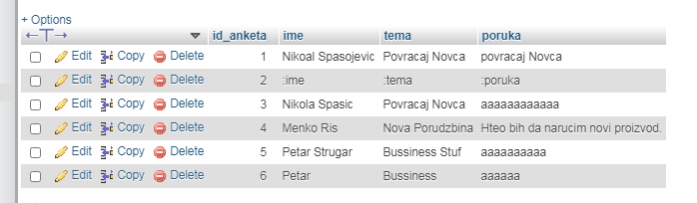

### Baner

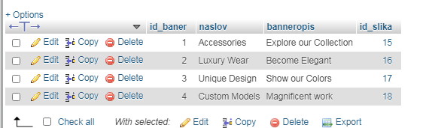

### Boja

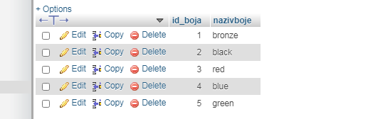

### Kontakt

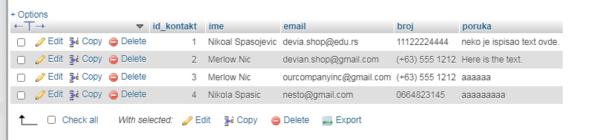

### Korisnici

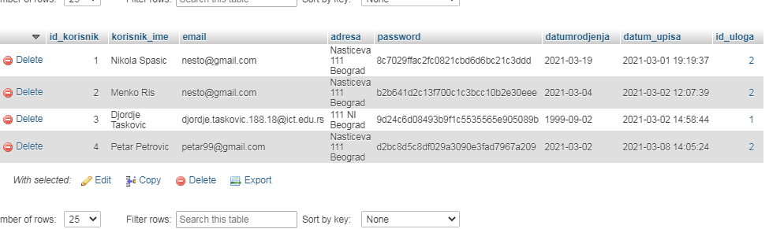

### Navigacija

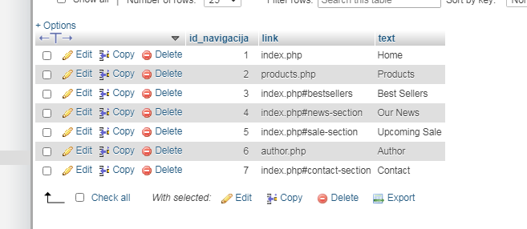

### Pol

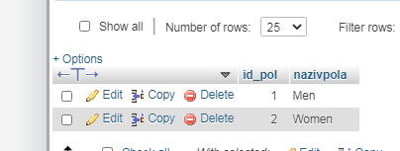

### Porudzbine

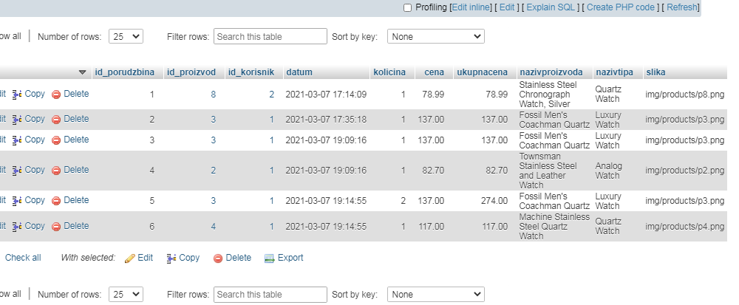

### Proizvod

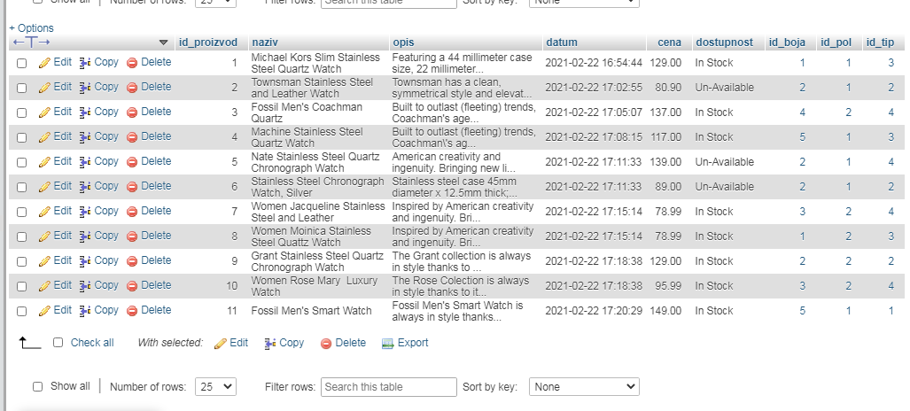

### Slika

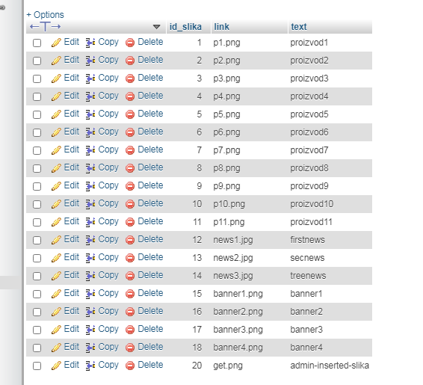

### Slika_proizvod

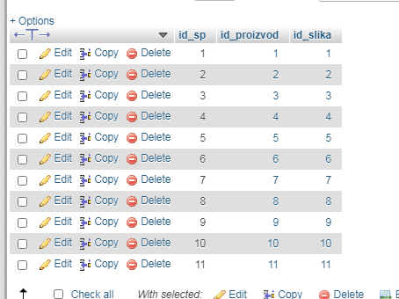

### Tip

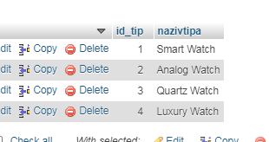

### Uloga

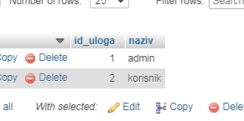

### Vesti

